Reach For The Skies
The Library Telescope Programme is a collaboration of
Westminster Reference Library and The Science & Facilities Technology Council

Skywatcher Heritage-90 Virtuoso
Maksutov-Cassegrain Telescope
Quick Start Guide
Enjoy using our telescope
Please read this guide carefully BEFORE you start
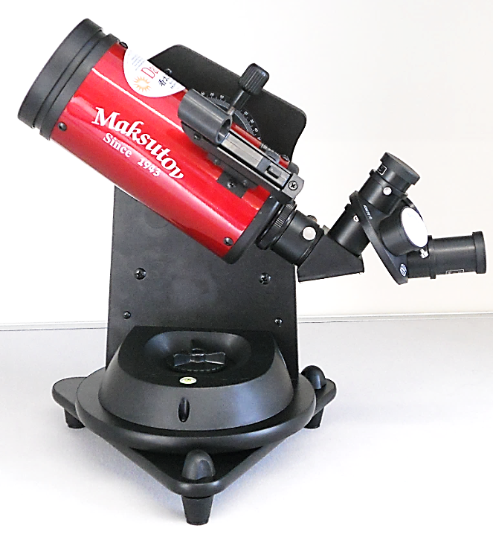

WARNING: Never look x directly at the Sun through the telescope or its finder scope — even for an instant — as permanent eye damage could result. Do not point the telescope at the Sun, as parts will melt! Children should use this telescope only with adult supervision.

Please read this guide carefully, it will enable you to use the telescope safely and gain the most from your experience of exploring the night skies!
You will already have watched the instructional video on how to set up and use the telescope in the library. Remember, if you need to refresh your memory this video is always available to watch online via the library website (insert link) and via YouTube (insert link).

Our telescopes have been modified and adjusted for Northern Hemisphere users.
This makes it easy to use with minimum adjustment necessary.

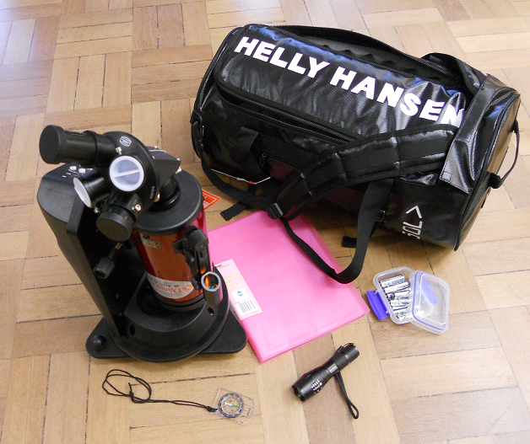

Carrying the Telescope Home
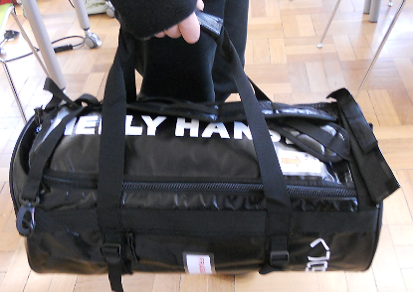
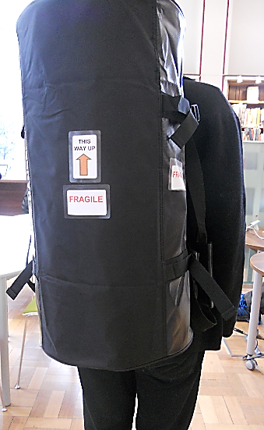
The telescope bag can be carried either horizontally using the hand straps or vertically using the shoulder straps. Please Note if you carrying it vertically always carry it and put it down the correct way up to avoid damage.
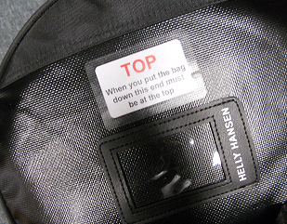
Contents: page

Proper Use and Care 4
Packing and unpacking the Telescope 5
Parts of the Telescope 6
10 Steps to using the telescope 7 - 12
Behold the Night Skies 13
Changing the batteries 14
Proper Use and Care: Please Read!
Do not look at the sun as permanent eye damage could result.
Do not point the telescope at the sun, as parts will melt.
Do not allow Children to use without Adult Supervision.
Do not touch or attempt to clean any lenses, it is very easy to scratch the lens coating. If they seem dirty, please inform a librarian.

Do Read this guide carefully before using the telescope and follow the instructions
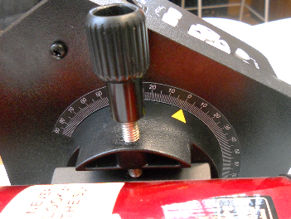
Do keep lens covers on when the telescope is not in use.
Do ensure that the telescope tube is securely attached to the base by keeping the locking screw firmly screwed down – more details on page 5
Do place the telescope on a solid and stable surface such as a steady table.
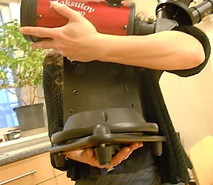
When moving the telescope always hold it from under the base with one hand and support the tube with the other.

Do have fun using the telescope!
Packing and unpacking the Telescope
To unpack the telescope place the bag on a flat surface stable and unzip the flap at the top. The Telescope should be positioned in the bag as shown in Figure 1. When you come to pack it up it must be placed in exactly the same position.
We won’t lie to you, this part can be a bit tricky but it’s important to pack it up carefully and get it right otherwise the equipment may get damaged, so take your time, follow the instructions and don’t rush.
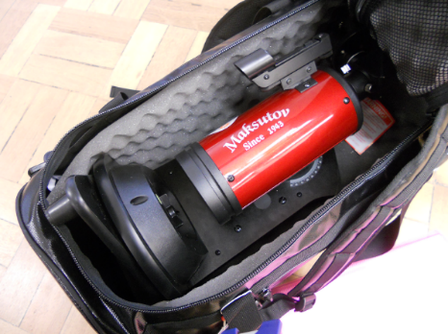
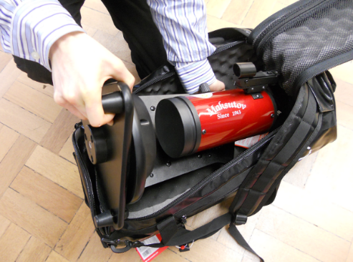
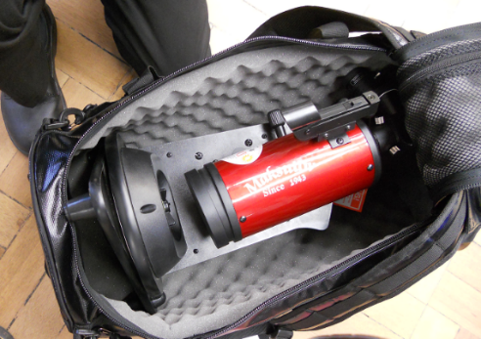
Figure 3 - Carefully lower the telescope into the bag with the telescope tube facing upwards and the back of the stand lying flat on the bottom.
The eyepiece at the top of the telescope tube must be at the closed end of the bag
One foot of the rotating base needs to be pointing strait up as shown. It’s a bit of a squeeze but you will be able to zip the top of the bag up around this foot.

Figure 1 – This is how the telescope should look when you unzip the bag, with the telescope tube facing upwards and the back of the stand lying flat on the bottom.

Figure 2 - When you put the telescope back in the bag tilt it as shown , put the top end in first with one hand underneath to support it.
Never try to put it in with the telescope tube facing down as this would place weight on the delicate, view finder and eyepieces.
Parts of the Telescope
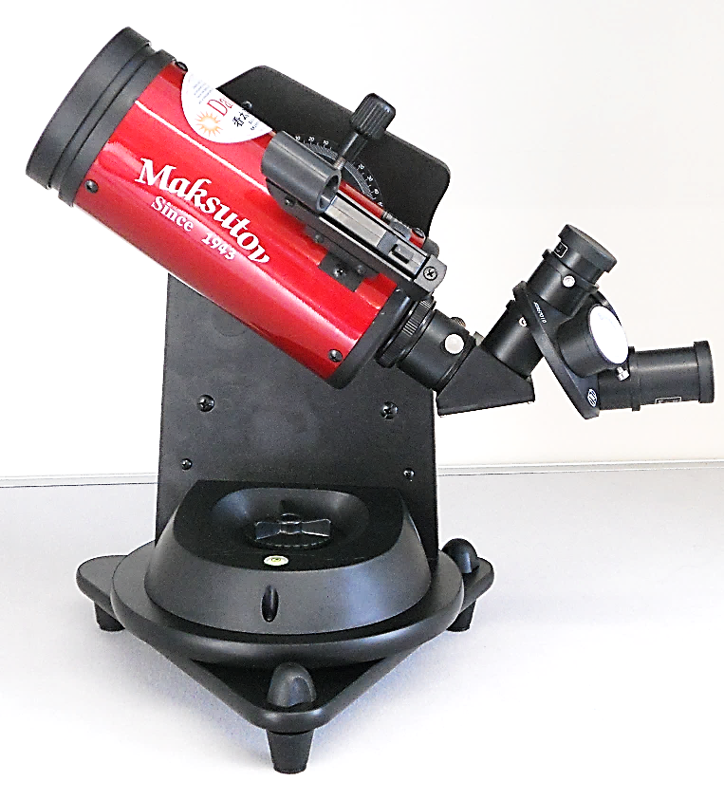
Parts of the telescope
Front view

1 Telescope Tube
2 Rotating Base
3 Locking Knob to rotate base
4 Adjustable Feet
5 Bubble level
6 Eye Piece Turret with 2 eyepieces
7 Red Dot Finder
8 Locking screw to secure tube to stand
9 Telescope stand
10 Lens cover

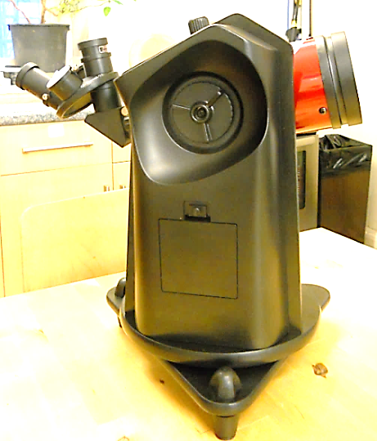
Parts of the telescope
Back view

11 Locking Knob to rotate the telescope tube
12 Focus knob
13 Hatch to battery compartment
14 Screw securing hatch to battery compartment

10 Steps to using the telescope
Practice setting up and using your telescope indoors before taking it outside in the dark so that you can become familiar with the controls in a warm comfortable environment where you can see what you are doing.
Plan where you will place the telescope outside, it needs a firm stable surface. If you have a really solid garden table that is ideal. If not then a good solid chair will work pretty well. In order for the telescope to work properly you must ensure that it is not subjected to any jots or vibrations.
1 Setting up
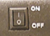
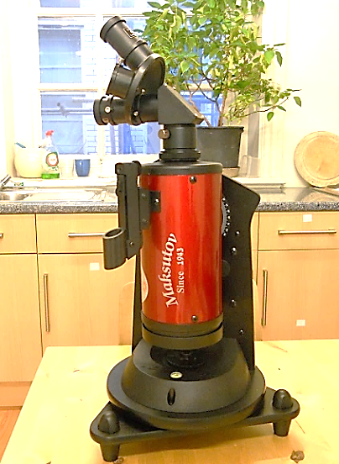
The following steps 1-3 must be followed BEFORE you hit the turn on the telescope at the control panel.
WHY ?- The telescope has an auto tracking feature that enables it to follow the object you are looking at, keeping it in view even though the earth is spinning. For this feature to work the telescope needs to accurately register its position. It can only do this if it’s properly set up before being turned on.

When you get your telescope home and take it out of its bag you will see that it is in this position. With the Tube vertical and the front lens facing down. This is the correct position for transporting the telescope safely.
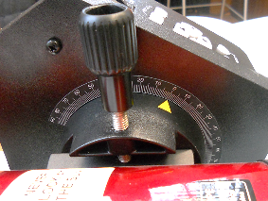
Before doing anything, ensure that the telescope tube is firmly attached to the stand. By checking that the screw knob is tight. This is very important, if it is loose then the telescope can easily slip off its stand and get damaged.

Next you will want to rotate the Tube to a Horizontal position. To do this loosen the knob on the back of the telescope (indicated by blue arrow). Rotate the tube horizontal position in the direction shown below. So the pointer mark, indicated here by a white arrow, points to zero on the scale.
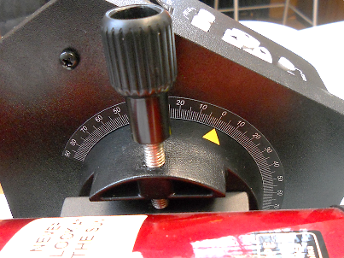
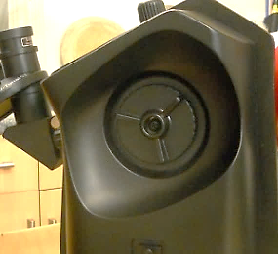
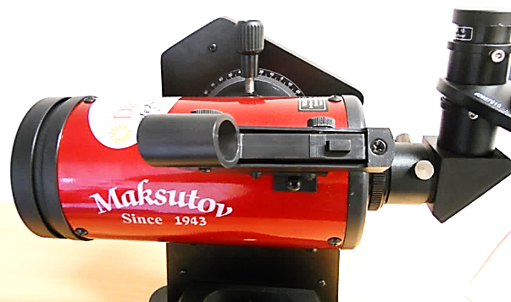

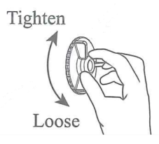
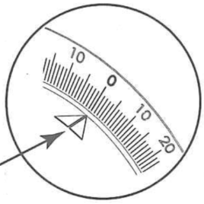

At this stage you will need to loosen the screw attaching the telescope tube to the base unit and slide it along so that it is supported in the middle. Make sure that you are holding the telescope tube firmly while making this adjustment so it cannot slip and when you have it in the right position screw it up tight so that the tube is firmly held.
2 Levelling the Telescope
Set the telescope on a firm, stable surface, you want to avoid any jolts or vibrations.
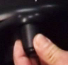
You want the base of the telescope to be level. This is indicated when the bubble in the level gage is floating in the centre.
Rotate the 3 adjustable feet from to adjust the tilt of the base until it is level.
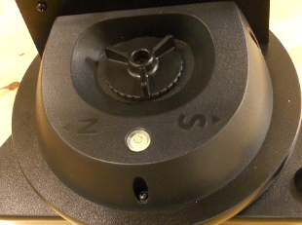
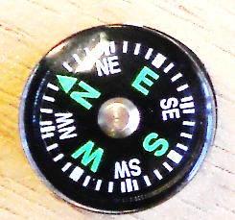
3 Finding North
Before turning the telescope the base should be pointing North.
Use the compass to find North and rotate the base so that so that the arrow marked N on the base is pointing in this direction.
In order to rotate the base first loosen the clutch knob on the base. Once you have it correctly positioned tighten the clutch knob again to lock it.
4 Turn the telescope on
Congratulations! you are now ready to turn on the telescope! Using the on/off switch on the control panel.
5 Moving the position of the telescope
To direct the telescope to point at the object you want to see you can either move it manually or use the control panel.
To move manually
Loosen the gear knobs on the base allowing you to rotate the telescope on its stand.
Loosen the gear knob on the back to allow you to tilt the tube. When it’s in the position you want, tighten the gears knobs to keep it in place.

To use the control panel
Make sure both gear knobs are fully tightened and the telescope turned on.
Just so you know- Once the telescope is turned on the buttons will flash red every 2 seconds but this is so faint that you will only see it in the dark.

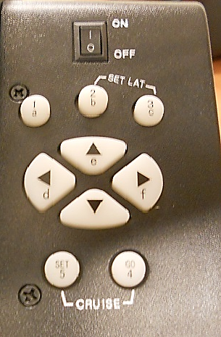
Use the directional arrows move the telescope up and down and rotate left or right. The numbered buttons control the speed of movement, 5 is quickest and 1 is so slow you won’t even notice it!
To conserve battery power- We recommend manually rotating the base to move the telescope left and right rather than using the controls.

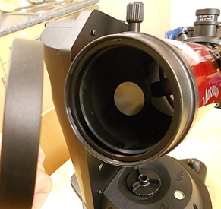
6 Take off lens caps off
From the front Telescope and eye piece that you will be using. You won’t see much with them on!
You will see that the eye pieces have rubber eye guards. When you take the lens caps off these will be in the down position. If you wear glasses then you can keep them in this position, if not you can pull them up as shown below. Their purpose is to keep your eye at the correct distance from the lens.
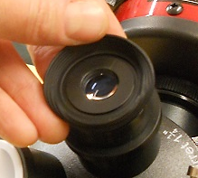
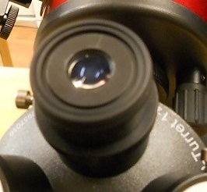
Remember - Do not touch or attempt to clean any lenses, it is very easy to scratch the lens coating. If they seem dirty, please inform a librarian.

7 Using the Red Dot Finder
This is used to aim the telescope at the object you wish to view. It has three controls: the one in the middle (1) is the on/off switch. The one on the front (2) moves it left and right and the one on the back (3) moves it up and down.
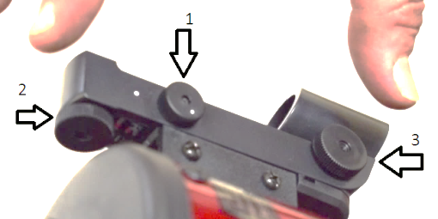
Remember – Always turn the red dot finder off when not in use to save battery power.

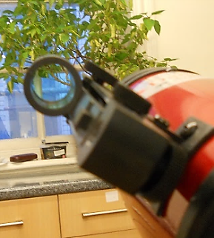
When you turn on the red dot finder and look through it you will see a red dot projected. Whatever the red dot points to is the object that the telescope is aimed at.
You can also use the directional buttons on the control panel to centre your object in the eye piece. We recommend using either speeds 3 or 4 for this.
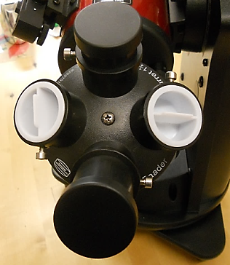
8 Using the eyepieces
The telescope comes with two eyepieces on a rotating turret. The eye piece on the top is the one that is in use. To select a different magnification simply turn the turret so that your chosen eyepiece is pointing directly up.
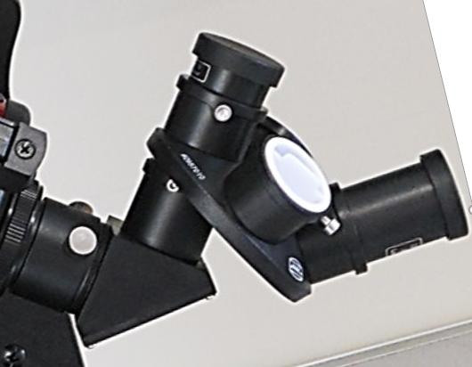
The longer eyepiece will give you less magnification but a wider field of view. If, for example you wanted to see the entire moon this would be the one to use.
The smaller eyepiece gives greater magnification for viewing objects in more detail. So, if you then wanted to zoom in on a particular crater just rotate the turret so the shorter one is on top.
You can use the directional buttons on the control panel to centre an object in the eye piece, we recommend using speeds 1 or 2 for this.
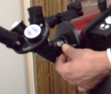
9 Focusing
To focus simply look at your object through the eyepiece and turn the focussing knob until you get a sharp image.

10 Using the controls to follow an object
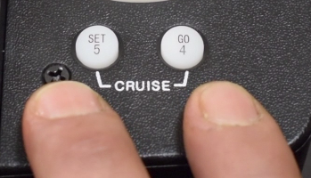
Once you can see your object though the eye piece and you are happy with the focussing you want the telescope to follow it through the sky.
To give the command just press buttons 4 and 5 together. The buttons will light up red just to show that it has received the command. The telescope is now following your object.

Pretty neat trick - The auto tracking feature keeps the telescopes moving to compensate for the rotation of the earth so it will follow the target you are watching while we all spin merrily though space! - This leaves you free to go off and make yourself a hot chocolate in the sure knowledge that when you return your object will still be in the eyepiece.

If you are viewing an object over a long period of time you will find that it eventually drifts out of the eyepiece and you will need to centre it again. However, if you find that it is wondering away frequently that means that the telescope was not accurately set up.

Don’t Panic! Just turn the telescope off at the control panel and repeat the set up procedure, steps 1 – 3 making sure that: The base of the telescope is properly level; The telescope tube is level with the pointer marker is pointing at 0; The North arrow on the base is pointing at North.

Once you are happy that it is properly set up turn it on again and give it another go. The more accurately you set it up the more accurately it will track your object

Behold The Night Skies!
When preparing to use your telescope outside we suggest wrapping up warm and taking a nice thermos of hot chocolate!

Ideally you should give your eyes about 20 minutes to accommodate to the darkness before viewing – you will see much more that way.

Among the equipment provided with the telescope is a red torch. This is a special torch designed for astronomical viewing and it will enable you to see the controls on the telescope enough to operate them without compromising your eyes ability to accommodate to the darkness.
Sky Guides
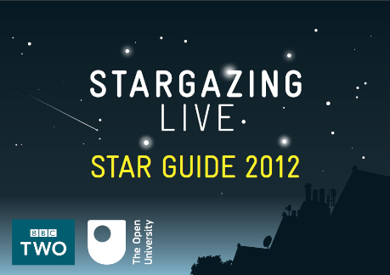
At the back of this guide we have included Stargazing Live - a great beginners guide to stargazing produced by BBC4 and the Open University, packed with useful hints and advice. It shows you what to look out for at each time of year. This guide can also be downloaded free from the BBC website.

http://downloads.bbc.co.uk/tv/guides/bbc_stargazing_live_star_guide.pdf

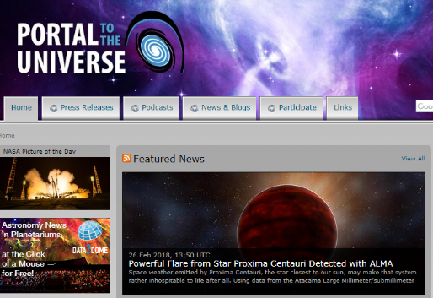
Portal to the Universe - A one-stop portal for online astronomy content, serving as an index, aggregator and a social networking site for astronomy.

http://www.portaltotheuniverse.org/

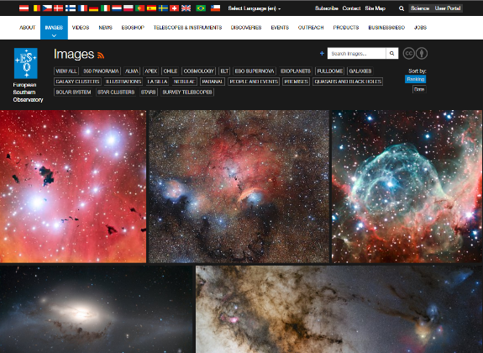
ESO - The European Southern Observatory is the foremost intergovernmental astronomy organisation in Europe and the world's most productive astronomical observatory. Their website contains impressive images and video footage from some of the most advanced telescopes in the world.

http://eso.org/public/videos/

Changing the Batteries
Unscrew the knob and remove the hatch to the battery compartment. Take out the whole battery unit and replace with the spare batteries provided. Put everything back as it was before and place the old batteries in the box provided.
