CONTROL OF LEGIONELLA AUDIT PROFORMA

INTRODUCTION: This document is an audit sheet designed to assist persons in control of cooling systems which incorporate cooling towers or evaporative condensers to assess their level of compliance with the requirements of the Control of Substances Hazardous to Health Regulations 1999 and the (revised) Approved Code of Practice (ACoP) - 'Legionnaires' disease: the control of legionella bacteria in water systems'.

THIS AUDIT IS NOT A RISK ASSESSMENT IN ITSELF

THIS PROFORMA IS NOT A RISK ASSESSMENT. IT MERELY ADDRESSES THE MOST IMPORTANT ASPECTS OF THE ACoP, AND IS DESIGNED AS A METHOD OF CHECKING COMPLIANCE.

WHEREVER FURTHER ACTION IS REQUIRED IT WILL BE NECESSARY TO REVIEW THE RELEVANT PART(S) OF YOUR RISK ASSESSMENT AND/OR WRITTEN SCHEME OF PRECAUTIONS.

It is designed to be an audit to assess the adequacy of the existing assessment and to highlight areas where further action is necessary. Further information is available in the new ACoP which now includes guidance formerly given in the document HS(G)70, 'The Control of Legionellosis (including Legionnaires Disease).'

Name and address of company:

1. Cooling system:

2. Date:

3. Audit carried out by:

4. Next review due:

NOTIFICATION

Risk Assessment | Yes/No | Further Action Required? Yes/No
5.Is the cooling tower/evaporative condenser notified to the LA?

The Notification of Cooling Towers and Evaporative Condenser Regulations 1992

require that all of these devices are registered with the local authority. If yours is not,
contact the environmental health department of your local authority for the required
registration form.

Risk Assessment | Yes/No | Further Action Required? Yes/No
6. Is there a written risk assessment for the system?
7. Does it contain an up to date schematic plan of the system?
8. Does it contain details of the precautions to be taken?
9. Does it contain instructions for the operation of the system?
10. Does the assessment conclude that there is a significant risk?
11. Does the assessment consider the tower's physical condition?
12. Does it consider the tower's positioning?
13. Does it consider the population density near the premises?
14. Does it consider any 'at risk' groups of persons?

Notes: Question 10 - For systems incorporating a cooling tower or evaporative condenser there will automatically be a risk of exposure and a written assessment must be recorded. The degree of risk will depend on a variety of factors including the condition of the tower, the population density within the vicinity of the premises (potential numbers of persons exposed) and whether there are any particularly susceptible persons nearby.

System Schematic | Yes/No | Further Action Required Yes/No
15. Does it show all system control valves?
16. Does it show standby plant (spare pumps etc.)?
17. Does it show any associated storage tanks?
18. Does it show system bleed valve?
19. Does it show chemical dosing pumps and injection points?
20. Does it show system drain valve?
21. Does it show the origin of the water supply?
Precautionary Measures | Yes/No | Further Action Required? Yes/No
22. Has elimination or replacement with a lower risk system been properly considered?

It should be noted that the precautions to be taken are required to protect persons against EXPOSURE to the legionella bacteria. The COSHH Regulations set out a hierarchy of measures to eliminate or reduce risks so far as is reasonably practicable. The first matter which should be considered is substitution of the system for a lower risk device such as closed chillers of air blast cooling where this is reasonably practicable. If this cannot be done, the necessary measures for control are more than just a chemical treatment of the water. They consist of a whole range of measures including design, operation, maintenance, monitoring and management and should include the provision of drift eliminators.

Cleaning and Disinfection | Yes/No | Further Action Required? Yes/No
23. Is there a written cleaning and disinfection procedure?
24. Is it carried out at least every six months?

25. If not, why not and how often?

26. Does it specify chlorine level at start of pre-clean chlorination?
27. Does it specify contact/circulation time?
28. Does it specify chlorine level at end of pre-clean chlorination?
29. Does it give the method for cleaning all accessible parts?
30. Does it specify chlorine levels at start of post-clean chlorination?
31. Does it specify contact/circulation time?
32. Does it specify chlorine level at end of post-clean chlorination?
33. Is the removal of the tower fill/pack for cleaning and disinfection specified in the assessment?

34. If not, why not?

35. Are they removed for cleaning and disinfection in practice/
36. Are there suitable health and safety procedures for carrying out cleaning and disinfection?

On-Going Water Treatment | Yes/No | Further Action Required Yes/No
37. Is a water treatment programme in place?
38. Does it use chemicals to control scale?
39. Does it use chemicals to control corrosion?
40. Does it use chemicals to control bacterial and algae (biocides)?
41. Are alternating biocides used?
42. Are the chemicals automatically dosed?
43. Is there an automatic bleed to control dissolved solids?

Correct and Safe Operation | Yes/No | Further Action Required Yes/No
44. Are there procedures for circulation of all parts once per week?
45. Is there a shutdown of the installation at least once per year?

46. If yes to question 45 how long does it last?

< 1 week
1 week - 1 month
> 1 month

47. Are there procedures for start-up after shutdowns?
48. Instructions for draining during long shutdowns?
49. Instructions regarding valve settings for normal operation?
50. Procedures for switching duty/standby pumps.

Monitoring and Records | Yes/No | Further Actions Required Yes/No
51. Daily check to ensure conformance with operating procedures?
52. Daily visual check made on the cleanliness of the system water?
53. Chemical water quality checks carried out at least monthly?
54. System physical condition checks carried out at least weekly?
55. Dip slide tests taken at least weekly?
56. If not, how often?
57. Are legionella tests carried out every quarter?
58. If not, how often?
59. Records of all tests undertaken maintained?
60. Recommendations for remedial action recorded?
61. Completion of remedial action recorded?
62. Are there records of plant usage?

Programme Management | Yes/No | Further Action Required? Yes/No
63. Is there a responsible person nominated in writing?
64. Is there an appointed deputy?
65. Are the duties of all persons involved clearly defined?
66. Are all persons involved adequately trained?
67. Are the responsibilities of the occupier and consultant(s) clearly defined?
68. Have the other relevant health and safety issues – COSHH assessments for chemicals, safe access etc been addressed?

Physical Condition and Design | Yes/No | Further Action Required? Yes/No
69. Are the drift eliminators suitable, in good condition and effective?
70. Is the system water in good condition?
71. Is the sump free from sediment?
72. Are all visible surfaces free from slime or algae?
73. Are all visible surfaces free from scale deposits?
74. Are all visible surfaces free from corrosion?
75. Is the water flow even across the whole of the tower fill?
76. Have all dead legs or poor flow areas been eliminated?
77. Has all redundant plant been isolated from the system?
78. Are all pipe runs as short and direct as possible?
79. Is the tower constructed of impervious
materials?
80. If constructed of wood, is this in good condition?
Drift eliminators should be of a multi-pass type. Old style single-pass eliminators are not acceptable. There should be no readily apparent emission of droplets in the exit airstream and where it is possible to look through the air path (from inlet to outlet) there should be no daylight visible. Eliminators should be checked for damage and correct location frequently as they are a vital control measure for minimising exposure of persons to a potentially contaminated aerosol. Negative answers to questions 69 to 80 would suggest that control of water is poor, and that the control measures are not effective and require a thorough review.

COOLING TOWER / EVAPORATIVE CONDENSER DETAILS
Manufacturer: |  | Model:
Type: (See Diagram B | elow)
Year of Manufacture:
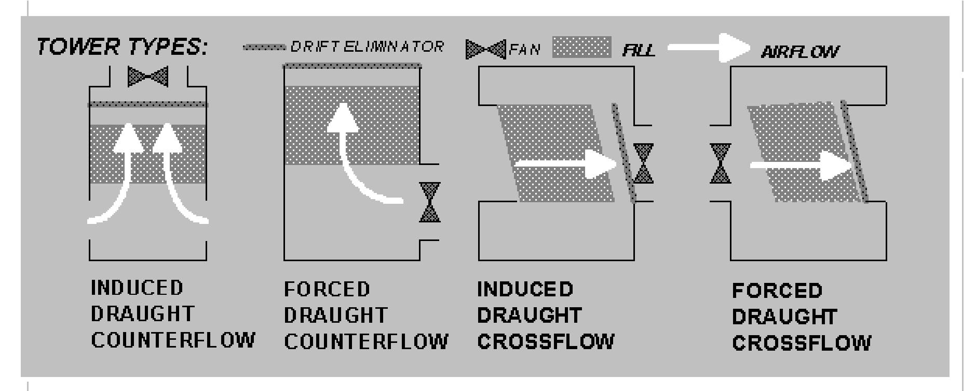

CONTROL OF LEGIONELLA AUDIT PROFORMA

Please complete the details of any contractors below:
(a) Ongoing water treatment contractor:
Name
Address
Contract
Phone

- Cleaning and disinfection contractor:
Name
Address
Contract
Phone

- Risk Assessment:
Name
Address
Contract
Phone

