WESTMINSTER CITY COUNCIL

POLICY FOR LEASEHOLDERS IN HOUSING RENEWAL AREAS

Updated January 2017

CONTENTS
- Introduction 1

- Who the policy applies to 1

- Overall approach 2

- Procedures for acquiring properties by agreement 4

- Definitions 5

- Options and entitlements for resident leaseholders
that do not wish to stay in, or return to, the Housing Renewal Area 6

- Options and entitlements for resident leaseholders that wish 9
to return to, or stay in, the Housing Renewal Area

- Options and entitlements for Flexible and 18
Rent to Mortgage resident leaseholders

- Becoming a social housing tenant (for resident leaseholders) 19

- Entitlements for non resident leaseholders 21

- Further information about financial entitlements 22

- Compulsory Purchase 24

- Appeals 26

- Discretion and exceptional circumstances 26
15. Updating the policy 26
16. Glossary 27
17. Appendices
Appendix A: Boundaries of the Housing Renewal Areas 30
Appendix B: Examples of equity loan arrangements 34

- Introduction

1.1 In 2010 the City Council published a Housing Renewal Strategy which set out plans for housing renewal over a number of years in the:
- Church Street and Paddington Green neighbourhood
- Tollgate Gardens Estate
- Ebury Bridge Estate
- Westbourne Green area, covering the Warwick and Brindley Estates (residents voted against housing renewal so it is no longer going ahead).
- Brunel Estate (residents voted against housing renewal so it is no longer going ahead).

1.2 A key aim of the strategy is to increase the supply and quality of affordable housing. To achieve this some existing leasehold properties will need to be demolished and some new homes will be built for private sale.

1.3 Aside from the information in section 12 about compulsory purchase this policy is discretionary and aims to set out the headline financial compensation and general assistance leaseholders will receive from the City Council where their properties are identified for demolition, and the City Council’s overall approach to acquiring properties.

1.4 There is a glossary in section 16 which explains some of the terminology in this policy. Other relevant definitions are set out in section 5.

- Who the policy applies to

2.1 This policy applies to leaseholders, both resident and non resident, in the housing renewal areas set out in Westminster’s Housing Renewal Strategy where (i) their properties have been identified for demolition, and (ii) the Cabinet Member for Business, Skills and Housing has made a decision that housing renewal, including the demolition of those identified properties, should proceed, subject to necessary planning consents.

2.2 The policy also applies to leaseholders that own a proportion of their property through the Flexible Ownership or Rent to Mortgage schemes. Their options and entitlements are, however, different and are set out in section 8.
2.3 This policy will also apply to leaseholders in any new housing renewal areas covered in an updated Housing Renewal Strategy, in the same way as it applies to leaseholders on those estates currently identified in the strategy.

- Overall approach

3.1 Approach to the purchase of leaseholders’ properties
The City Council will work with leaseholders individually and in a way suited to their needs, to discuss their options and entitlements, and the policy will be communicated in an accessible way.

3.2 Every effort will be made to negotiate the acquisition of leaseholders’ properties by agreement. However, where all attempts to acquire by agreement are unsuccessful, the City Council may have to use its powers of compulsory purchase as a last resort. Further details on the compulsory purchase process are set out in section 12 of this policy.

3.3 Approach to compensation
Regardless of whether leaseholders’ properties are acquired by agreement or compulsorily, the City Council will pay leaseholders compensation in line with the statutory framework (see section 12). Aside from offering the compensation set out in this policy it is the City Council’s aspiration that leaseholders will be neither financially better, or worse off, from having their homes acquired. However for resident leaseholders choosing one of the rehousing options, this may not be achieved in every individual case, for the reasons explained in paragraph 3.5 below.

3.4 Approach to rehousing and relocation (for resident leaseholders)
The impact of housing renewal on leaseholders, where their homes are being acquired is recognised, and it is understood that many resident leaseholders have connections to their local area and want to remain there. A range of options are available for leaseholders that want to stay in or close to the Housing Renewal Area, or in Westminster, to suit different circumstances. A summary of the different options, which are mostly subject to meeting an eligibility criteria, are set out in the following chart. Every reasonable effort will be made, where possible, for resident leaseholders to remain home owners if this is their wish.

3.5 Leaseholders must bear in mind that it may not be possible to exactly replicate the same costs at another property (compared with leaseholders’ existing properties) as utility costs, ground rents, insurance, service charges and council tax will vary. Also lending rates and criteria are subject to change over time, so the cost of the same value mortgage may be different at an alternative property.

3.6 The help and assistance (whether financial or otherwise) available to leaseholders to buy another property, in or outside the Housing Renewal Area, (set out in sections 6 and 7) will be available to leaseholders for a reasonable period, after which time they may be withdrawn. Details of any deadlines imposed by the City Council will be provided to affected leaseholders in writing.

3.7 Approach to advice and support (for resident leaseholders)
Independent advice will be available to help each leaseholders assess the best option for them. Independent legal and financial advice may also be provided in some circumstances.

3.8 Approach to implementing this policy
The City Council may appoint agents to act on its behalf to deliver parts of this policy. References to the “City Council” in this policy may also therefore include any appointed agent. Leaseholders will be provided with all the relevant information where appointed agents are used.

- Procedures for acquiring properties by agreement

4.1 Once the Cabinet Member for Business, Skills and Housing agrees that the City Council can enter into negotiations to buy leaseholders’ properties, every leaseholder will be informed in writing of the City Council’s decision to acquire their property. They will receive an invitation to enter into negotiations to sell by agreement (which the leaseholder will need to accept or reject in writing). The information will include general details of:
- The rehousing options available for resident leaseholders
- The advice and general support available to resident leaseholders to help them assess their options
- Compensation entitlements and how to claim them
- The City Council’s procedures for acquiring properties.

4.2 Leaseholders will be given sufficient time to consider their options and will be advised of any dates by which they need to decide if they want to sell their property by agreement or make any other decision. Resident leaseholders will be given a reasonable period of time to decide, which (if any) of the relocation options they want to pursue and they will be advised of any time periods for which they are available. All offers relating to this policy will be set out in writing and the leaseholder will need to accept or reject them in writing.

4.3 If attempts to acquire properties by agreement have been exhausted, a Compulsory Purchase Order (CPO) will be sought as a last resort. It may be necessary for work to progress a CPO to be undertaken whilst negotiations to acquire by agreement are ongoing, but the City Council’s position will remain that it will continue such negotiations to acquire by agreement right up until the point that any CPO is confirmed (see section 12).

- Definitions

5.1 Definition of a resident and non resident leaseholder
With the exception of section 12 which relates to compulsory purchase and statutory entitlements, this policy is discretionary and applies to situations where the City Council is seeking to buy a leaseholder’s property by agreement. The definition of a non resident leaseholder in section 12 (see 12.7) which relates to statutory compensation where compulsory purchase powers have been used varies from the definition set out here.

5.2 For the purpose of this discretionary policy the definition of a resident leaseholder is one that has been in occupation for 12 months preceding the date of the notification letter from the City Council setting out its intention to acquire the property by agreement (see 4.1). Where housing renewal is taking place in phases, these letters may be sent out in phases. The Council Tax register will be used to determine if leaseholders meet the residency qualification. Additional sources of information may be used to determine residency where necessary.

5.3 The policy with regard to the definition of resident leaseholders, will not be applied inflexibly and there may be situations where special circumstances apply, for example if leaseholders do not meet the residency definition as they are working away from their main home for a period. See section 14 on discretion generally.

5.4 Any leaseholder not meeting the criteria set out in the above paragraphs will be considered a non resident leaseholder for the purposes of this discretionary policy and will only be eligible for the option and entitlements set out in section 10.
5.5 Definition of the Housing Renewal Area
Each Housing Renewal Area is defined by the boundaries of a master plan and a map of the current master plan areas is in Appendix A but these maybe amended or changed at the City Council’s absolute discretion by means of a Cabinet or Cabinet Member decision from time to time. The size of the Housing Renewal Area differs between schemes, in some cases it may be a single estate while in others it may be a more than one estate or a whole area.

5.6 Definition of a Housing Renewal Site
A Housing Renewal Site is part of a Housing Renewal Area which is being redeveloped separately. The Housing Renewal Area may be divided up into a number of Housing Renewal Sites.

- Options and entitlements for resident leaseholders that do not wish to stay in, or return to, the Housing Renewal Area

6.1 This section sets out the general financial entitlements for resident leaseholders that do not wish to return to the Housing Renewal Area, together with the general help they may receive from the City Council to purchase another property in another area, or in Westminster (but outside the Housing Renewal Area). There are separate options and entitlements set out in section 8 for those that have bought through the Flexible Ownership and Rent to Mortgage schemes.

6.2 Financial entitlement
Leaseholders choosing this option will receive the market value of their property plus a home loss payment of 10% of the market value of the property, up to a maximum of £53,000. The home loss payment will be made on the day the
property is acquired by the City Council.

6.3 A disturbance payment compensating leaseholders for all reasonable costs associated with the move will also be made. As the disturbance payment may cover a range of moving costs, the amount may not be determined on the day the property is acquired, and if this is the case the payment will be made as soon as reasonably practicable thereafter.

6.4 Further details as to how the market value and disturbance payments are calculated are set out in section 11.

6.5 Practical help with buying a replacement property outside Westminster
Where it is needed, the City Council can provide practical, non financial help to assist leaseholders to buy another replacement property. The need for this will be assessed on a case by case basis and will be limited to information on how to purchase a property on the open market.

6.6 Practical help with buying a replacement property in another part of Westminster (outside the Housing Renewal Area)
The need for and level of help to be provided will be assessed on a case by case basis, in accordance with individual needs, and may include (but is neither guaranteed to include nor restricted to) the provision of:
- Information on how to purchase a property on the open market
- Information on any other leasehold properties the City Council knows are for sale
- Help to find a replacement property in Westminster. In some circumstances the City Council or its agent may be able to facilitate the purchase of a replacement leasehold property from its own vacant stock (this is dependent on the supply of housing stock and is subject to government rules and conditions)
- Advice on intermediate housing options in Westminster.
6.7 Financial help to buy a replacement property in another part of Westminster (outside the Housing Renewal Area)
Where the options described in section 7 to return to the Housing Renewal Area are unsuitable for the leaseholder, due to their particular circumstances, as it would involve them having to move twice, they may be offered an equity loan from the City Council’s agent to buy another property locally (near to the Housing Renewal Area). This option may be offered where leaseholders:
- Have a need to remain close to the Housing Renewal Area, due to the location of their employment, support networks, or for other factors considered reasonable, and
- Are unable to afford to buy another property outright of the same size and type, due to any difference in property prices.

6.8 The offer to purchase a replacement property is likely to be from the City Council’s agents own housing stock and will be an ex social housing property. Any offers will be confirmed in writing and the leaseholder will need to accept or reject them within the reasonable timescales set out in the offer letter. This option will be subject to the available resources and housing supply of the City Council’s agent.

6.9 Where this option is agreed, leaseholders will be eligible where they agree to contribute to the purchase of the new property:
- The market value of the property being acquired (made up of any equity in the property plus the outstanding mortgage)
- Any home loss payment (10% of the market value of the property being acquired, subject to the £53,000 cap)
- Any other capital/savings it is considered reasonable for the leaseholder to contribute.

6.10 Properties must be of the same size and type as the ones in which they have been living and cannot have a greater number of bedrooms than the leaseholder’s existing property being acquired by the City Council.

6.11 The outstanding proportion of the property’s purchase price will be funded by an interest free equity loan from the City Council’s agent which will be secured as a charge on the property. There will be no repayments on the equity loan for 25 years after which it must be repaid in full. Leaseholders should note that this equity loan product differs from the product offered to returning leaseholders by the City Council in section 7, as the agent must offer a product which meets the requirements of the regulator. The equity loan is also for the leaseholder only and not for their heirs or assigns and the loan must be repaid in full in the event of the leaseholders death.

6.12 Becoming a social housing tenant
In some circumstances where leaseholders are unable to purchase a replacement property (whether within Westminster or outside) they may be eligible to become a social housing tenant in Westminster. Further information about eligibility is in section 9.

7. Options and entitlements for resident leaseholders that wish to return to, or stay in, the Housing Renewal Area

7.1 This section sets out options and entitlements for resident leaseholders that want to return to, or stay in, the Housing Renewal Area. There are separate options and entitlements in section 8 for those that have bought through the Flexible Ownership and Rent to Mortgage schemes.

7.2 The definition of the Housing Renewal Area is in 5.5. Returning to, or staying in, the Housing Renewal Area may not mean in most cases to exactly the same estate (where the Housing Renewal Area covers more than one estate), or to the same block or location in a block (where the Housing Renewal Area covers only one estate). There may be exceptions to this due to the nature of some individual schemes and arrangements and options will be developed separately where this applies.

7.3 Financial entitlement
Leaseholders choosing this option will receive the market value of their property plus a home loss payment of 10% of the market value of the property, up to a maximum of £53,000. Depending on the option chosen these sums may not be paid to the leaseholder directly but put towards the purchase of another property.

7.4 A disturbance payment compensating leaseholders for all reasonable costs associated with the move will also be made. As the disturbance payment may cover a range of moving costs, the amount may not be determined on the day the property is acquired, and if this is the case the payment will be made as soon as reasonably practicable thereafter.

7.5 Further details as to how the market value and disturbance payments are calculated are set out in section 11.

7.6 Options for buying one of the new build properties
Leaseholders are able to buy one of the new build properties that are available to them and these properties will be agreed between the City Council and the developer for each Housing Renewal Area or Housing Renewal Site (see section 5 for definitions of each).

7.7 As previously stated this option will be available to leaseholders for a reasonable period (see 3.6) after which the option will be withdrawn (this is because the City Council needs to agree with the developer how many properties in the new scheme will be available to retuning leaseholders). Leaseholders will be advised in writing of all relevant timescales and details relating to the offer (including the location of the new build properties they are able to buy) and when they will need to decide if they want to purchase one of them.

7.8 The way in which properties can be purchased will depend on individual financial circumstances and leaseholders’ options will be assessed in conjunction with the independent advisor. Details of the possible options are summarised below.

7.9 Leaseholders wishing to buy one of the new build properties may need to live in temporary housing for a period until the new properties are ready, so may need to move twice. More information on temporary housing arrangements can be found in 7.32 – 7.40 below. Information on the associated financial arrangements when leaseholders need to move twice are in 7.31.

7.10 OPTION 1: Buying one of the new properties outright
Leaseholders are eligible to buy one of the new properties outright if they are able to raise sufficient finance, using the compensation received as a result of the acquisition of their existing property, plus any additional capital or savings they are able to put into the purchase and/or by raising a higher mortgage.

7.11 Leaseholders choosing this arrangement are, subject to their personal finances, able to buy a property which is larger than the one where they have been living.

7.12 OPTION 2: Buying one of the new properties with an equity loan
The new properties for sale will generally be of a higher value than the existing properties being acquired. Leaseholders may however be able to buy one with an equity loan from the City Council, which will enable them to have similar housing costs compared with their existing property. It should be noted however that the housing costs cannot be exactly replicated, as lender rates are subject to change. Utility, ground rent and service charge costs may also be different at the new properties compared with the leaseholder’s existing property.

7.13 Leaseholders are eligible for this option where they agree to put the value of their existing property, plus any home loss payment, into the purchase of the new property. Examples of this arrangement are in Appendix B. The Leaseholder’s contribution will be made up of:
- The market value of the property being acquired (made up of any equity in the property plus any outstanding mortgage). More information on how market value is calculated is in section 11
- Any home loss payment (10% of the market value of the property being acquired, subject to the £53,000 cap)
- Any other capital/savings they want to put into the purchase.

7.14 The remaining proportion of the new build property will be funded by an interest free equity loan from the City Council which will be secured as a charge on the property (examples of equity loan arrangements are in Appendix B). There will be no repayments on the equity loan and it only needs to be repaid upon sale of the property. Any increase or decrease in the value of the property will be apportioned between the leaseholder and the City Council in line with their original contributions which are calculated as percentages (for more information see Appendix B example 3).

7.15 Under the equity loan arrangement, the leaseholder will be the sole legal owner and is able to sublet the property. The leaseholder is also able to sell the property with the agreement of the City Council, which will not be unreasonably withheld. Prior to any sale the City Council will require a further independent valuation to be obtained so that the amount that is due to be repaid to the City Council can be calculated. The property must be sold at full market value. The valuation will be at the expense of the leaseholder along with all associated administrative and other costs connected with the sale.

7.16 The leaseholder is responsible at all times for repairs, service charges, major works, insurances and all other costs associated with the new property.

7.17 The leaseholder is able to increase their share in the new property at any time, however in order to do so a new independent valuation of the property will need to be obtained so that revised percentage shares can be calculated as between the City Council's equity share and the Leaseholder's equity share. Again this valuation, and any associated administrative costs, will be the responsibility of the leaseholder.

7.18 New properties bought under this arrangement cannot have a greater number of bedrooms than the leaseholder’s existing property being acquired by the City Council, unless leaseholders can finance the cost of any additional bedroom/s themselves. The cost of any additional bedroom/s, which the leaseholder will have to bear, will be determined by taking the difference in the market value of a new build property the leaseholder is eligible to buy with one of the size they want to buy.

7.19 It should be noted that if the leaseholder’s existing property was purchased using a mortgage, a further mortgage to at least the same value (as the one held at the existing property being purchased by the City Council) will need to be raised so the purchase of the new property can take place. Independent financial advice may be available to leaseholders, if needed, to help them find a new mortgage.

7.20 In the event of the leaseholder’s death after the completion of the sale, any heirs that; were resident with the leaseholder at the time of their death, had been living with them as their principal home for six months, and are members of their family, will have the opportunity to transfer these arrangements into their name and at their own expense, for a period of five years from grant of probate. Family members are defined as the leaseholder’s, spouse, civil partner, people living with them as a spouse or civil partner, parent/s, grandparent/s, children, grandchildren, siblings, uncles, aunts, nephews and nieces. After five years, any heirs that met this qualification, and transferred the arrangement into their own name, will have the option to purchase the property outright, after which the City Council will enforce a sale.

7.21 OPTION 3: Becoming a shared owner at one of the new properties
Leaseholders are eligible for this option where:
- They are not eligible for the equity loan option (see 7.13) as they are unable to put the market value of their existing property plus any home loss payment into the purchase of the new property (because, for example, they are unable to raise the same mortgage again due to a change in their circumstances) and
- They nonetheless have or can raise sufficient finance to buy at least a 25% share in one of the new build properties and meet all other costs. The actual level of ownership will be calculated in accordance with each leaseholder’s financial circumstances and they will be expected to contribute their home loss payment to the purchase.

7.22 Under a shared ownership arrangement rent is paid on the part of the property which is not owned in addition to any mortgage. A shared ownership product specific to the housing renewal scheme is being developed which will be made available to leaseholders.

7.23 Arrangements for buying one of the new build properties
The arrangements set out below in 7.24 – 7.30 apply to all situations, however there are some additional arrangements in 7.31 – 7.40 which will apply where the new build properties are not ready to move into straight away and temporary accommodation is needed.

7.24 Allocating the new properties
As stated above the properties which will be available to returning leaseholders will be agreed between the City Council and the developer. To avoid leaseholders having to move twice (when there are new properties ready for them to move into), the new build properties available for returning leaseholders may be:
- On another estate (but still within the Housing Renewal Area or Housing Renewal Site (see section 5 for definitions of both) to where they have been living, or
- In another part of the estate or block/location to where they have been living.

7.25 There may be exceptions to the above (in 7.24), with regards to the location of the new properties leaseholders can buy on some schemes, and they will be advised where these apply. Where there are no exceptions, leaseholders may still be able to buy a new property in the location of their choice, if there are properties available, but would need to find and pay for own temporary housing costs until the new properties are ready. In these cases they will only receive a disturbance payment relating to one move.

7.26 A Local Lettings Plan will be developed for each scheme setting out how the new build properties available to returning leaseholders will be allocated. Leaseholders will be consulted on the plan, however the City Council will have ultimate discretion over the final plan. The Local Lettings Plan will set out how properties will be allocated if more than one leaseholder wants to buy the same available home. The factors which will be taken into account may include the size, location and orientation of the original home, any exceptional individual circumstances and the length of time the leaseholder has been resident in the local area. Timescales will be set for the allocation of properties so housing renewal can proceed.

7.27 Assessing the need for disabled adaptations
An assessment of any adaptations needed, and to be included in the new property, will be carried out by the City Council’s Occupational Therapist.

7.28 General processes
Detailed arrangements with relevant timescales will be developed for each Housing Renewal Area or Site separately and leaseholders will be made aware of how the process will work. Some general principles are below although these may be revised for different housing renewal schemes:
- All the new homes will be allocated through a Local Lettings Plan
- The way in which the leaseholder is purchasing one of the new homes, and the eligibility criteria, will be set out in an offer letter from the City Council which the leaseholder must accept or reject in writing
- The offer will include details of the property the leaseholder is buying and its value. It will also include the amount the leaseholder is contributing to the purchase, expressed as an absolute sum and a percentage contribution if they are buying with an equity loan, and as a percentage of ownership, if they are buying as a shared owner. Where the value of the leaseholder’s existing home and/or the new property have not yet been determined, or a new property has not yet been allocated, these amounts may be based on estimates. Once actual amounts are agreed and a new property has been identified a reconfirmed offer will be issued
- All the relevant legal documents relating to the offer will be available
- A mechanism will be established so the valuation of the leaseholder’s existing home and the new one they are buying are within the same timeframe
- The offer will be personal to the leaseholder and is not for their heirs or assigns
- The offer will be conditional on the leaseholder selling their property to the City Council by separate agreement and meeting the eligibility criteria
- Leaseholders will be advised when the new build property is nearly complete so they have plenty of time to apply for a new mortgage (if applicable).
- Leaseholders can withdraw from the offer at any time until contracts have been exchanged on their purchase of the new property but the City Council reserves the right to charge them £4k per year, or part thereof, for every year spent in temporary accommodation
- The City Council will only withdraw from the offer if the leaseholder is no longer eligible for it or if the development is unable to go ahead for any reason (or has not been completed by a certain point in time). They may also withdraw from the offer if the leaseholder has breached their tenancy agreement in the temporary housing provided, such as would justify proceedings for possession being taken (regardless of whether such proceedings are in fact taken), and where the breach cannot be resolved by agreement. Types of breaches of the tenancy agreement which might be regarded as serious include persistent rent arrears.

7.29 Changes in circumstances
Leaseholders should advise the City Council as soon as possible if they have changed circumstances. Where this means they can no longer buy in the way set out in the offer or the reconfirmed offer, their circumstances will be reassessed to consider the alternative options set out in this policy so far as they are still available. If another option to buy one of the new build is agreed a revised offer will be issued.

7.30 Arrangements in the event of the leaseholder’s death
If the leaseholder dies before contracts have been exchanged on the purchase of the new property the offer will be withdrawn.

7.31 Financial arrangements where the new build properties are not ready to move into straight away and temporary housing is needed
The City Council will hold the leaseholders equity from the sale of their existing property plus any home loss payment until the sale of the new build property completes. Leaseholders will be issued with a Promissory Note (see the glossary for more information about Promissory Notes) setting out:
- That it is holding their money for the purchase of a replacement home
- That interest will be paid annually at the rate at which the City Council receives interest on its assets (currently 0.59%). The basic rate of income tax (currently 20%) will be deducted before the interest is paid so that the interest received is “net”
- When and how (including timescales) their money will be repaid should the offer be withdrawn.

7.32 Temporary housing
As explained above, where leaseholders wish to return to a new property in the Housing Renewal Area, it may be necessary for them to relocate to temporary housing while the properties are built.

7.33 Leaseholders will be offered an assured shorthold tenancy in the local area where possible which will be managed by City West Homes. Each leaseholder will be made one reasonable offer of temporary housing in a property with the same number of bedrooms as their existing property. The temporary housing cannot be sublet.

7.34 Every effort will be made to offer a property which meets leaseholders’ preferences and requirements and takes account of the location of their support networks, employment and schools and the needs of any disabled household members. However, all temporary housing offers will be subject to the availability of supply.

7.35 Any disabled adaptations (integral and non-integral) present in a leaseholder’s existing property will be reinstated in the temporary housing and carried through into the new build property in the Housing Renewal Area.

7.36 There will be a right to appeal against the offer of temporary housing. Appeals must be made within 21 days of the offer by email or in writing and setting out why the offer is considered unreasonable. Appeals will be considered by the Strategic Director of Housing, Regeneration and Property or any other person delegated to make the decision, acting in their complete discretion, within 21 days following receipt of the appeal, unless further information is needed. Where such further information is needed, it will be requested within the 21 day period referred to.

7.37 Where the appeal is successful an alternative offer will be made. If the appeal is unsuccessful the City Council’s original offer of temporary housing will be reiterated and the leaseholder will need to either accept that offer or choose another housing option. Where appeals are unsuccessful leaseholders will be advised how to obtain independent advice as to the options open to them.

7.38 The housing costs in temporary housing will be no more than the housing costs paid by the leaseholder at their existing property. Existing housing costs are calculated as being the total of any mortgage and service charge payments made by the leaseholder in respect of their existing property. If there was no mortgage at the property being acquired by the City Council, the housing costs in temporary housing will be equivalent to any ground rent and service charge costs at their existing property. The leaseholder will be responsible for all other charges at the temporary accommodation.

7.39 Leaseholders that are eligible for Housing Benefit are expected to apply.

7.40 Leaseholders can find their own temporary housing but, where this option is pursued, would need to cover all the costs associated with the property themselves.

7.41 Buying another leasehold property in the Housing Renewal Area
In some cases leaseholders can remain in the Housing Renewal Area by buying a replacement leasehold property which is for sale and is not being demolished. The City Council may be able to assist in finding another such property.

7.42 The need for and level of help will be assessed on a case by case basis, in accordance with individual needs, and may include (but are not guaranteed to include and are not restricted to) the provision of:
- Information on how to purchase a property on the open market
- Information on any other leasehold properties the City Council knows are for sale in the area
- Help to find another property in the area. In some circumstances the City Council may be able to facilitate the purchase of another leasehold property from its own vacant stock (this is dependent on the supply of housing stock and is subject to government rules and conditions)
- Advice on intermediate housing options.

7.43 Becoming a social housing tenant in the Housing Renewal Area
In some exceptional circumstances leaseholders may be able to remain in the Housing Renewal Area by becoming a social housing tenant. This option is explained further in section 9 below.

- Options and entitlements for Flexible and Rent to Mortgage resident leaseholders

8.1 A small number of leaseholders affected by the housing renewal schemes own a proportion of their property rather than having full ownership, as they have bought under the Flexible Ownership or Rent to Mortgage schemes. As the above schemes vary and the proportion owned differs (and can be as little as 10%), the City Council will work with each leaseholder individually and offer them one of the following options (in 8.2) taking into account their personal circumstances, preferences and their level of ownership.
8.2 Options are:
- Becoming a shared owner at a new property in the Housing Renewal Area or Housing Renewal Site, or at another property outside the Housing Renewal Area (but within Westminster), as long as sufficient finance to buy at least a 25% share can be raised. The actual level of ownership will be calculated in accordance with each leaseholder’s financial circumstances and they will be expected to contribute their home loss payment to the purchase
- Becoming a social housing tenant (see section 9)
- In some limited circumstances buying a property outside the Housing Renewal Area (but inside Westminster) with an equity loan from the City Council’s agent. Full information about the product will be made available to leaseholders before a final offer is made (leaseholders should note that the product offered will be different from that offered to returning leaseholders described in section 7)
- To move away and make their own arrangements.

8.3 The City Council will work with each leaseholder and offer them one of the above options. The level of ownership and personal circumstances of each leaseholder will be taken into account when considering these options.

8.4 Financial entitlement
Leaseholders will receive the market value of their interest in the property (see section 11 for an explanation of how the value is determined) plus a home loss payment of 10% of the market value of their interest in the property up to a maximum of £53,000. The home loss payment will be made on the day the property is acquired by the City Council.

8.5 There may be circumstances when Rent to Mortgage resident owners may be entitled to an additional amount depending on when they bought their share in the property and the level of discount they received at the time. This will be assessed in line with individual circumstances.

8.6 A disturbance payment for all reasonable costs associated with the move will also be made. As the disturbance payment may cover a range of moving costs, the amount may not be determined on the day the property is acquired, and if this is the case the payment will be made as soon as reasonably practicable thereafter.

- Becoming a social housing tenant (for resident leaseholders)

9.1 In some circumstances a resident leaseholder may be eligible to become a social housing tenant either in the Housing Renewal Area or in another part of Westminster.

9.2 Resident leaseholders may be eligible for this option where:

- None of the alternative home ownership solutions set out in this policy are appropriate due to the leaseholder’s financial circumstances and no suitable reasonable alternative accommodation is available, or

- They wish to revert to the status of a tenant, and owner occupation is no longer suitable because of their disability or ill health, or the disability or ill health of their partner.

9.3 Factors which will be taken into account to assess eligibility will include:
- The suitability of available home ownership options
- The length of time the leaseholder has lived in Westminster or the Housing Renewal Area and factors which require them to remain there such as; location of employment, support networks and any other reasonable factors
- Whether their housing needs could be met in other ways and if reasonable alternative housing is available elsewhere
- The leaseholder’s financial circumstances including the level of equity in the property, any personal debt and if they may find it difficult to get another mortgage
- Any vulnerability issues such as age, ill health or disability.
9.4 Applications will be assessed on a case by case basis and final agreement will depend on the supply of social rented housing.

9.5 Financial entitlement
Where it is agreed that a leaseholder will become a social housing tenant in Westminster, they will receive:
- The full market value of their property (or interest in the property) minus a discount of 30% to reflect the loss of an asset (the social housing property) to the City Council
- A home loss payment of 10% of the full market value of their property (or interest in the property) up to a maximum of £53,000 (no discount will be applied to the home loss payment)
- A disturbance payment to reflect the cost of moving (see section 11 for more information about valuations and disturbance payments).

9.6 The social housing tenancy
Leaseholders eligible for this option will have priority to bid for a social housing tenancy for a reasonable period. Where leaseholders bid for a City Council tenancy it will be offered as a secure tenancy. It should be noted that some private registered provider (housing association) tenancies will be offered as fixed term tenancies.

9.7 The rent charged will be in line with the Rent or Tenancy Policy of the City Council or any private registered provider (housing association).

9.8 The size of the property needed will be assessed in line with the City Council’s Housing Allocation Scheme.

9.9 If the leaseholder does not bid for a property direct offers may be made, which will take into account where possible of the tenant’s stated preferences and any reasonable factors.

9.10 If the leaseholder wants to return to the Housing Renewal Area and there are no available properties to bid for, they will need to bid for a property outside the Housing Renewal Area. In some circumstances they may be given priority to bid for properties within the Housing Renewal Area, when the new build properties become available. These circumstances may include where the leaseholder:
- Has children attending local schools in the Housing Renewal Area and the travel time, or costs from the property to which they initially moved, are unreasonable in the long term
- Is receiving support from a family member, or giving support to a family member living in the Housing Renewal Area, and this provision of support is not sustainable from the existing property in the long term
- Has employment in the Housing Renewal Area and the time or cost of travel to work is unreasonable in the long term.

- Entitlements for non resident leaseholders

10.1 Non resident leaseholders (see section 5 for the definition of a non resident leaseholder) are entitled to receive the market value of the property (see 11.1 for more information about valuations) plus a basic loss payment of 7.5% of the agreed value of the property, up to a maximum of £75,000. It should be noted that for the statutory basic loss payment (which will become payable if properties are acquired by agreement (or in accordance with a Compulsory Purchase Order), the definition of a non resident leaseholder is different and is set out in 12.7.

10.2 Non resident leaseholders are entitled to the reimbursement of reasonable costs incurred in selling the property to the City Council. They are also entitled to compensation for the reasonable costs, excluding the purchase price, of acquiring an interest in a replacement property within the UK within one year of the date on which the City Council purchases their existing property. Compensation may include, but is not restricted to:
- Stamp duty land tax arising from the purchase of a replacement property capped at the equivalent stamp duty value of the agreed purchase price of the property sold to the Council. The Council will not reimburse any capital gains tax liability arising from the sale of the property
- Solicitor/legal fees arising from the purchase of a replacement property
- Surveyors fees arising from the purchase of a replacement property
- Furniture storage costs (if the property was furnished) for up to one year from the date of the purchase of the original property .

- Further information about financial entitlements

11.1 Valuation and market value (for resident and non resident leaseholders)
The City Council will appoint a qualified valuer to act on its behalf to undertake a valuation of the property due to be acquired to determine its market value. Leaseholders can also appoint a qualified valuer to act on their behalf and reasonable costs associated with this will be reimbursed by the City Council.

11.2 Valuations will take into account any improvement works undertaken before the valuation date and are on the basis of open market valuations which, in effect, do not take into account any increase or decrease attributable to the Housing Renewal or the fact that the purchase is or may be compulsory.

11.3 If the City Council’s and the leaseholder’s valuer cannot reach agreement the matter may be referred for dispute resolution.

11.4 If the leaseholder does not accept the valuation agreed between their valuer and the City Council’s valuer, or the valuation following any dispute resolution, they will be determined to have rejected the City Councils offer to buy by agreement. If a Compulsory Purchase Order is subsequently made, and compensation still cannot be agreed, the leaseholder will have the statutory right to have the matter referred to Lands Chamber of the Upper Tribunal as set out in 12.8.

11.5 Disturbance payments (for resident leaseholders)
Disturbance payments will be made to cover all reasonable expenses associated with the sale of the property, moving, and in connection with the purchase of a replacement property.

11.6 If the leaseholder is moving into one of the new build properties in the Housing Renewal Area, disturbance payments may include expenses associated with moving twice if this involves first living in temporary housing (or if they are becoming a social housing tenant and it first involves their taking a tenancy in another area). Disturbances payments will only apply to one temporary move, where the leaseholder chooses to find and fund their own temporary housing in order to return to a particular estate or block/location which would not normally be available to them (see 7.25).

11.7 For leaseholders not moving into one of the new build properties in the Housing Renewal Area, disturbance payments will need to be claimed within one year of their property being acquired unless there are exceptional circumstances.

11.8 Disturbance payments may include, but are not restricted to:
- Early mortgage redemption fees at the existing property
- Mortgage and lender fees arising from the purchase of a replacement property
- Stamp duty land tax arising from the purchase of a replacement property capped at the equivalent stamp duty value of the agreed purchase price of the property sold to the Council
- Solicitor/legal fees arising from the purchase of a replacement property
- Surveyors fees arising from the purchase of a replacement property
- Registered packing and removal services
- Disconnection and reconnection of utility supplies and redirection of post
- In some cases, payment for replacing white goods or furnishings owned by the leaseholder where the existing white goods/furnishing do not fit into the new property
- Removal and reinstatement of disabled adaptations as agreed by the City Council’s Occupational Therapist.

11.9 Disturbance payments will only be made in respect of one replacement property so in cases where joint leaseholders are not purchasing a replacement property together they will need to decide who will claim.

11.10 All disturbance claims must be supported by receipts and invoices bearing the name and address of the company providing such receipts and invoices, the details of which will be verified by the City Council.

- Compulsory Purchase

12.1 The City Council will make every effort to buy leaseholders’ properties by agreement, however where attempts to acquire properties by agreement are unsuccessful, the City Council will, as a last resort, seek to rely on its powers of compulsory purchase. A Compulsory Purchase Order (CPO) is subject to confirmation by the Secretary of State.

12.2 The law in this area is complex and this section is intended to only provide a summary of the legal framework. The overarching principle behind compensation for the compulsory acquisition of land is that no one should be financially worse or better off as a result of that compulsory acquisition.

12.3 Powers of Compulsory Purchase
Section 17 of the Housing Act 1985 gives local authorities the power to purchase land and property in order to provide housing accommodation. This type of acquisition may be by agreement with the leaseholder, or compulsorily with permission from the Secretary of State. The City Council also has powers under Section 226(1)(a) of the Town and Country Planning Act 1990 (the 1990 Act) to compulsorily acquire land which it thinks will facilitate the carrying out of development, redevelopment or improvement on or in relation to that land and that proposed development, redevelopment or improvement is likely to contribute to achieving the promotion or improvement of the economic, social or environmental well-being of the area for which the City Council is administratively responsible. The City Council may under Section 227 of the 1990 Act acquire land by agreement for the purposes set out in section 226 of the 1990 Act.

12.4 Objections and appeals to compulsory purchase
Where the City Council seeks, as a last resort, to acquire properties compulsorily, affected leaseholders have a statutory right to object to the compulsory purchase of their property, and for their objections to be heard at a Public Local Inquiry, or by written representations. If the Secretary of State decides to confirm the compulsory purchase order, there is a statutory right of appeal to the High Court, but only on limited legal grounds.

12.5 Statutory compensation for resident leaseholders
Where properties are being purchased compulsorily, resident leaseholders are entitled to compensation reflecting the market value of the property plus two additional forms of compensation as follows:

- A home loss payment. This is intended to compensate leaseholders for being forced to sell and move from their home at a time not of their choosing. To qualify, the displaced leaseholder must have lived in the property being acquired as their principal home, for at least one year ending on the day they have to move. The amount payable is 10% of the agreed purchase price of the property, up to a maximum of £53,000.

- A disturbance payment. This is to compensate for reasonable costs associated with moving to and acquiring or renting another property.

12.6 Rehousing
In certain circumstances, there is a legal obligation upon the City Council to re-house resident leaseholders under Section 39 of the Land Compensation Act 1973 where ‘suitable alternative residential accommodation on reasonable terms’ is not available.

12.7 Statutory compensation for non resident leaseholders
Where properties are being purchased compulsorily, non resident leaseholders are entitled to the market value of the property plus a basic loss payment under the Land Compensation Act 1973, of 7.5% of the agreed purchase price up to a maximum of £75,000. They are also entitled to compensation for the reasonable costs, excluding the purchase price, of acquiring a replacement property within one year. A non resident leaseholder for these purposes is one that has not lived in the property being acquired, as their principal home, for at least one year ending on the day the property is acquired.

12.8 Referral of compensation issues to the Lands Chamber of the Upper Tribunal
Where a compulsory purchase order has been confirmed by the Secretary of State but the compensation payable in respect of property acquired under it is in dispute, leaseholders have the statutory right to apply to a specialist tribunal to seek its determination as to what the compensation should be. In circumstances where the amount of compensation cannot be agreed, the leaseholder also has the right to request an advance payment of 90% of the value of the compensation as assessed by the City Council. If such a request is made, the advance payment must be paid within three months of the request.

- Appeals

13.1 Leaseholders can appeal to the Strategic Director of Housing, Regeneration and Property or any duly delegated person, about how this policy has been applied to their personal circumstances. Appeals must be made within 21 days of any decision complained of, by email or in writing, of any written notification of the application which the leaseholder seeks to challenge, setting out the reason why the leaseholder believes that decision does not accord with the policy. The Strategic Director or delegated person will decide on the appeal within 21 days following its receipt, and will do so acting in his or her total discretion.

13.2 If the appeal is successful an alternative decision will be made. If the appeal is unsuccessful the City Council’s original application of this policy will remain. The leaseholder will however be advised of how to get independent advice of the options open to them.

13.3 Leaseholders also have certain statutory rights of appeal where a compulsory purchase order is being sought which are set out in section 12 above.

- Discretion and exceptional circumstances

14.1 There may be limited circumstances when the Strategic Director of Housing, Regeneration and Property or duly delegated persons, may exercise discretion in relation to this policy due to exceptional individual circumstances and will do this by taking into account all the circumstances considered relevant.

- Updating the policy

15.1 The City Council reserves the right to amend the policy in any way in the future in its absolute discretion as a result of any matters including any changes in legislation, circumstances or otherwise.

- Glossary

Assured shorthold tenancy
A tenancy which lasts for a minimum period of six months, however it can be offered for a longer fixed period or continue indefinitely with the consent of the tenant and landlord. At the end of the fixed period, or at any time thereafter, the landlord is entitled to possession of the property as long as they give the tenant two months notice.

Equity loan
An equity loan arrangement is where a buyer contributes a proportion to the purchase price of a property. The remainder of the purchase price is provided by a third party who then holds a charge over the property equivalent to the proportion of the purchase price contributed by them. Equity loan arrangements can vary but the buyer is normally the sole legal owner and responsible for repairs and service charges. In the equity loan scenario set out in this policy the leaseholder will be the buyer and the City Council or its appointed agent will be the third party referred to.

Fixed term tenancy
Both councils and private registered providers (housing associations) (‘social landlords’) can now offer social housing tenancies on fixed terms. The length of the fixed term will vary between social landlords but it will typically be for five years and may be renewed. Different social landlords may have different policies on when a fixed term tenancy will be renewed.

Flexible owner
A flexible owner, owns a share of a Council property and pays a social rent on the proportion they don’t own. Every secure tenant that qualifies for the Right to Buy has the right to become a Flexible Owner, if they cannot afford to buy the property outright with the Right to Buy discount. Flexible ownership is also offered to Westminster City Council tenants that don’t meet the qualifying period for the Right to Buy. Flexible owners are responsible for repairs and for a proportion of other charges at the property. The minimum share that can be owned is 25% (prior to 1994 it was 10%).

Integral and non integral adaptations
An integral adaptation is built in to the property, such as a walk in shower and a non integral adaptation can be fitted once the property is built such as a grab rail.

Intermediate housing
Intermediate housing is for households that cannot afford market housing but do not qualify for social housing. There are different intermediate housing products, which may include low cost home ownership products or discounted rental schemes. The eligibility criteria for intermediate housing in London is determined by the Mayor.

Promissory Note
This is a legally binding financial instrument, which is a form of IOU, whereby the “maker” of the Promissory Note, promises to pay the “payee” a specific amount “on demand”. Where it is being used for the purposes of this policy (where the City Council is holding the leaseholders money until their purchase of a new build property in the Housing Renewal Area completes) the “maker” of the Promissory Note is the City Council and the “payee” is either:
- The developer when the sale completes, or,
- The leaseholder where the offer or the reconfirmed offer is terminated before completion.

“On demand” for the purposes of this policy means in either of the above circumstances.

Rent to Mortgage
The Rent to Mortgage scheme was ended in 2005 by the Housing Act 2004. The scheme enabled Council tenants to buy their homes by paying a proportion of the Right to Buy price (RTB), where they couldn’t afford to buy them fully under the Right to Buy. Tenants could buy by making a minimum initial payment of any amount they could afford up to 80% of the RTB price. Rent to Mortgage owners do not pay any rent but they pay full service charges and a proportion of repairs costs.

Secure tenancy
A tenancy that can only be brought to an end by the landlord by a court order and the order will only be granted by the court if one of the statutory grounds for possession is made out and other statutory tests (including in certain cases, the reasonableness of possession action) are met.

Shared ownership
A shared owner is someone that part owns their property (normally with a social landlord), but unlike someone that has bought with an equity loan, does not own it fully. The shared owner has a lease and pays rent as a percentage (normally up to 2.75%) on the unowned equity. They are normally responsible for all repairs and service charges. Shared owners can staircase up by buying additional shares to full ownership of the property. Permission is generally needed to sub let.

- Appendix A: Boundaries of the Housing Renewal Areas
1
9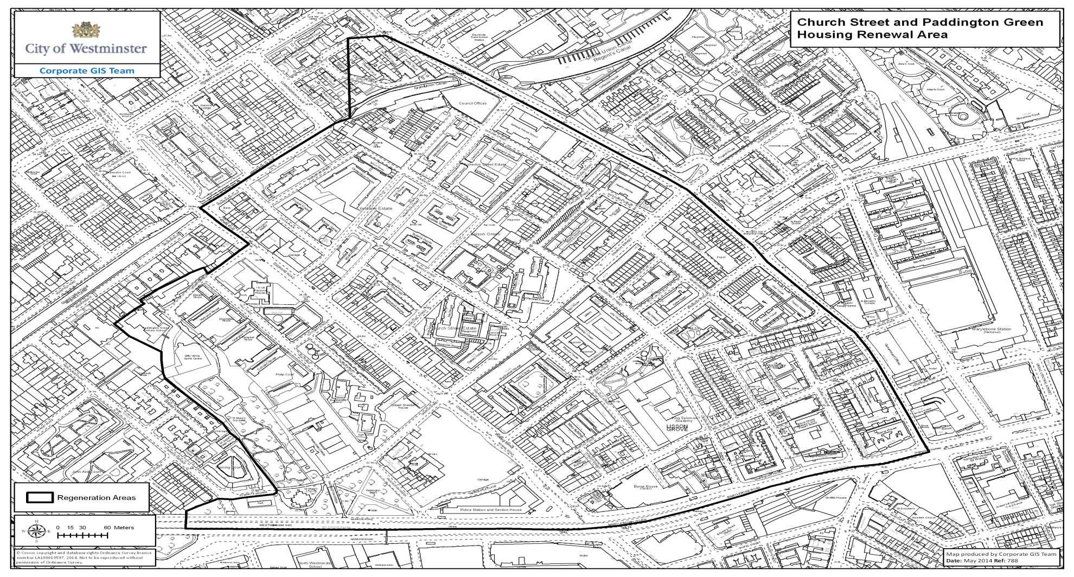

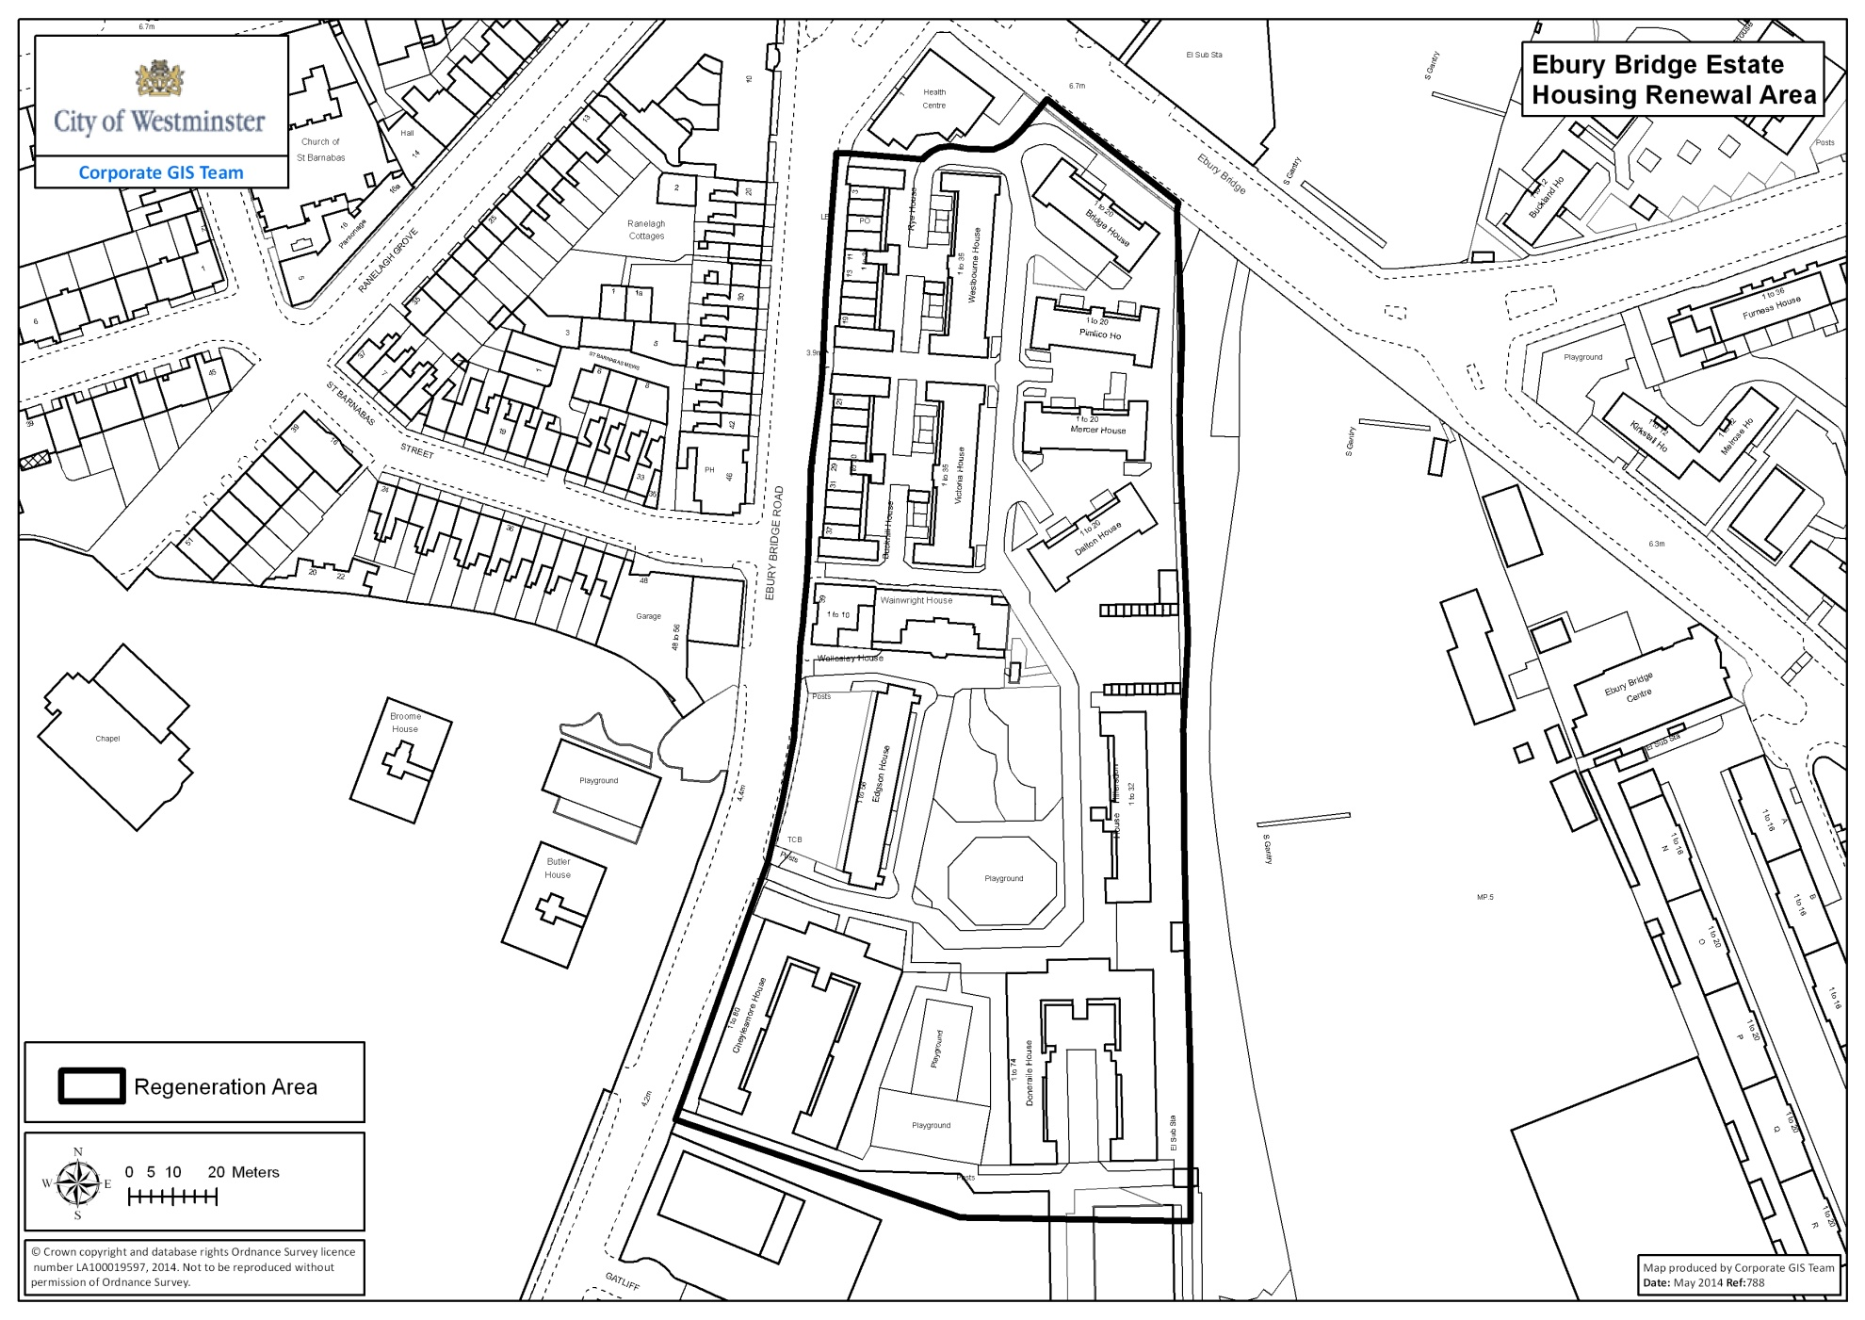
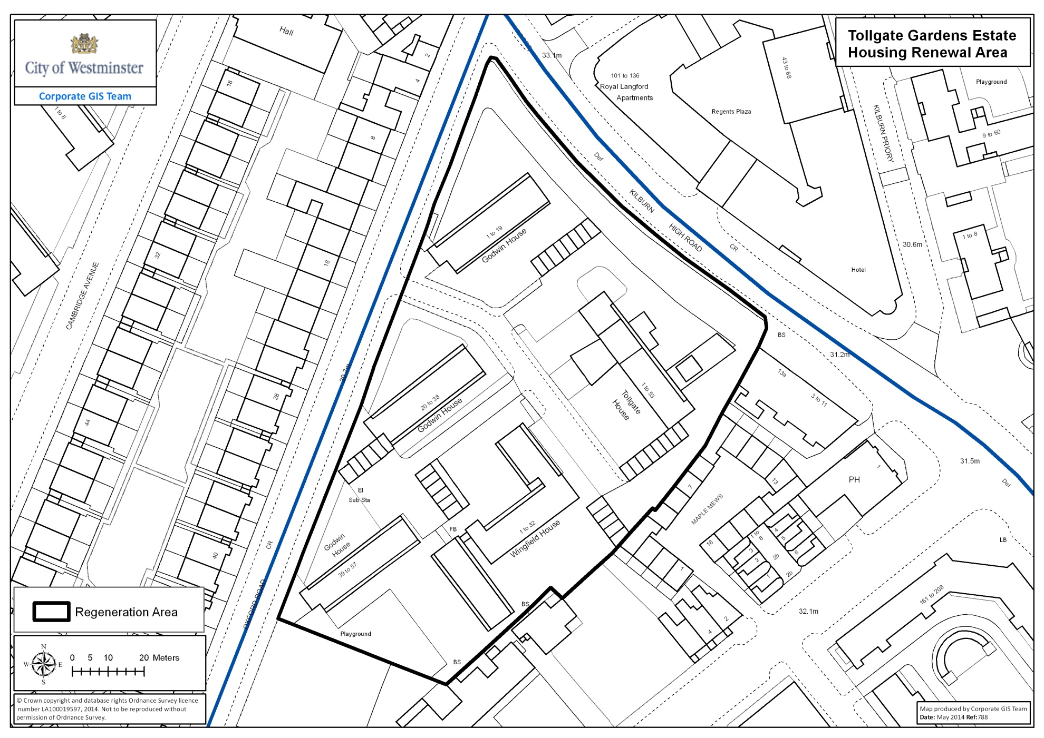
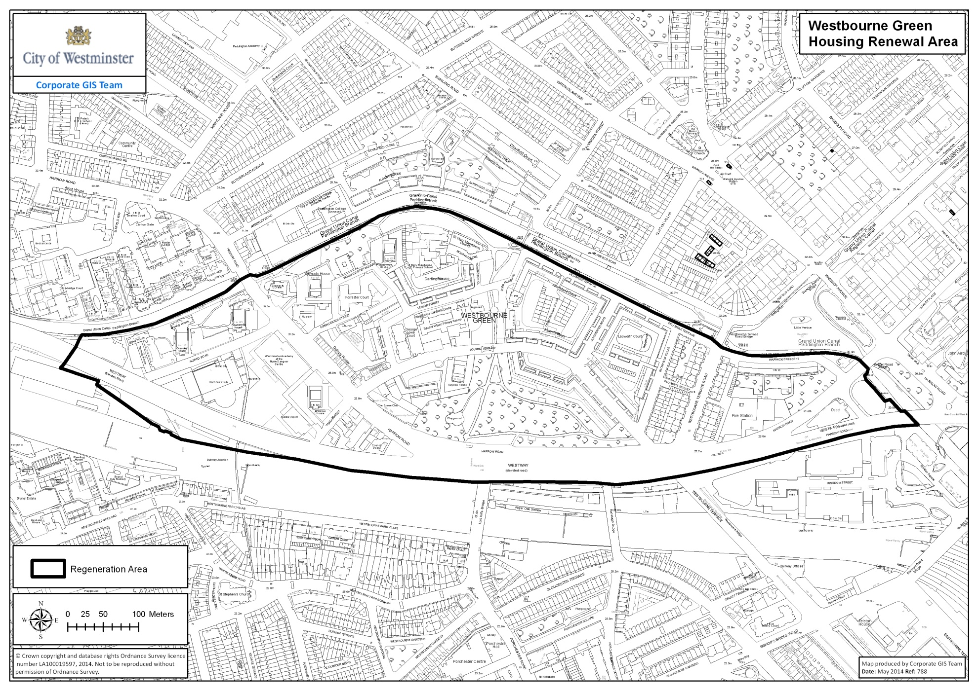

- Appendix B: Examples of equity loan arrangements

Example 1:
Where the leaseholder has a mortgage at their existing property

Value of the property being acquired £250,000

Leaseholder contribution:
Outstanding mortgage on the property being acquired* £100,000
Equity £150,000
Home loss payment (10% of the market value) £25,000
Total contribution £275,000

Value of new property £380,000
Leaseholder contribution £275,000
Difference £105,000

Leaseholder contribution 72%
City Councils contribution** 28%

*In this example a new mortgage of £100,000 will need to be raised before the sale of the new property can complete
**The City Council’s contribution is funded by a charge on the property in the form of an interest free loan on which there are no repayments. The leaseholder is the sole legal owner of the property.

Example 2: Where the leaseholder has no mortgage at their existing property

Value of the property being acquired £250,000

Leaseholder contribution:
Value of property being acquired £250,000
Home loss payment (10% of the market value) £25,000
Total contribution £275,000

Value of new property £380,000
Leaseholder contribution £275,000

Difference £105,000

Leaseholder contribution 72%
City Councils contribution* 28%
* The City Council’s contribution is funded by a charge on the property in the form of an interest free loan on which there are no repayments. The leaseholder is the sole legal owner of the property.

Example 3: Selling the property
When the property is sold the City Council and the leaseholder will receive any increase in value proportionate to their contribution. The following example assumes the property has gone up 2% from its original value of £380,000 to £387,600 (note property values can go down as well as up)

The leaseholder |  | The City Council
Contribution | 72% | Contribution | 28%
2% increase in property value | £5,472 | 2% increase in property value | £2,128
Amount received if the property was sold*  *Minus any outstanding mortgage | £275,000  + £5,472  £280,472 | Amount received if the property was sold | £105,000  + £2,128  £107,128

http://transact.westminster.gov.uk/docstores/publications_store/wcc_housing_renewal_report2010_lowres.pdf
Though readers should note that, if a compulsory purchase order is made and confirmed, the Council will be under statutory obligations in relation to the payment of compensation: see section 12 below for further information
The City Council is not bound by these rules
The maximum is subject to review by the Secretary of State
Again, the maximum is subject to review by the Secretary of State

