Instructions for statutory undertakers removing parking sensors
Should parking sensors need to be excavated during a statutory undertaking in the carriageway (e.g. Utilities works), the sensors will need to be carefully removed and returned to the City Council.
For a safe and damage free removal of a sensor, please carefully break out approx 100mm depth around the sensor and remove the sensor in one piece avoiding damage to the exterior.
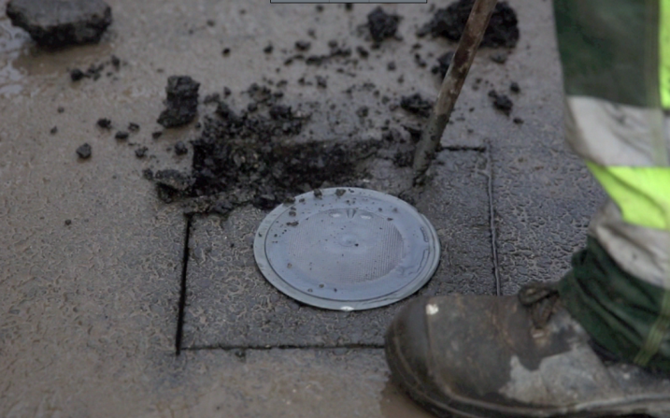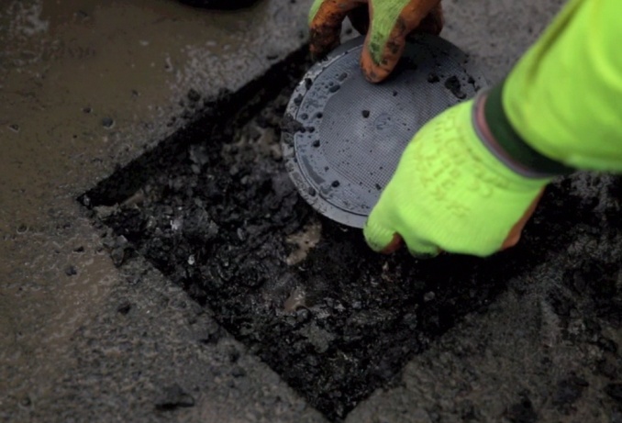
Sensors have a diameter of 142mm and height of 43mm, and are set within the wearing course of the carriageway at a depth of approximately 55mm. Each sensor is an independent unit, constructed of robust plastics and has no extruding wires or electrical connections. Excavation should not represent a safety risk to a site officer.
Once sensor(s) have been removed and works have been completed on site, do not attempt to re-install the sensors, but resurface the road to the City Council’s agreed standards and return the sensors to the site listed below. The person returning the sensors will need to complete a return form.
Drop-off Locations

Access Hours
Monday to Friday
7.30am to 2.30pm

Harrow Road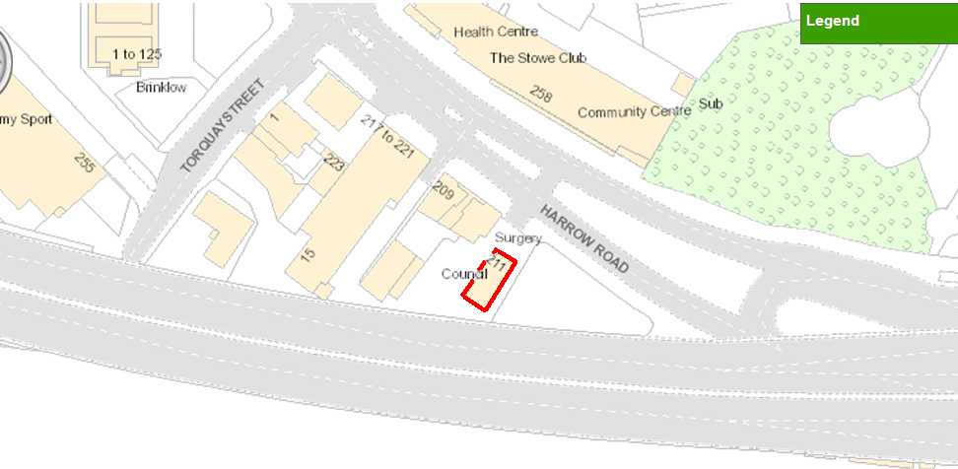

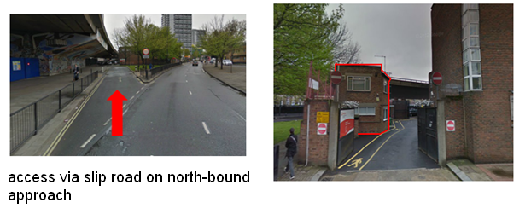

Westminster Cleansing Depot
211 Harrow Road
W2 5EH

Access Hours
Monday to Friday
7.30am to 1.30pm

There is potential for more drop-off sites to be made available in future; this instruction will be updated with additional sites should these become available.

The City Council expects all statutory undertakers to use due diligence when removing parking sensors so as to reduce any risk of damage to the City Council’s asset. It is also expected that the sensors are returned to the City Council at the statutory undertakers’ earliest opportunity

For any queries please contact Earl Fairclough 020 7641 7037 efairclough@westminster.gov.uk

