SECTION 77 OF THE TOWN AND COUNTRY PLANNING ACT
1990 (AS AMENDED)

CALL IN INQUIRY INTO THE PROPOSED DEVELOPMENT OF THE UNITED KINGDOM HOLOCAUST MEMORIAL AND LEARNING CENTRE LOCATED WITHIN VICTORIA TOWER GARDENS, MILLBANK, LONDON SW1P 3YB

PROOF OF EVIDENCE OF BRETT LITTLE, BA, MSc, CMILT
On behalf of
THE SECRETARY OF STATE FOR HOUSING COMMUNITIES AND LOCAL GOVERNMENT

TOWN AND COUNTRY PLANNING (INQUIRIES
PROCEDURE) (ENGLAND) RULES 2000
V5 07/09/20

CONTENTS

1.0 QUALIFICATIONS AND EXPERIENCE 3
2.0 INTRODUCTION AND SCOPE OF EVIDENCE 4
3.0 ENGAGEMENT TO DATE AND COMMON GROUND 5
4.0 DISPUTED MATTERS AND RESOLUTION 9
5.0 CONCLUSIONS 12

LIST OF APPENDICES

1.0 QUALIFICATIONS AND EXPERIENCE

Brett Little will say:-

  - I hold the degrees of Bachelor of Arts (with Honours) in Geography from the University of Salford and MSc in Transportation Planning & Engineering from the University of Southampton. I am a chartered member of the Institute of Logistics and Transport and a member of the Chartered Institution of Highways & Transportation.

  - I have 23 years’ experience in the field of transport planning. I am the Head of Pedestrian Modelling for WSP, a leading engineering consultancy. In a previous role before joining WSP in 2017, I was Pedestrian Modelling Manager at Transport for London, where I was involved in major projects throughout London.

  - Since joining WSP I have led the pedestrian modelling team in the UK, assessing pedestrian capacity and experience in a number of different environments from rail stations to urban areas such as Oxford Street.

  - I am familiar with the Application Site and the surrounding area having worked on this and a number of other projects in the locale.

  - I have read all the relevant background information and have been assisted by the same colleagues who worked on the Application and made such enquiries as I consider to be necessary to fulfil my duties as an expert witness.

  - I confirm that my evidence to this Inquiry has been prepared and is given in accordance with the guidance of my Professional Institutions and I confirm that the opinions expressed are my true and professional opinions.

- INTRODUCTION AND SCOPE OF EVIDENCE

  - I am instructed by the Secretary of State for Housing, Communities and Local Government (the "Applicant") in respect of proposals for the installation of the United Kingdom Holocaust Memorial and Learning Centre (the “UKHMLC”) within Victoria Tower Gardens, Millbank, London (the “Site”).
  - I will be providing evidence on matters pertaining to the pedestrian modelling of the persons expected to visit the UKHMLC. This is divided into two parts as follows:

- Part 1 sets out the work undertaken to date with regards to pedestrian modelling, including a summary of the documents submitted and all matters having been agreed with Westminster Council (WCC) during the application process;
- Part 2 responds to the issues raised by the Rule 6 Parties with reference to the technical evidence already prepared and submitted to WCC.

- ENGAGEMENT TO DATE AND COMMON GROUND

  - In this section I present a summary of the engagement undertaken to date with Westminster City Council, setting out the methodology and findings

Work to date

  - The pedestrian modelling assessment in support of the planning application consists of two elements.

  - Firstly, a projection has been made of the number of overall visitors to the memorial, including both those entering with tickets and those only viewing the memorial from the outside.

  - Secondly, the movement of these visitors has been modelled in several locations of interest, in order to demonstrate that there is adequate capacity along all walking routes to safely and efficiently accommodate pedestrians, and that within VTG there will continue to be ample space to accommodate visitors to the memorial as well as existing leisure users of the park.

Visitor numbers

  - The Operational Business Plan produced by Barker Langham for the applicant projects 930,000 annual visitors to the Memorial; for the purposes of the transport and pedestrian modelling assessment this has been rounded up to one million annual ticketed visitors for robustness.

  - The figure of one million refers to the annual number of visitors with tickets entering the UKHMLC, of which 100,000 will be school trips (TA paragraph 8.2.6), 60,000 will be special interest groups (TA paragraph 8.2.10), and the remaining 840,000 will be general admission visitors.

  - In addition, there will be visitors who will go to Victoria Tower Gardens to view the memorial from the exterior without a ticket and not enter the UKHMLC. Research into visitor numbers at comparable sites around the world has provided an estimate of up to 10,000 people entering Victoria Tower Gardens on a busy day, of which 3,300 will have tickets to enter UKHMLC and the remaining 6,700 will visit the park to view it from the exterior (TA paragraph 8.5.23). This figure represents the busiest day, as a worst case to test the capacity of the park, it does not represent an average day and cannot therefore be multiplied to reach an annual figure.

Pedestrian modelling at park entrances

  - In order to identify the locations where pedestrian activity will be busiest and therefore analysis was required, the daily visitor numbers were broken down further by time and direction.

  - An extremely robust approach was taken in profiling visitor numbers, including that 90% of all general admission and non-ticketed visitors will enter and exit via Gate 1 (the northernmost gate, shown in the figure below) insofar as it is the closest to Westminster Underground station and the Houses of Parliament; in practice, it is likely that a proportion may approach from the south which is home to a number of other attractions including the Tate.

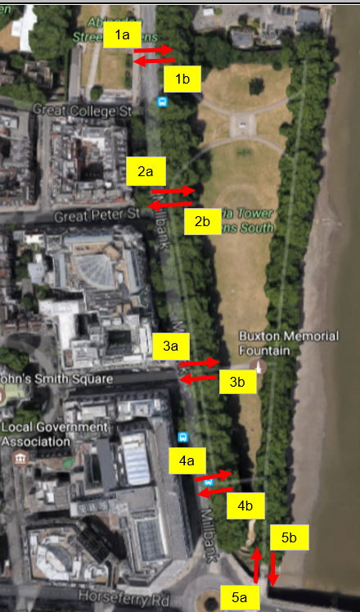

  - A robust approach has also been taken to the temporal profile of general admission visitors. This has been based on the surveys of the existing park users, who gravitate strongly towards the middle of the day. In practice, tourists wishing to visit multiple sites in a day may choose to come earlier or later.

  - Gate 1 was shown to be the most used entrance to Victoria Tower Gardens; entry and exit movements were analysed and modelled to ensure there was sufficient capacity available to accommodate all users.

  - Transport for London’s Pedestrian Comfort Level (PCL) assessment was applied to the eastern footway of Abingdon Street immediately north of Gate 1. The presence of the security booth and hostile mitigation area currently presents a pinch point at this location.

  - TfL’s Pedestrian Comfort Levels classify the level of comfort based on the level of crowding a pedestrian experiences on the street. Guidance is provided for different area types and times of day. Pedestrian crowding is measured in pedestrians per metre of clear footway width per minute. This is calculated from data on pedestrian activity and the street environment. The classification consists of levels A to E, with A being a pedestrian environment where movement is very comfortable, to E where movement is restricted and uncomfortable.

  - This section of footway at Gate 1 currently exhibits a PCL of C+, which means movement is somewhat restricted, this level is below TfL’s preferred benchmark, due to the presence of the aforementioned constraints. The future scenario would not lead to a worsening in the score.

  - However, a minor relocation of the hostile mitigation barrier further south (which would provide even greater protection, since park users would be segregated from the highway) would lead to a significant improvement even with the additional UKHMLC demand, with PCL increasing to A- which represents a comfortable environment and unrestricted pedestrian movement.

  - A dynamic pedestrian modelling exercise, has been undertaken for the busiest time periods using industry standard Legion pedestrian modelling software. A key output of the modelling are Pedestrian Levels of Service.

  - Fruin’s Levels of Service (John J Fruin; “Pedestrian Planning and Design”) refer to the level of comfort experienced by pedestrians within an area. The 6 band scale is used to assess comfort of different people densities from good through to unacceptable (A to F as shown below). Levels A to C are comfortable in terms of pedestrian movement, Level D introduces some small restrictions to movement but is still in the main a comfortable experience for most pedestrians. It is commonly used across the transport and planning industries, especially in high density areas by Network Rail and Transport for London.

Fruin Pedestrian Levels of Service

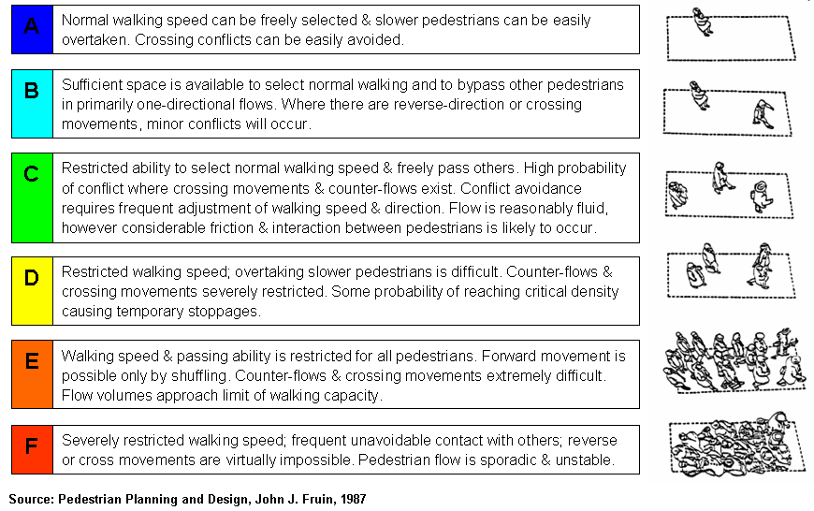

  - Figure 11 in the TA illustrates the Fruin Level of Service for the peak hour in terms of flows into the park which consist of forecast UKHMLC ticketed visitors, UKHMLC unticketed visitors added to the day-to-day users (as recorded by the surveys).

  - The gate was tested with the worst case flows of pedestrians, which would in reality only occur on the busiest few days of the year and for a limited period of time. The results show that the gate operates at Fruin LoS C with the memorial related flow added. which is an acceptable level of service. There are small occurrences of Level of Service D, where some restrictions to movement are felt, at the northern end of the gate for short periods. The analysis shows there is sufficient capacity to accommodate the modelled flows.

Pedestrian modelling within the park

  - Pedestrian surveys were carried out by Intelligent Data Collection Limited (commissioned by Atkins), on Saturday 27th May, Bank Holiday Monday 29th May, and Wednesday 13th September 2017 between the hours of 07:00 and 20:30. People were counted entering & exiting from each gate, with these counts then aggregated over 15-minute time periods.

  - The patterns of 15-minute entry and exit data indicates that Victoria Tower Gardens users were not staying for a long period of time. The data indicated that a large number of Victoria Tower Gardens users walk in and out within the same 15 minutes segments.

  - The survey showed that a maximum of 300 people currently enter Victoria Tower Gardens in a 15 minute period and leave Victoria Tower Gardens within 15 minutes. The busiest day was identified as Saturday 27th May 2017. Within the survey the hour with the highest occupancy of people in the Victoria Tower Gardens was shown to be 11:45 to 12:45.

  - The circulation of pedestrians within Victoria Tower Gardens once the Memorial is in place was dynamically modelled using industry standard Legion micro simulation software under a series of incrementally increased sensitivity test demand populations all of which were comfortably accommodated within the park.

Common Ground

  - The planning committee report issued by WCC summarises the approach taken with regard to modelling projected visitor numbers, as well as the baseline surveys undertaken within Victoria Tower Gardens. WCC have not questioned the methodologies or findings of either.

  - The planning committee report also notes that, while the presence of the UKHMLC will result in increased footfall along Abingdon Street, this does not constitute a road safety issue, and congestion at park entrances is not raised as a concern.

- DISPUTED MATTERS AND RESOLUTION
19

Disputed Matters

Matters Raised

  - In these circumstances, having regard to the matters set out in the Rule 6 statements, and as identified by the Inspector in his pre-Inquiry note, I consider the main issues in dispute are:-

- Annual visitor numbers (WCC planning committee report section 9.7 and The Thorney Island Society paragraph 9(4))

- Increased volume of pedestrians / visitors will add to existing overcrowding

- The Visitor Management Strategy measured the users of VTG in May and September. Royal Parks' figures suggest that in July and August there are nearly twice as many visitors. Therefore, the impact has been underestimated. (London Parks & Gardens Trust paragraph 13)

Response

  - Annual visitor numbers: WCC’s planning report (section 9.7) states that the UKHMLC is expected to attract approximately 3.65 million visitors per year.

  - The Transport Assessment (paragraph 8.2.5) states that a million visitors per year are expected; this rounds up the Operational Business Plan’s estimate of 930,000 for robustness. This figure reflects the projected annual demand for tickets based upon the size and catchment of the attraction.

  - Of these, a maximum of 3,300 tickets would be issued on any given day. This is based upon the capacity of the attraction to accommodate visitors. The transport assessment considers the worst case scenario where the number of visitors in a day equals 3,300, which is the maximum number of tickets possible for a single day. This is a robust assessment given that in practice some ticket holders may be no-shows.

  - On some days demand for tickets will be lower than the maximum number available, and over the course of the year the total number of ticketed visitors is anticipated to be 930,000 (rounded up to one million). This is due to seasonality, school holidays, weather and other factors which will reduce demand during some parts of the year.

  - In addition, the transport assessment acknowledges that others will also wish to view the memorial from the park without obtaining tickets or entering. Therefore, a busy day has been forecast as a total of 10,000 total visitors per day comprising of 3,300 ticketed visitors and 6,700 who will view the memorial from the park and not enter. The figure of 10,000 represents a busy day, with all tickets sold and a high number of non-ticketed visitors, it is not representative of an average day and cannot therefore be multiplied to an annual visitor number as visitor levels will be lower outside of the peak season. Therefore, there is no discrepancy in the figures put forward in the transport assessment.

  - While the number of tickets issued will remain the same every day, and it is assumed for robustness that all tickets will be reserved, it is likely that there will be much more fluctuation in the number of visitors viewing the memorial from the exterior. The figure of 6,700 people per day is very much a robust estimate of a busy day, more likely to occur during school holidays and in good weather, while at other times fewer people may choose to visit the park if they do not have a ticket to also enter the UKHMLC.

  - In summary, the transport impacts of the proposed scheme have been assessed on the basis of a busy day with 10,000 total visitors; however, on many days there may be far fewer than 6,700 visitors viewing the memorial from the outside. The TA does not extrapolate the maximum 10,000 daily figure to an annual total.

  - Increased volumes: the peak surveyed park population was added to the forecast visitor numbers to assess the park capacity using pedestrian modelling software. In addition, higher numbers than forecast were also tested in order to assess the resilience of the park to additional visitors. Whilst this showed higher densities within the park it did not result in overcrowding or unacceptable levels of pedestrian density.

  - Survey period: whilst the survey periods chosen by Atkins may not be during the Summer they do cover a Bank Holiday, characterized by sunshine and with temperatures exceeding 20ºC, with higher than average use of the park, and can therefore be considered a reasonable baseline.

  - In addition, sensitivity tests were formulated to assess the park under higher volumes than those predicted which included both people within the park and people entering and exiting during the assessment period. 1,000 people were placed in the park (not entering the UKHMLC). This was in an increase from the peak surveyed population of 319, therefore in excess of three times the surveyed number of people in order to test the capacity of the park itself to accommodate an increase in both stationary and circulating pedestrians. The analysis found no undue crowding or uncomfortable pedestrian densities under the scenarios tested.

Summary

  - The UKHMLC will add visitors to the park both those wishing to enter the facility but also potentially additional visitors wishing to view the Memorial from the exterior. However, the analysis showed that the park can accommodate these additional visitors without reaching unacceptable levels of crowding and it will therefore continue to be available to its current users as a place to walk and spend time.

  - The park was dynamically modelled using industry standard software, under a series of incrementally increased sensitivity test demand populations all of which were comfortably accommodated within the park.

  - The busiest entry point to the park was also tested dynamically to ensure that it had enough capacity to accommodate all flows. The gate and footway were tested with normal use, plus UKHMLC ticket holders and non- ticket holders and found to be adequate in terms of capacity.

- CONCLUSIONS

  - The evidence set out above, and presented in the Transport Assessment and TA Addendum, demonstrates that all matters pertaining to trip generation and pedestrian modelling have been dealt with to the satisfaction of WCC. All objections raised by Rule 6 parties have been addressed, and in my opinion there are no reasons outstanding to deny planning permission for the proposed UKHMLC on these grounds.

