United Kingdom Holocaust Memorial
  - Archaeological Mitigation Strategy
Ministry of Housing, Communities and Local Government
April 2020

Notice
This document and its contents have been prepared and are intended solely as information for the Ministry of Housing, Communities and Local Government and use in relation to the United Kingdom Holocaust Memorial (UKHM)
Atkins Limited assumes no responsibility to any other party in respect of or arising out of or in connection with this document and/or its contents.
This document has 88 pages including the covers.

Document history
Revision | Purpose description | Origin-ated | Checked | Reviewed | Author-ised | Date
Rev 1.0 | Client Draft | AF | TH | KS | KS | <date>

Client signoff
Client | Ministry of Housing, Communities and Local Government
Project | United Kingdom Holocaust Memorial
Job number | 5152854.121
Client signature / date

Contents

Chapter Page
1. Introduction 6
1.1. Project Background 6
1.2. Scheme Overview 6
1.3. Roles and Responsibilities 7
1.4. Archaeological Summary 7
2. Purpose and Scope 9
2.1. Purpose 9
2.2. Scoping and Consultation and Draft Archaeological Condition 10
2.3. Compliance with Legislation and Policy 10
2.4. Guidance 11
3. Previous Archaeological Work for Scheme 12
3.1. Environmental Statement 12
4. Archaeological Baseline 13
4.1. Geology and Topography 13
4.2. Results of the geoarchaeological evaluations 14
4.3. Palaeolithic Period (c. 800,000 BP – c. 10,000 BP) 18
4.4. Mesolithic Period (c. 10,000 BC – c. 4,000 BC) 19
4.5. Neolithic Period (c. 4,000 BC – c. 2,000 BC) 19
4.6. Bronze and Iron Ages (c. 2,000 BC – AD 43) 21
4.7. Romano-British Period (AD 43 – AD 410) 23
4.8. Anglo-Saxon Period (AD 410 – 1066) 23
4.9. Later medieval Period (1066 – 1520) 24
4.10. Post Medieval and Modern (AD 1540 – Present) 26
4.1. Results of the Geophysical Investigation 42
7. Objectives and research themes 48
7.1. Introduction 48
7.2. Regional Archaeological Research Frameworks 48
7.3. Geographical Context 49
7.4. Research Themes 50
7.5. Specific Research Objectives (SROs) 52
8. Standards and responsibilities 53
8.1. Responsibilities of the Principal Contractor 53
8.2. Responsibilities of Archaeological Contractor 53
8.3. Compliance with Heritage Specific technical standards 54
8.4. Health and Safety Considerations and Protocols 55
8.5. Communication and engagement 55
8.6. Monitoring of progress 55
8.7. GIS/BIM outputs 56
9. Sequence of Mitigation 56
10. Engineering Solutions 56
10.1. Overview 56
11. General Methodology 57
11.1. Health and Safety 57
11.2. Fieldwork 57
11.3. On Site Artefact and Palaeoenvironmental Processing 57
11.4. Monitoring and Stakeholder Liaison 58
12. Public Engagement and Outreach 58
12.1. Overview 58
13. Geoarchaeological Investigations and Deposit Modelling 58
13.1. Overview 58
13.2. Aims and Objectives 59
13.3. Methodology 59
13.4. Recording 59
13.5. Deposit Modelling 59
13.6. Reporting 60
14. Archaeological Excavation 61
14.1. Overview 61
14.2. Aims and Objectives 61
14.3. Methodology 63
14.4. Fieldwork 63
14.5. Finds 64
14.6. Human Remains 64
14.7. Environmental Sampling 64
14.8. Recording 64
14.9. Health and Safety 65
14.10. Reporting 65
14.11. Archiving 65
15. Construction Integrated Recording (CIR) 66
15.1. Overview 66
15.2. Aims and objectives 66
15.3. Methodology 68
15.4. Fieldwork 68
15.5. Environmental sampling 70
15.6. Human remains 70
15.7. Recording 70
15.8. Reporting 70
15.9. Archiving 70
16. Unexpectedly Significant Findings Procedure 70
17. Finds 71
17.1. Overview 71
17.2. Methodology 71
17.3. Post-excavation 72
18. Human Remains 72
18.1. Overview 72
18.2. Methodology 73
18.3. Recording 74
18.4. Reporting 74
18.5. Archiving 74
19. Environmental Sampling 74
19.1. Overview 74
19.2. Methodology 75
19.3. Post-excavation 76
20. Recording and Reporting 77
20.1. Recording 77
20.2. Human remains 78
20.3. Finds 78
20.4. Report preparation 79
20.5. Post Investigation Assessment and Updated Project Design 80
21. Archive Preparation and Deposition 81
21.1. Overview 81
21.2. Methodology 81
21.3. Physical archive 82
21.4. Human remains 83
21.5. Digital archive 83
22. References 84

Introduction

Project Background

This Archaeological Mitigation Strategy (AMS) has been produced for the Ministry of Housing, Communities and Local Government (MHCLG) in relation to the archaeological programme in support of the construction of the United Kingdom Holocaust Memorial (UKHM) (henceforth referred to as “the Scheme”). The scheme requires a programme of archaeological management, investigation and recording to be undertaken during the enabling works and subsequent construction of the scheme.

The AMS is a high-level document outlining the broad approaches to mitigation by record of the archaeological remains that would otherwise be removed during construction.

The AMS details the measures that will be undertaken to appropriately record archaeology within the footprint of the Scheme. This AMS has been designed in consultation with Greater London Archaeological Advisory Service (GLAAS), the archaeological advisor to Westminster City Council (WCC). The AMS also follows the GLAAS guidelines for delivering archaeological projects within Greater London and within archaeological priority areas in Greater London.

Scheme Overview

The proposed development comprises the construction of a new ground level memorial, with associated double basement level, covering approximately 0.4ha (16% of the total Site’s footprint, See Figure 1-1, below). The insertion of new services, and landscaping activities are expected.

The proposed construction activities would entail:
- Creation of a piling mat to 1m depth of topsoil/subsoil removal;
- Insertion of a piled wall to encompass the site to a depth of c. 10m below ground level, but with piles likely extending to c. 15m below ground level;
- Bulk excavation to formation depth with total removal of all deposits within the footprint of the basement (8-10m below ground level); and
- Concrete floor poured at formation depth and works continuing from there.

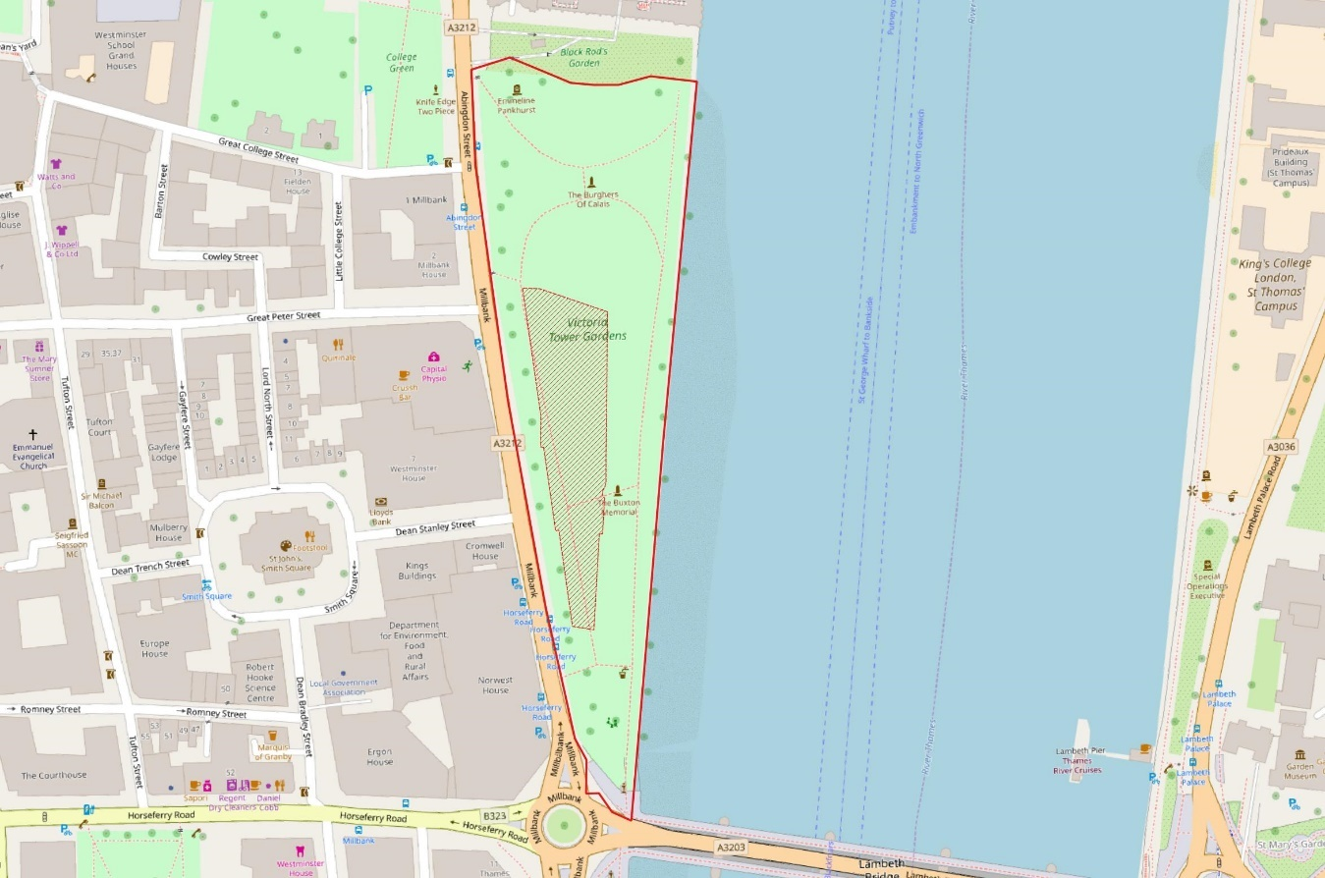
Figure 1-1 - Proposed scheme footprint

Roles and Responsibilities

The Ministry of Housing, Communities and Local Government has appointed Atkins to provide specialist design and environmental consultancy expertise to assist with delivery of the scheme. The following roles and responsibilities have been identified:
- Ministry of Housing, Communities and Local Government (the Client) – commissioning body for the Scheme.
- Principal Contractor – the nominated contractor employed by the Client to deliver construction of the scheme.
- Scheme Archaeologist – Atkins, archaeological consultant for the Scheme.
- Archaeological Contractor(s) – the nominated archaeological company employed by the Client to carry out archaeological investigations on the Scheme.
- Statutory Consultees – Greater London Archaeological Advisory Service (GLAAS) and Historic England

Archaeological Summary

The Site lies within a Grade II Registered Park which contains four further listed structures: The Grade I Listed statue of the Burghers of Calais, the Grade II* Listed Buxton Memorial, the Grade II Listed statue of Emmeline Pankhurst, and the Grade II Listed river embankment wall.

The World Heritage Site covering Westminster Abbey and the Houses of Parliament is immediately to the north of the Site. The Scheduled Monument of the Jewel Tower is 45m north-west of the Site.

The Site also lies within the Westminster Abbey and Parliament Square Conservation Area, and the Westminster and Thorney Island Archaeological Priority Area.

Archaeological survival is expected to be high, as the site has remained open public space since the early 20th century. Archaeological features that may be affected by the Scheme comprise:
- Palaeoenvironmental remains within alluvial deposits associated with the Rivers Thames and Tyburn of Low or Medium significance;
- Evidence of early exploitation of the River Thames and River Tyburn, including jetties, boats etc. of most likely Low to Medium significance, but potentially up to High significance;
- Evidence of land reclamation from the 16th century onwards, including revetments, river-walls etc, of Low to Medium significance;
- Evidence of riverine industrial activity from the 16th century onwards, including wharves, docks etc, of Low to Medium significance;
- Garden features associated with the former layout of Grade II Registered Park, of Low significance.

A geophysical ground penetrating radar survey of the site was undertaken in 2017 and has informed all subsequent archaeological reporting and fieldwork design.

This was followed by an initial phase of monitoring geotechnical test pits and assessing the logs from geoarchaeological boreholes carried out in April and June 2019. The results of this informed a subsequent programme of purposive geoarchaeological sampling to date the alluvial sequence and create a sub-surface deposit model.

The results of the surveys and archaeological investigations to date indicate that the balance of probability is that there are no archaeological remains of such significance to be a constraint on construction of the UKHM. It has been established that:
- the remains of features associated with both the former medieval Abbots Mill and medieval to early post medieval Queens Slaughterhouse (and any other remains directly associated with the medieval Palace and Abbey at Westminster) lie outside of and to the north-west of the scheme footprint;
- no evidence for anything other than post medieval land reclamation and subsequent development and re-development of riverside wharfs and associate features has been identified overlying the alluvium within the scheme footprint. The buried remains of this form of development are not unique in London, but are nevertheless, given their probable association with the development of the suburbs around Westminster from the 17th century onwards, of medium significance and require detailed archaeological investigation before their removal;
- the evidence for post medieval reclamation and development of the area within Victoria Tower Gardens is uniformly sealed by c. 1.2m of homogeneous topsoil, imported onto the site during creation of the current park in the late 19th to early 20th centuries. No buried features atypical of the creation of a late 19th to early 20th century municipal park or features established by any notable park designers/architects have been identified within the park from historic mapping, documentary sources or historic photographs. The park archaeology within the scheme footprint is therefore considered to be of low significance and can largely be re-created from the documentary record alone;
- no anthropogenic influence was noted within the alluvium underlying the post medieval reclamation on the site in the geotechnical boreholes and no significant peat deposition identified;

.

Purpose and Scope

Purpose

The purpose of this document is to set out the strategy for the planning and delivery of a programme of archaeological mitigation within the Scheme footprint required for the delivery of construction of the Scheme. The archaeological mitigation will comprise a programme of investigative archaeological fieldwork with associated post excavation assessment, analysis, updated project design and final reporting and publication. It is also envisaged that there will be delivery of an associated public outreach programme during the archaeological fieldwork and reporting phases.

This AMS is an iterative document that will inform and be informed by detailed design of the Scheme. The AMS will also be regularly updated as new archaeological data becomes available as a result of archaeological works undertaken in support of delivery of the Scheme.

This AMS is a high-level framework document to provide an archaeological strategy for how the archaeology within the footprint of the Scheme will be approached. Detailed methodologies for individual investigations delivered under the umbrella of the AMS will be delivered as Written Schemes of Investigation (WSI) produced by the contracting archaeological unit(s) appointed to the works by the Client and agreed with the statutory consultees.

The AMS will:
- describe the archaeological background within which the Scheme is being developed; this will include reference to any relevant and appropriate archaeological research frameworks;
- establish the roles, responsibilities and consultative procedures required to successfully deliver the protocols established by the AMS;
- describe the engineering processes which the archaeological programme for the Scheme will be delivered alongside;
- establish the archaeological toolkit of methodologies that will be applied to achieve the objectives of the archaeological programme for the Scheme;
- establish the post excavation, archival, reporting, publication and outreach processes that will be followed in delivering the archaeological programme for the Scheme.

This document does not represent a Written Scheme of Investigation (WSI); this will be produced for the archaeological works by the appointed Archaeological Contractor(s). The WSI will be forwarded to the Statutory Consultees for their comment and approval.

Scoping and Consultation and Draft Archaeological Condition

Consultation has been made with the Greater London Archaeological Advisory Service (GLAAS) throughout implementation of the archaeological programme to support the Scheme to date and during the design of this Archaeological Management Strategy.

No development shall take place until a written scheme of investigation (WSI) has been submitted to and approved by the local planning authority in writing. No groundworks shall take place other than in accordance with the agreed WSI, which shall include the statement of significance and research objectives, and

A. The programme and methodology of site investigation and recording and the nomination of a competent person(s) or organisation to undertake the agreed works

B. Details of a programme for delivering related positive public benefits

C. A method statement for protecting buried remains outside the basement footprint during the construction period

D. The programme for post-investigation assessment and subsequent analysis, publication & dissemination and deposition of resulting material. This part of the condition shall not be discharged until these elements have been fulfilled in accordance with the programme set out in the WSI

Informative

The written scheme of investigation will need to be prepared and implemented by a suitably professionally accredited archaeological practice in accordance with Historic England’s Guidelines for Archaeological Projects in Greater London. It should include a contingency arrangement in case of the unexpected discovery of archaeological remains of national significance. This condition is exempt from deemed discharge under schedule 6 of The Town and Country Planning (Development Management Procedure) (England) Order 2015.

Compliance with Legislation and Policy

All archaeological works will be planned, managed and undertaken based within the legislative and policy framework provided by, but not limited to the following documents.
- Ancient Monuments and Archaeological Areas Act (1979);
- Planning (Listed Buildings and Conservation Areas) Act (1990);
- National Heritage Act 1983 (amended 2002);
- Burial Act (1857) and amendments;
- Treasure Act (1996);
- National Planning Policy Framework (NPPF; 2019);
- The London Plan (2016); and
- The Westminster City Plan (2016).

Guidance

The following general guidance and standard documents will guide all work undertaken. Where relevant others, are referred to directly in the appropriate Specific Methodologies as set out in Sections 9 to 21 of this Strategy.
- Chartered Institute for Institute for Archaeologists (CIfA), 2014a. Code of Conduct.
- Chartered Institute for Archaeologists, 2014d, Standards and Guidance for Archaeological Excavation
- Chartered Institute for Archaeologists, 2014e, Standards and Guidance for Archaeological Watching Brief
- Chartered Institute for Archaeologists, 2014f, Standards and Guidance for the Archaeological Investigation and Recording of Standing Buildings or Structures
- Chartered Institute for Archaeologists, 2014g, Standards and Guidance for the Creation, Compilation, Transfer and Deposition of Archaeological Archives
- Chartered Institute for Archaeologists, 2014h, Standard and Guidance for the collection, documentation, conservation and research of archaeological materials
- DCLG, 2018. National Planning Policy Guidance.
- Campbell, G, Moffett, L and Straker, V 2011 'Environmental Archaeology. A Guide to the Theory and Practice of Methods, from Sampling and Recovery to Post-excavation (second edition)'. Portsmouth: English Heritage
- GLAAS (Greater London Archaeological Advisory Service), 2015, Greater London Archaeological Advisory Service Guidelines for Archaeological Projects in Greater London. London, Historic England
- GLAAS 2016: Greater London Archaeological Priority Area Guidelines
- Historic England, 2008, MoRPHE Project Planning Note 3: ‘Archaeological Excavation’
- Historic England, 2011, Environmental Archaeology: A guide to the theory and practice of methods, from sampling and recovery to post-excavation
- Historic England, 2015a. Management of Research Projects in the Historic Environment: The MoRPHE Project Managers’ Guide.
- Historic England, 2015b. Conservation Principles, Policies and Guidance: For the sustainable management of the historic environment.
- Historic England, 2016. Preserving Archaeological Remains: Decisions-taking for Sites under Development.
- Historic England, 2020. Deposit Modelling and Archaeology: Guidance for Mapping Buried Deposits.
- Watkinson, D and Neal, V., 2001. First Aid for Finds.

Previous Archaeological Work for Scheme

Environmental Statement

The Environmental Statement (ES) for the Scheme was published in November 2019 and included an archaeology chapter (Chapter 9).

ES Chapter 9 was informed by assessment and survey work carried out between 2017 and 2019 and includes the following Appendices to this AMS:
- Appendix. A: Archaeological Detailed Desk-Based Assessment (DDBA)
- Appendix. B: Geophysical Magnetometer and Ground Penetrating Radar Survey
- Appendix C: Geoarchaeological watching brief on geotechnical works
- Appendix D: Geoarchaeological evaluation and deposit modelling

ES Chapter 9 was informed by all of these surveys and includes a summary of their results. The appendices to this AMS should be consulted for detailed presentation of the surveys’ full results.

The scope of the assessment and survey work informing Chapter 9 of the ES was prepared to fulfil the requirement set out in paragraph 189 of the National Planning Policy Framework (NPPF 2019), which states that ‘In determining applications, local planning authorities should require an applicant to describe the significance of any heritage assets affected, including any contribution made by their setting. The level of detail should be proportionate to the assets’ importance and no more than is sufficient to understand the potential impact of the proposal on their significance.’

The level of information prepared, comprising detailed desk-based assessment, geophysical survey, geoarchaeological monitoring of geotechnical works, geoarchaeological evaluation and deposit modelling was determined in consultation with GLAAS.

Archaeological Baseline

Geology and Topography

The British Geological Survey (BGS) digital data indicates that sub surface geology of the Site comprises alluvium. There are a number of useful historic BGS boreholes within 50m of the boundary of Victoria Tower Gardens. One borehole (BGS ref: TQ37NW53) was drilled in 1906, at the London Hydraulic Power Station (now 2 Millbank) from a height of 14 ft above Ordnance Datum (4.3m OD). The borehole recorded 16 ft (3.8m) of made ground, directly overlying a 5 ft (1.5m) thick peat deposit. This lay on top of 1ft 6 inch (0.5m) thick deposit of sand, and 9ft 6inches (2.9m) of ‘ballast’.

Three further boreholes are noted to the east of Victoria Tower Gardens, drilled in 1910, likely ahead of the development of the park (BGS ref: TQ37NW36-38). These were drilled at 1ft 9 inches (c 0.57m OD). The locations of the boreholes are noted on Figure 4-1, below.

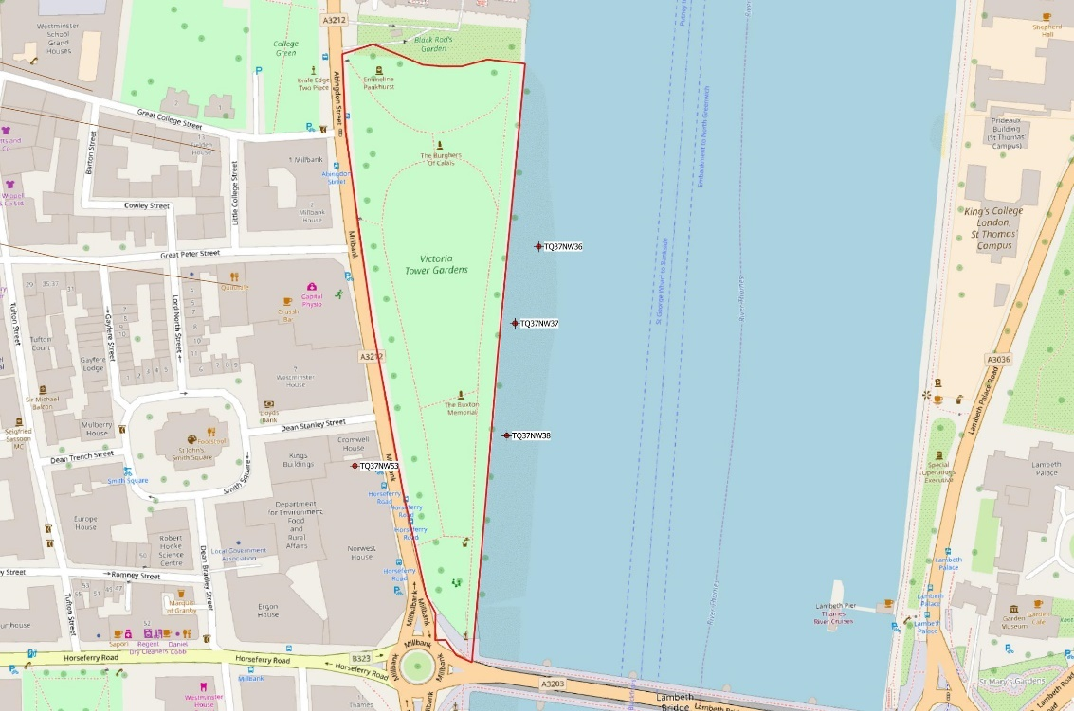
Figure 4-1 - Location of historic BGS boreholes

Borehole TQ37NW36 is located towards the northern extent of Victoria Tower Gardens. The upper 7 inches of the borehole (0.17m) was labelled as ‘mud’. This overlay 4 feet (1.2m) of ‘hardcore and mud’, which in turn overlay 2ft (0.6m) of muddy clay. Underneath these mud deposits lay 4 feet (1.2m) of ‘fine sand and little clay’, which in turn overlay ‘Thames ballast gravel’.

Borehole TQ37NW37 is adjacent to the centre of Victoria Tower Gardens. The upper foot (0.3m) of the borehole is recorded as ‘mud’. This overlay 6 feet 10inches (2m) of ‘hardcore and mud’, which in turn overlay 2 feet 5 inches (0.7m) of ‘sand with shells’. Beneath this sandy deposit a 9 inch (0.2m) thick deposit of clay was noted, overlying another deposit of sand with shells measuring 4 feet (1.2m) thick. This overlay 6ft (1.8m) of ‘fine sand with pebbles’, which in turn overlay ‘Thames ballast gravel’.

Borehole TQ37NW38 is located towards the southern extent of Victoria Tower Gardens. The upper 4 inches (0.1m) of the borehole is recorded as ‘mud’. This overlay 7 feet 6 inches (2.2m) of ‘hardcore and mud’, overlying 1 foot (0.3m) of sandy clay, which in turn overlay peaty clay deposit, 3 feet (0.9m) thick. This in turn directly overlay Thames ballast gravel.

Natural Thames gravels, labelled as “Thames ballast gravel” is recorded at 6.4m-6.7m below the top of the borehole (10.4m-10.7m below present ground level), in the north-most borehole, it is recorded at 5.1m below the top of the borehole (9.1m below present ground level), likely reflecting scouring of the Thames gravels.

The upper mud deposit recorded in the boreholes is likely indicative of modern (at the time) activity of the River Thames. The thick deposit labelled as ‘hardcore and mud’ identified in the three boreholes is more ambiguous, but likely reflects reclamation deposits. Earlier riverine deposits (sandy clay, or fine sand) are recorded at a depth of approximately 2.3m from the top of the borehole (6.3m below present ground level).

The alluvial deposits are likely heavily waterlogged, providing anaerobic conditions, suitable for the preservation of organic material such as wood. In two of the boreholes (TQ37NW37, 38) a layer of peat was recorded at 3.3m below the top of the boreholes (8.3m below present ground level), indicating a period of drying out in the floodplain. Palaeoenvironmental remains, including micro and macro fossilised plant remains, may survive in these deposits.

Results of the geoarchaeological evaluations

A programme of archaeological monitoring (watching brief) of geotechnical test pits was undertaken in April 2019 alongside an assessment of the geotechnical borehole logs. The assessment of the borehole logs from the geotechnical survey were used to inform the design of a purposive geoarchaeological borehole assessment programme aimed at refining the deposit model within the footprint of the scheme as well as to date the alluvial deposit sequences. The fieldwork for this was undertaken in July 2019 and the results reported on by October 2019 at the latest.

The results of the assessment of geotechnical borehole logs, carried out in April 2019, were supplemented with further geoarchaeological information maintained by MOLA (site code: VTG13) and BGS historic boreholes to produce a north – south transect of the sub-surface geology of the Site (Figure 4-18).
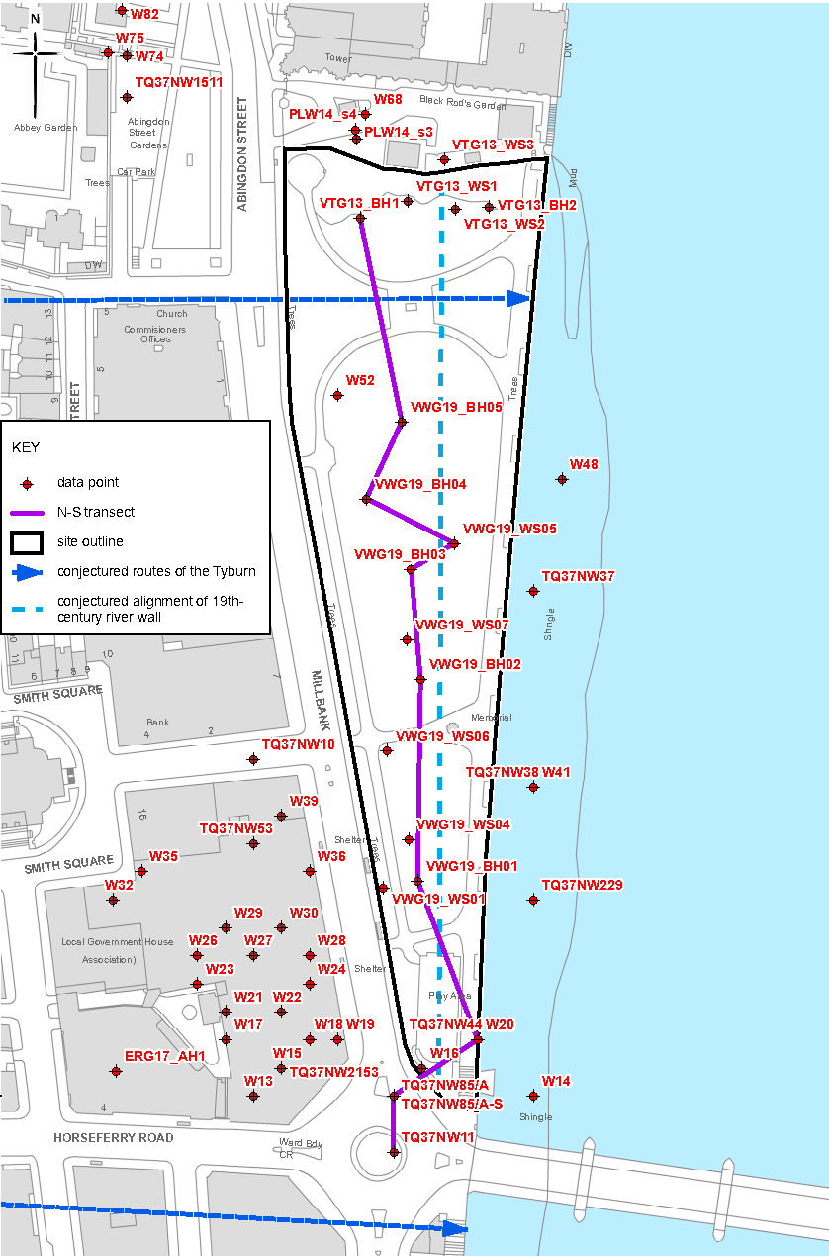
Figure 4-1 - Borehole and window sample locations used to produce the transect, after MOLA 2019, Fig 2

Pleistocene terrace gravels were identified at a depth of c. -2.0m OD (c. 6.5m below ground level) dropping off gradually to the south to c. -4.0m OD (8.5m below ground level), and sharply to the north to c. -3.0m OD (7.5m below ground level). The sub surface topography here seems to indicate a palaeochannel running through the southern extent of the Site, with higher terrace gravels to the north and south of it (Figure 5-19).

No evidence of early human activity was recovered from the highest levels of early Holocene sands directly on top of the Pleistocene gravels (c. -1.6m OD; 6.1m below ground level). These gravels were overlain with alluvial deposits measuring on average 2m – 3m in thickness, although in the area of the suspected palaeochannel, deposits were approximately 5m thick. No significant peat horizons were identified in the alluvial deposits.

These alluvial deposits were overlain in turn with up to 4.5m of made ground deposits, including c. 1.2m of topsoils imported in during the construction and extension of Victoria Tower Gardens. It is possible that elements of the made ground have truncated the top of the earlier alluvial deposits.
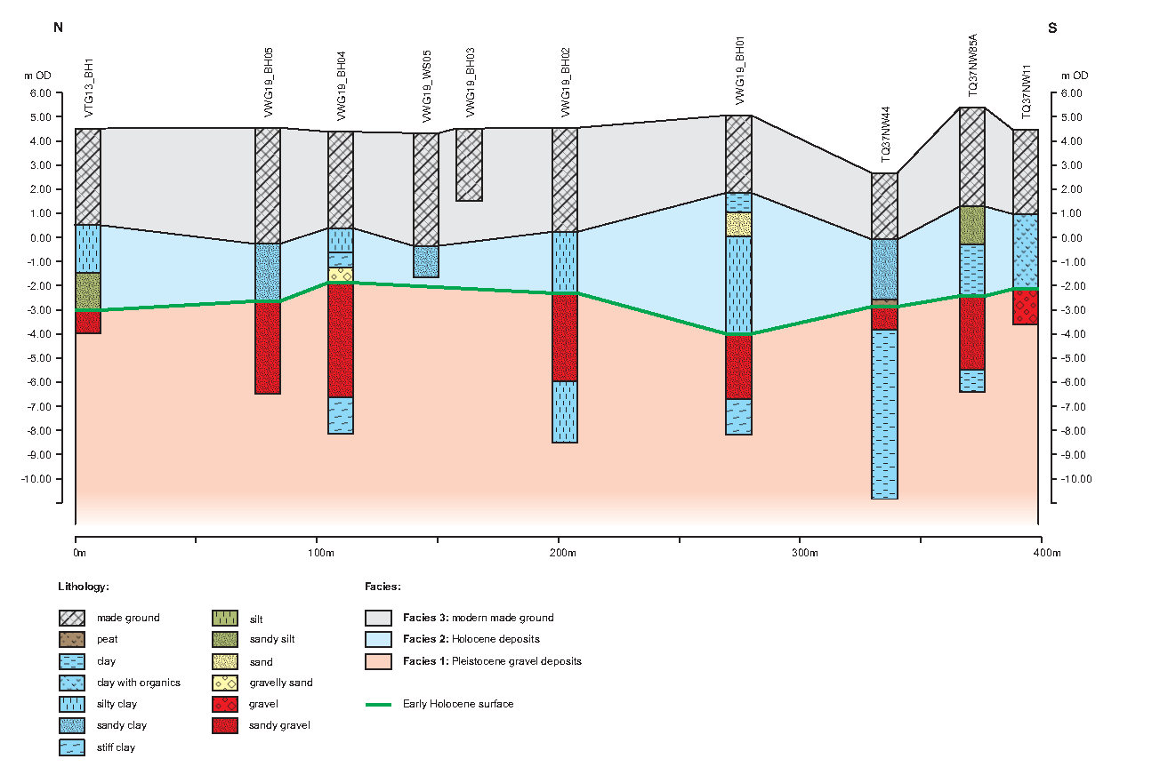
Figure 4-2 - Deposit model from the north-south transect showing levels and thickness of deposits. After MOLA 2019, Fig 3

The results of the investigation indicated a generally low potential for evidence of Mesolithic to Neolithic activity. The overlying alluvial deposits, however, were considered to have a high potential for indirect anthropogenic evidence, and palaeoenvironmental evidence for the reconstruction of Mesolithic to post-medieval environments.

The archaeological monitoring of the geotechnical test pits undertaken in April 2019 showed there to be a homogeneous importation of top-soil into Victoria Tower Gardens burying the footings of the demolished river-side structures of post medieval date shown on historic mapping. This topsoil was almost certainly imported during the creation of the current park in the late 19th to early 20th centuries.

The monitoring exercise also confirmed that brick and stone foundations were sealed by this imported topsoil c. 1.2m below current ground level. This evidence confirmed the results of the GPR survey undertaken in 2017 and included identification of the post-medieval river wall that will lie against the eastern edge of the proposed basement area as well as identifying foundations of former wharf side structures recorded by the historic mapping.

There was also no indication within the assessed borehole logs to suggest that the made ground sandwiched between an imported topsoil and top of the underlying alluvium were anything other than post-medieval in date and represent the land reclamation and development of the riverside wharfs and associated structures illustrated by 17th to 19th century mapping and artworks depicting the Site.

The results of the purposive geoarchaeological works reported on in November 2019 largely confirm this analysis with radiocarbon dates being obtained from two samples of material within the alluvial deposits from boreholes drilled for geoarchaeological purposes (See Appendix I). The lower sample, taken at -2.65m OD recorded a date of c.3956 – 3796 BC (early Neolithic); and the upper sample, taken at -2.25m OD returned a date of c. AD765 – 940 (mid Saxon).

Interestingly, the early Neolithic date came from near the top of a peat horizon at depth in the southern part of the Site, under which the peat and alluvial clays and silts extended down to the surface of the underlying gravels, suggesting that the lowest part of these deposits could date to the interface between the Late Upper Palaeolithic and Mesolithic period, rare for this part of London. The palaeoenvironmental data from this deposit sequence suggested showed a relatively cold environment and the nature of the deposits was considered to represent part of the channel edge of the proto-Tyburn.

The early Neolithic sequence at the top of this alluvial build up showed the progression from colder conditions to the establishment of alder car in a relatively wetland environment. The highly organic deposition then came to an end with successions of silts, sands and gravels oscillating from freshwater to brackish environments. These suggested a succession of channel migrations on the part of the Tyburn with hydraulic erosion and re-working of material.

A succession of relatively re-worked deposits seems to have occurred across the site during the prehistoric period from the early Neolithic all the way through into the Romano-British period, when more organic rich silt, clay and sand once more became established. These more organic deposits themselves appear to have been truncated during the mid-Saxon period with post medieval reclamation deposits lying directly over these facies. How this truncation occurred is presently unknown, but could have been due to hydraulic erosion and/or truncation of a foreshore ahead of reclamation at the beginning of the post medieval period.

Palaeolithic Period (c. 800,000 BP – c. 10,000 BP)

The Palaeolithic period (800,000 – 10,000 BC) coincides with the end of the Pleistocene period. It is marked by the first instances of flaked flint tool cultures and spans the biological evolutionary period from early hominid species to anatomically and behaviourally modern humans, by the Upper Palaeolithic (40,000 – 10,000 BC). During this time the climate warmed, after the end of the last glaciation, and the environment became increasingly wooded, with birch and pine forests. The land was inhabited by a variety of animal species including, but not limited to mammoths, hippopotami, bears, hyena, red deer and aurochs, the remains of which have been identified in the 19th century on the south-west side of Trafalgar Square, 1.2km north-west of the site in the Ipswichian gravel terrace. During this period the Site would have been within the River Thames. The chance find of a Middle Palaeolithic axe, and Lower Palaeolithic flake was made 130m south of the site on Millbank (MLO10662). The results of the MOLA geoarchaeological borehole assessment (see Section 5.4) identified that early Holocene gravels would have been submerged during this period and that there is little if any potential of archaeology of this period being present within the Site.

Subsequent to this the purposive geoarchaeological evaluation of the Site identified the possibility that late Upper Palaeolithic to early Mesolithic (c. 12,000 – c. 9,000 BP) organic alluvial deposits within a former channel of the Tyburn could be present resting immediately above the Pleistocene gravels. These deposits were from palaeoenvironmental evidence laid down in relatively cold conditions on the edge of the proto-Tyburn and represent a well preserved and rare example of remains of this date from Central London.

Mesolithic Period (c. 10,000 BC – c. 4,000 BC)

The Mesolithic period (10,000 – 4,000 BC) is typically characterised by increasingly complex flint tools, including the use of microlith technologies, and is typically identified through finds assemblages rather than structural remains. Activity would have likely been focused close to rivers, for predictable resources, such as hunting and fishing, as well as communication. There are no known remains dating to this period within the study area and it is likely that at this time the Site was within the River Thames or associated tidal marsh at its confluence with the Tyburn. The results of the MOLA geoarchaeological (see Section 5.4) and borehole assessment suggested that early Holocene gravels may have been submerged during this period. However, the subsequent purposive geoarchaeological evaluation identified the presence of a sequence of organic alluvial deposits, including peats within the southern part of the Site lying directly over the Pleistocene gravels. The top of these deposits was dated to the early Neolithic suggesting that the sequence below represented deposition from the Late Upper Palaeolithic through the Mesolithic period (c. 12,000 BP – c. 4,000 BP).

The organic nature of these alluvial deposits associated with a former Tyburn channel in this area mean that they likely contain significant, and rare for this part of Central London, palaeoenvironmental remains which could provide evidence of the early Holocene development of the Lower Thames Valley. Although the Site would not have been suitable for habitation at the time, it may have been used for early wetland exploitation; such evidence may include such features as walkways, fish traps and fish weirs etc.

Neolithic Period (c. 4,000 BC – c. 2,000 BC)

The Neolithic period (4,000 – 2,000 BC) is marked by the increased domestication of plants and animals, and the adoption of early agrarian communities. The former forests were cleared to make way for farmland, as small farmstead settlements were established. There are no remains dating to this period within the study area. It is likely that during this period, sediment build-up occurred in the study area, caused by possibly shifting courses of the River Thames and River Tyburn, resulting in the creation of Thorney Island. A residual flake was found as a chance find, 130m south of the site on Millbank (MLO3202). The purposive geoarchaeological evaluation of the Site identified an organic alluvial sequence, the bottom of which formed in the Late Upper Palaeolithic resting over Pleistocene gravels and the top of which at -2.65m OD was dated to the early Neolithic c.3956 – 3796 BC. At this point the sequence appears to have been truncated, with a succession of silty sand deposits representing successive migrations of the Tyburn channel of low archaeological potential apparently extending across the Site from the early Neolithic through to Romano-British period.

The deeply stratified alluvial deposits in this area likely contain palaeoenvironmental remains which could provide well preserved and rare evidence of the interface between the Mesolithic and Neolithic periods in Central London.

Bronze and Iron Ages (c. 2,000 BC – AD 43)

The geoarchaeological evaluation of the Site indicates that organic rich alluvium laid down between the end of the last Ice Age and early Neolithic was truncated by a succession of migrations of the Tyburn channel with deposition of reworked sand, silt and gravel deposits dating from the early Neolithic through to Romano-British period

Throughout the prehistoric period, the Site was within the confluence of the River Thames and River Tyburn and would not have been suitable for extensive settlement. It is possible that it was used for wetland exploitation, possibly for fishing or fowling when waters receded. The rivers would have also served as an important communication route at this time, the Thames remaining the primary transport artery until the mid-19th century.

The Site was located in close proximity to a possible settlement site on Thorney Island, to the north-west. It is possible that evidence of wetland exploitation and management features, such as jetties, boats, revetments etc. may be contained deeply buried within the local deposits.

The Bronze Age (2,000 – 600 BC) marks the first adoption of metal technologies. This period saw increased economic and cultural communications with the rest of Europe, as well as a degree of population migration. The climate became wetter and forced the adoption of settlements in lower valleys. Ore resources, such as tin and copper, both necessary for bronze smelting, would have become increasingly important.

During this period, the Site was likely within the River Thames or Tyburn. A possible east – west timber revetment was identified during excavations at St Stephen’s Chapel, 200m north of the Site edge (site code: PWC92), which appear to have been cut from a depth of -0.15m - -0.3m OD. The feature is tentatively dated to this period, based on approximate river levels at the time compared to the level of the feature, this revetment appears to have been replaced at a later date, likely as a defence against tidal inundation.

The Iron Age (600 BC – AD 43) is marked by the adoption of iron tools, as well as an increased complexity of land use and division. Settlement areas became more extensive, aimed at better exploitation of the land. The period saw the development of hillfort sites, possibly defended intermittently occupied sites, or storage areas. These may indicate an increase in tension between social groups during this period.

There are no remains dating to the Iron Age in the near vicinity of the Site. It appears that during the late Bronze Age the floodplain of the River Thames flooded, prompting relocation of the settlement on Thorney Island, that was not reclaimed following the recession of river levels in the Iron Age.

In the Bronze and Iron Ages, the practice of ritual deposition of items, including metalwork, in watered areas was widespread throughout Britain and the continent. It is possible that these remains are in fact, ritual deposits, opposed to residual artefactual remains. There is a possibility that such deposition could be responses related to contemporary identification of and concerns regarding changing climate, river levels and flooding.

Examples of this practice undoubtedly include Bronze Age finds including bronze swords and axes have been recovered from the River Thames 175m south-east of the site (MLO8884; MLO8885) and 210m east of the Site (MLO26849; MLO26850). Of note for the Iron Age are the Waterloo Helmet, the Battersea Shield, and the Wandsworth Shield, all recovered from the River Thames in the mid-19th century (found outside the study area). These are all of the La Tène style, which dated from around 500 BC, in the early to middle Iron Age.

Romano-British Period (AD 43 – AD 410)

By AD 53, the Roman settlement of Londinium (London) was established approximately 2.5km north-east of the Site, on the site of the present City of London. Within the study area, an antiquarian find, comprising a Roman concrete floor with tiles, roof tiles and “rubbish” such as bone and pottery was noted during excavations for foundations of the new Cannons House in 1883, 110m west of the Site (MLO23316). Further Roman walls, and part of a hypocaust system were reported running under the nave of Westminster Abbey, 260m north-west of the site, this likely points to the presence of a small riverside settlement near the Site at this time. No further settlement remains have been identified in the study area. The residual find of three bronze coins of Constantine were recovered 130m south of the Site in 1915 (MLO12948).

During this period, the site would have been within the confluence of the River Thames and River Tyburn. Although this area would have been unsuitable for intensive occupation, its location in proximity to a possibly high-status structure or settlement area suggests a potential for riverine features, such as a possible jetty, that may have provided access to the wider area through river travel could be represented at depth within the alluvium.

The geoarchaeological evaluation of the Site suggests that the series of successive channel migration deposits of limited archaeological and palaeoenvironmental value, laid down during the latter part of the prehistoric period was during the Romano-British and early to mid-Saxon periods replaced by the development of more organic alluvial deposition. Palaeoenvironmental evidence from within these suggested a good state of preservation and proximity to anthropogenic activity.

Anglo-Saxon Period (AD 410 – 1066)

The withdrawal of the Roman administration in the 5th century is seen as a period of decline in Britain. Population and general urban decline were met with successive settlements of northern Germanic peoples and the establishment of the Anglo-Saxon Kingdoms by the 7th century. This redrawing of the political geography of the country also saw the adoption of Christianity as the dominant religion. It is conjectured that by the 7th century, a minster existed at Westminster, lending some credence to the legend of the founding of Westminster Abbey in AD 616 by Mellitus, the first Bishop of London.

The focus of activity during this period was the trading settlement of Lundenwic, centred on Covent Garden and the Strand, 1.5km north-east of the site, although remains of 8th and 9th century timber structures have been found, 670m north of the site at Treasury Green, comprising an earlier sunken floored building with a later hall building. These have been variously interpreted as a palace and a farm. In 785, King Offa of Mercia granted lands at Thorney Island to “St Peter, and the needy people of God…” suggesting that the earliest ecclesiastical settlement in the vicinity of the Site dated to this time. A further charter in the 10th century indicates the restoration of a Benedictine Abbey by St Dunstan, although these foundations were laid by King Edward the Confessor.

Following his coronation in 1042, Edward vowed to make pilgrimage to the tomb of St Peter in Rome, but due to political reasons he was dissuaded from undertaking the journey. Instead, he was relieved of his promise by the Pope in return for founding or restoring a monastery to the saint. The king moved his palace to Westminster and began construction on the church, which was completed in 1065, eight days before his death. Elements of the Saxon abbey were uncovered beneath the nave in the 19th century. Edward’s palace was likely located nearby, close to the present Westminster Hall, which was constructed as an extension in the late 11th century (see below) on reclaimed land.

An 8th century sword was recovered in Black Rod’s Garden, immediately north of the Site, 35 feet below ground level during excavations for a new boiler house. During this period, the main focus of activity would have been in the area of Westminster Abbey and Westminster Hall, to the north-west of the Site. The Site would have likely been on the edge of Thorney Island, within the River Thames flood plain at its confluence with the Tyburn and was possibly used for wetland exploitation and river transportation, the location being favourable for the establishment of early wharves and jetties, and possibly for beach markets outside the main trading port of Lundenwic.

The geoarchaeological evaluation undertaken on the Site indicates that the build-up of organic alluvial material that recommenced in the Romano-British period continued through to the mid to late Saxon period with the top of the depositional at -2.25m OD returning a date of c. AD765 – 940. Palaeoenvironmental evidence from these sequences again indicated proximity to anthropogenic activity. The alluvial sequence then appears to be abruptly truncated’ although it is uncertain whether this is caused by a fluvial/tidal erosion surface or through human agency during reclamation from the late Tudor period onwards.

Palaeoenvironmental remains contained within these underlying alluvial deposits could give an indication as to the environment of Thorney Island at the time.

Later medieval Period (1066 – 1520)

On Christmas Day 1066, William the Conqueror was crowned King in Westminster Abbey. This undoubtedly marked the beginning of the importance of Westminster as a centre of ecclesiastical and secular power in England. By the end of the 11th century, William II had constructed the Great Hall (on the site of Westminster Hall), 235m north of the Site, expanding the palace with the largest hall in Europe, although it appears his designs may have been grander as he referred to it as a “mere bedchamber”.

Although it appears that Thorney Island was subject to serious flooding, owing to the presence of flood deposits in the Abbey undercroft, it appears that the general river level fell at this time, and the Site and area surrounding Thorney Island was in marginal marshland. Excavations as part of the Jubilee Line extension recorded reclamation ditches in three areas to the north of the palace, approximately 400m north-west of the Site, roughly centred around the modern junction of Millbank and Westminster Bridge (site codes: PSW93; PLS94; CNW97). This suggests that increased efforts to expand the area of dry land were made at this time, culminating in a broad area of reclaimed land either side of King Street, which ran from the Abbey to Charing Cross in the north in the latter half of the 12th century.

The royal palace and Benedictine monastery attracted developments along King Street. Wealthy courtiers, government officials, merchants and clergy constructed houses and took up residence along the street, wishing to be close to the seats of power. Around this time, timber walls and gates were constructed around the palace precinct, separating Green Yard and New Palace Yard. The riverside walls were more substantial, constructed of Kentish ragstone, and appear to have extended across at least the south and eastern sides of the Abbey precinct, roughly following Great College Street, extending north to the Jewel Tower, turning eastwards, along the south side of the palace precinct, to the north of the Site, and north along the Thames river frontage. The Westminster Abbey Great Drain was also likely constructed at the time and exits in a square hole in the precinct wall to the west of the Site. At the time, the area of the palace would have extended as far east as St Stephen’s chapel. To the north of the palace precinct, archaeological remains of a timber dock, approximately 51m in length, were recorded as part of the Jubilee Line extension works (site code: WSS94).

An excavation in 1963 on Abingdon Street, immediately west of the Site (ELO14661), recorded remains of the Great Drain, along with a 16th century extension. The Jewel Tower moat and gardens were recorded, as well as the palace foreshore, which included remains of a timber breakwater. This indicates the Site was still within the river in the 12th century, although the recorded breakwater would suggest attempts at riverine management in the area of the Site.

Under King Henry III the palace precinct was expanded to the north, in what is now Canon Row. The remains of gatehouses to New Palace Yard and Green Yard were recorded during excavations as part of the Jubilee Line extension works (site codes: PLS94; PLQ95). The building of the Exchequer dated to Henry III’s extensions to the palace and was located to the north of the Great Hall. Remains of its foundations were recorded in 1883 and 1885, but neither record entirely agrees with the other as to this building’s extent.

Developments were not just confined to the palace, as during this period the Abbey underwent redevelopments including the construction of the chapterhouse and belfry, the area surrounding which had a compacted brown silty clay surface, interpreted as a yard surface for the October Fair, which was held in the north of the Abbey precinct in the 13th and 14th centuries. Development continued along King Street, to the north-west of the Site. The excavation immediately north of the Site in Black Rod’s Garden (ELO17185) identified 13th and 14th century waterfronts, comprising earlier timber revetments, and a later ashlar stone faced river wall with a return to the north. This is possibly a continuation of the precinct wall (MLO48585).

In the 14th and 15th centuries, further land reclamation occurred to the east of King Street, in the area of Canon Row, 460m north of the Site. Excavations as part of the Jubilee Line Extension in this area found pits dating to this period, indicating occupation (Site Code: WUS92). Further developments within the palace precinct, most notably included the completion of St Stephen’s chapel, and the construction of the Grade I Listed Jewel Tower in 1364-1366, 135m north-west of the Site. Within the Abbey precinct, the nave and Lady Chapel were rebuilt.

In 1512 a fire destroyed the “privy” (royal apartments) area of the palace, prompting Henry VIII to move. In 1530, he acquired the site of Whitehall, 640m north of the Site, and his residence moved here. The buildings of the palace, whilst remaining a royal residence officially, were used for parliamentary accommodation and law courts.

The geoarchaeological evaluation of the Site strongly suggests that the alluvial sequence on the Site was truncated during the middle to late Saxon period and that the post medieval reclamation of the Site from the Thames and subsequent development as wharves lies immediately over this truncation event. It is possible that there is therefore no later medieval activity present ahead of the late Tudor and early Stuart developments.

Post Medieval and Modern (AD 1540 – Present)

The increased development of the site from the post-medieval period to the creation of the present gardens can be observed through historic mapping.
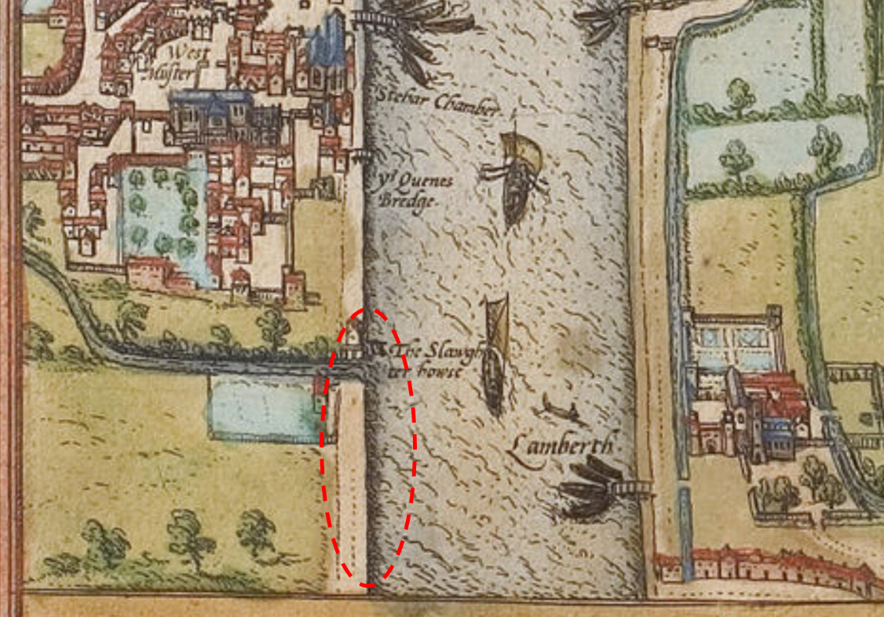
Figure 4-3 - Extract of Braun and Hogenburg's map of 1572 (approximate site of Victoria Tower Gardens)

The earliest map to show the area in any detail is Braun and Hogenburg’s map of 1572 (Figure 4-1). The map is a bird’s eye angled view of London, and although not to an accurate scale, clearly depicts the area of Victoria Tower Gardens and its surroundings. Although not named on the map, the River Tyburn is shown to flow through the north of the area now occupied by Victoria Tower Gardens with a building, labelled as the “Slaughter House” on the bank of the River Thames, with a possible jetty extending into the river.

To the south of the River Tyburn, partly within the north-western extent of the area now occupied by Victoria Tower Gardens, a large enclosed area is shown with an unnamed building on its eastern boundary. This is likely the mill, later labelled as “Abbott’s Mill” (MLO23201). The eastern half of the area occupied by Victoria Tower Gardens would have still been within the River Thames at this period, although it is clear that a programme of land reclamation was taking place to the south of the palace at this time, although it is not clearly shown on the map, it is reasonable to assume that some form of river wall or revetment, or series of revetments, was constructed at this time to prevent tidal flooding.
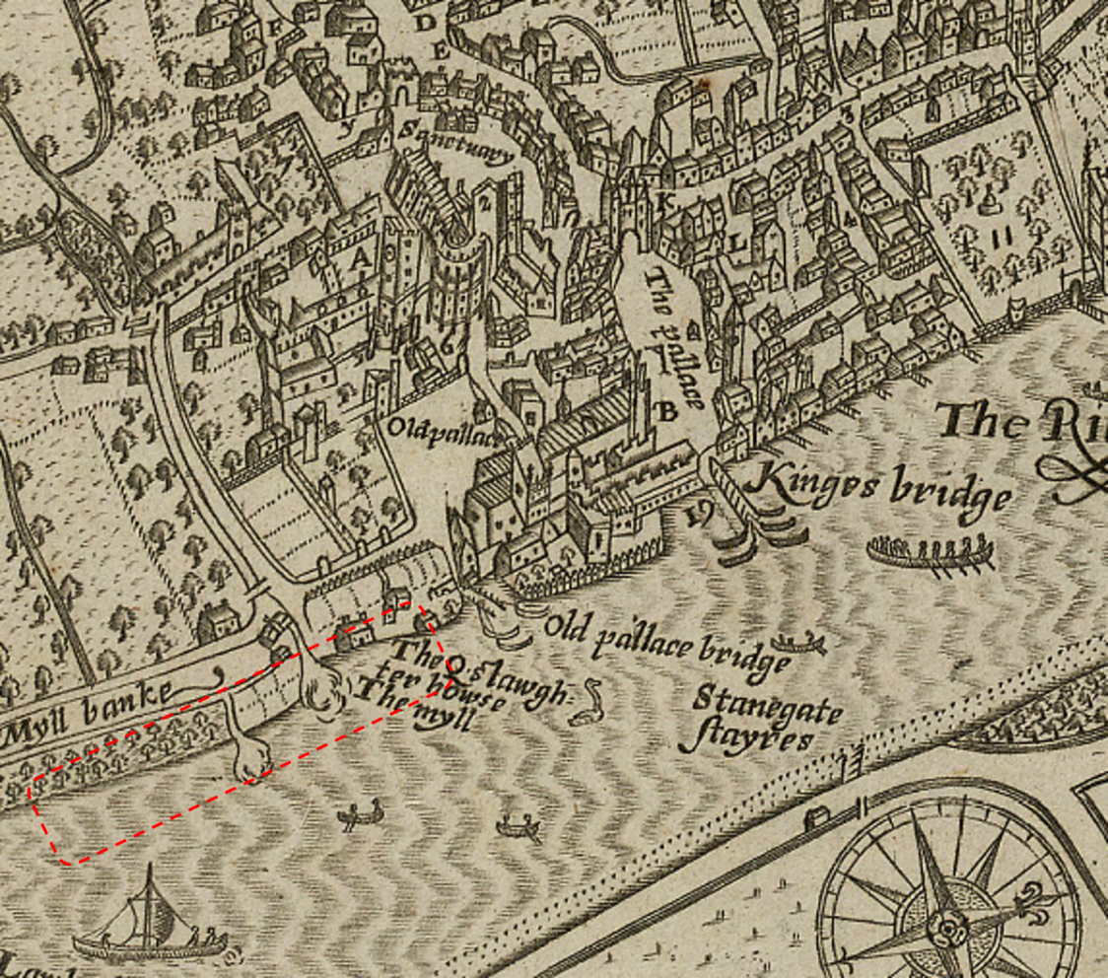
Figure 4-4 - Extract of John Norden's map of 1593 (approximate location of Victoria Tower Gardens)

Within 20 years of Braun and Hogenburg’s map, the “Myll Bank” (Millbank) had been laid out from the “Myll” (mill) in the north of the area now occupied by Victoria Tower Gardens, heading southwards roughly parallel to the river. The road appears to be a lot wider than at present and was flanked to the east and west by a diverted route of the River Tyburn, which was crossable by a bridge on what is now Old College Street. The river is shown to have two outfalls, one in the north of the area occupied by Victoria Tower Gadens, in alignment with Great College Street, and a smaller one a little to the south of this.

The Slaughterhouse shown on the earlier map is labelled as the “Q. Slawghterhowse”, which, owing to the proximity to the Palace of Westminster, may refer to the Queen’s Slaughterhouse, indicating royal connections. It is possible that animals came into the slaughterhouse by river, and the butchered carcasses left for the royal palaces along the River Thames at Greenwich, Richmond and Hampton Court the same way. The meat produced by a royal slaughterhouse would have also likely been used to feed garrisons, such as at the Tower of London, and the burgeoning Tudor Navy.
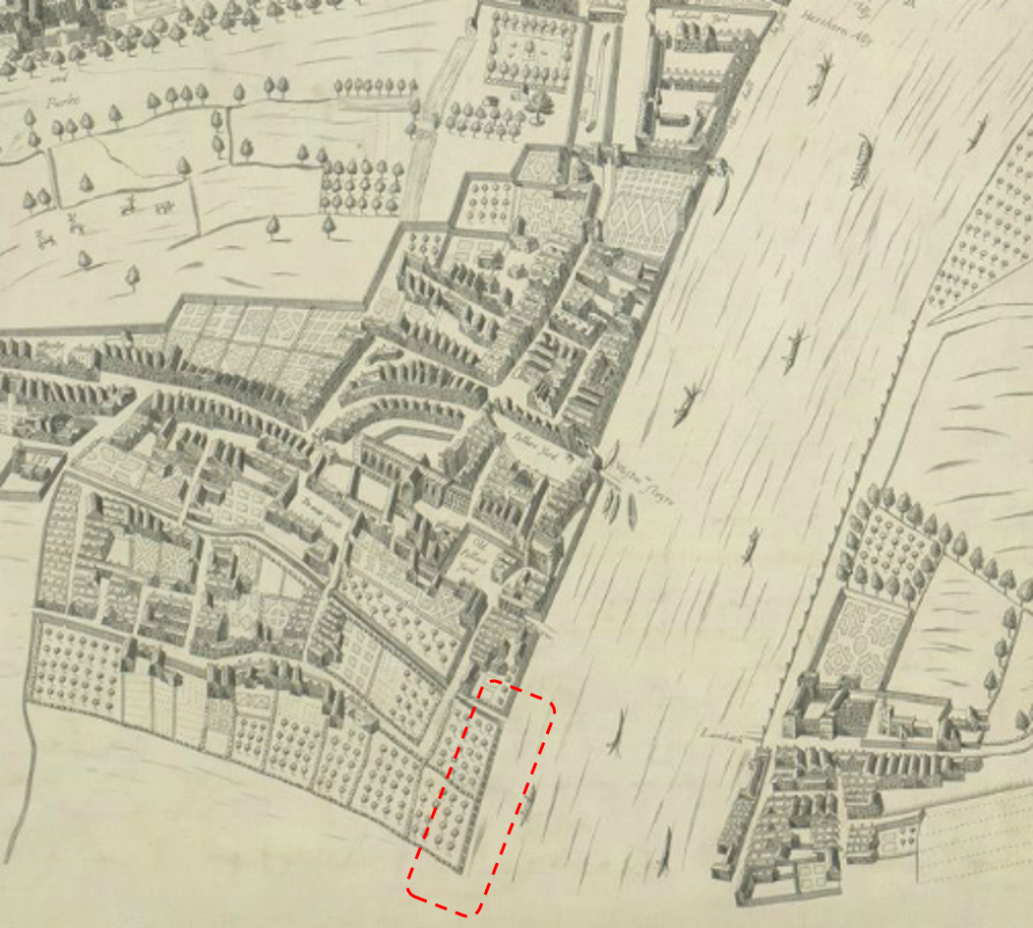
Figure 4-5 - Extract of Faithorne and Newcourt’s map of 1658 (approximate location of Victoria Tower Gardens)

No changes are observed in the Site until the mid-17th century. Faithorne and Newcourt’s map of 1658 (Figure 4-3), is an illustrative, almost isometric plan and not to scale. It appears to show that the slaughterhouse buildings to the north-west of the Scheme footprint have been cleared by this time. Comparison of this and the earlier maps with modern mapping indicate that the locations of both the slaughterhouse and Abbey Mill lies outside and to the north-west of the Scheme footprint. Much of the area occupied by Victoria Tower Gardens is still within the River Thames, the western extent appears to be orchards.
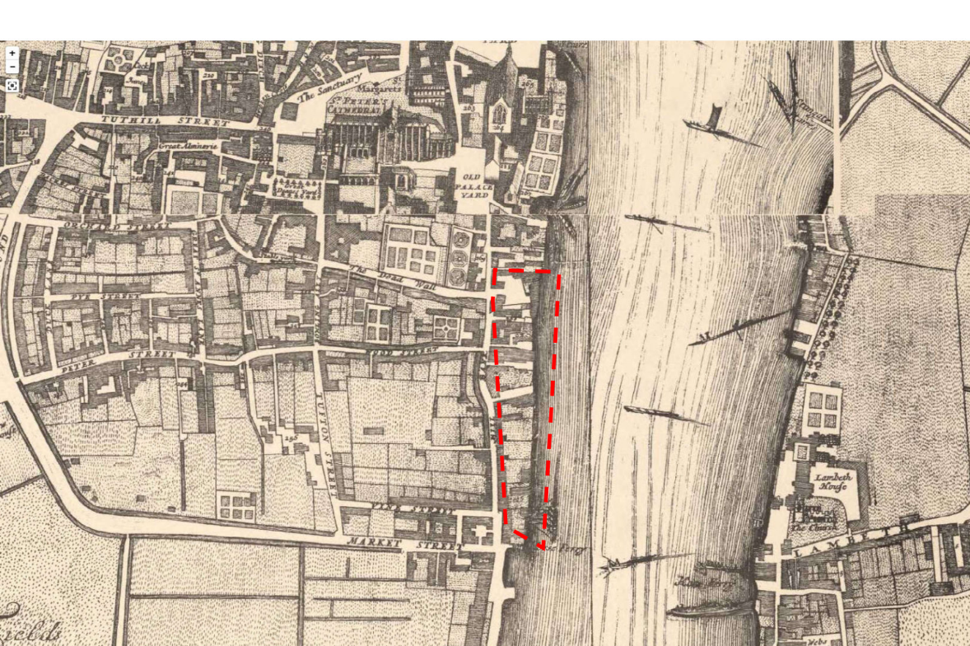
Figure 4-6 - Extract of Morgan’s map of 1682 (approximate location of Victoria Tower Gardens)

Morgan’s map of 1682 (Figure 4-4) shows that the north of the area occupied by Victoria Tower Gardens was occupied by “Maskalls Alley” (No. 268 on the map) which connected Millbank to the west, to the River Thames to the east. At this time Millbank was on a slightly more north-south orientated alignment than the present layout. North and south of the alley within the area of Victoria Tower Gardens, a series of large buildings are shown fronting onto Millbank. Those in the south are possibly residential in nature, with associated rear yards shown on the map. Those in the north have a more irregular plan and are likely indicative of wharves or warehouses connected to the riverfront. It appears that by this time at least two-thirds of the area now occupied by Victoria Tower Gardens had been reclaimed from the River Thames.

There is no indication of the earlier slaughterhouse or possible mill on the map, suggesting that these had fallen to disuse and had been replaced by this time. Immediately south of the area of the present Victoria Tower Gardens, a ferry crossing is noted, labelled on later maps as “Horse Ferry”. This refers to a type of ferry powered by horses on a treadmill. The ferry here was maintained by the Archbishop of Canterbury and served as the principal means of crossing the River Thames from Westminster Abbey to his palace at Lambeth. Although it is difficult to be certain it is very possible that the river front by this date had become established broadly on the line that will be followed by the eastern edge of the Scheme footprint.
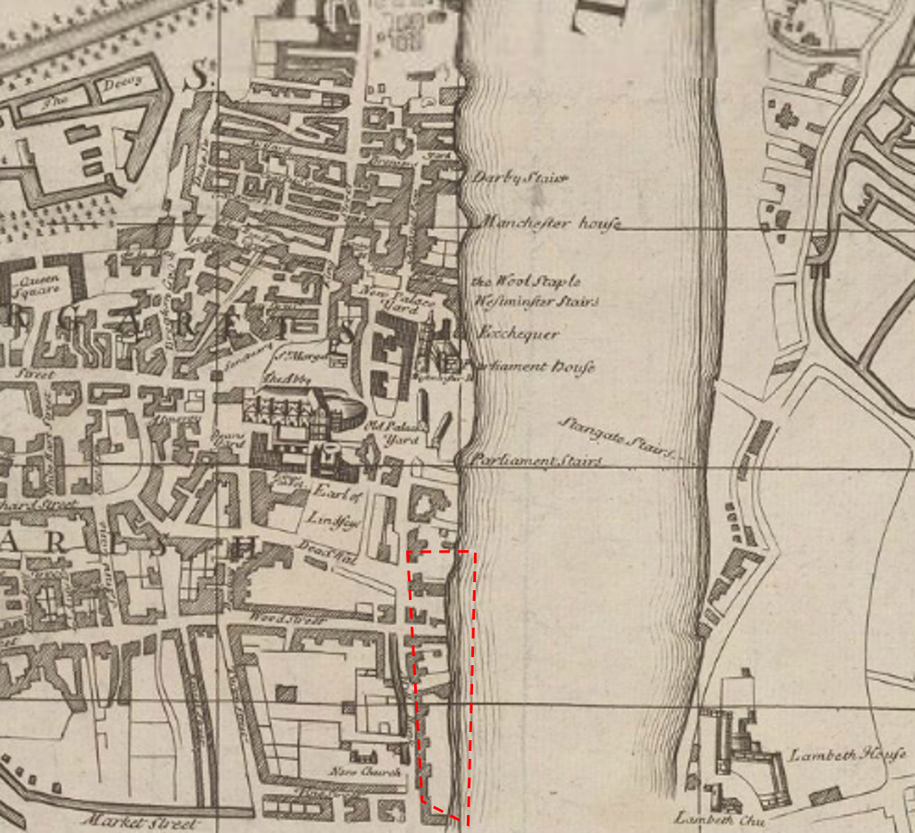
Figure 4-7 - Extract of John Smith's map of 1724 (approximate location of Victoria Tower Gardens)

Smith’s map of 1724 (Figure 4-5) shows little change to the nature of the area from Morgan’s map. However, it appears that the map may have been more accurately surveyed, as the foreshore area appears more irregular than Morgan’s largely uniform waterfront. It is likely that reclamation had occurred piecemeal. Again the river frontage on this map appears to broadly conform with the eastern edge of the Scheme footprint.
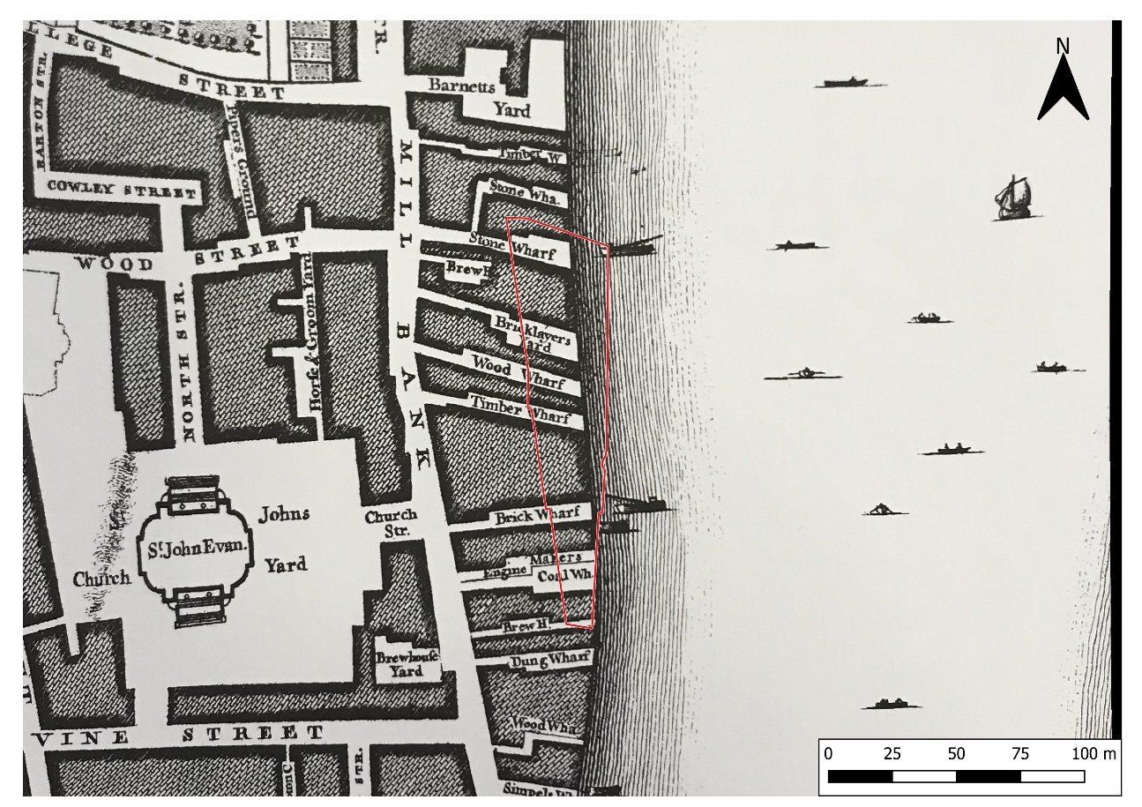
Figure 4-8 - Extract of Rocque's map of 1746 (with Scheme footprint)

Rocque’s map of 1746 (Figure 4-6) is the first on which the Scheme footprint can be reliably superimposed on and shows this area as being occupied by various wharves. These comprise large, irregularly planned warehouse buildings, interspersed by lanes and alleys to the river front. It should be noted that Rocque’s map does not differentiate between building properties in a block, nor were internal courtyards surveyed, and it is possible that areas of the buildings depicted were not developed, and existed as courtyards or general yards at the time.

The map does, however, note several wood, timber, brick and stone wharves within the Scheme footprint, as well as a coal wharf and bricklayer’s wharf. Unusually, an ‘engine makers’ is noted in the southern half of the Scheme footprint, and a brewhouse in the northern half. A second brewhouse may just lie within the very southern end of the Scheme footprint. It is possible that the timber, brick and stone wharves developed here in response to the contemporary expansion of the fashionable West End suburbs to the south of Westminster around this time.

The two brewhouses would have needed ample supplies of fresh water, and it is just possible that their location could be related to wells/pumps dug to the level of buried channels of the Tyburn.

The eastern edge of the Scheme footprint appears to run along the general line of the river frontage at this date; a situation that seems to remain the same on subsequent mapping until the expansion into the river of the embankment in this locality during the late 19th century.
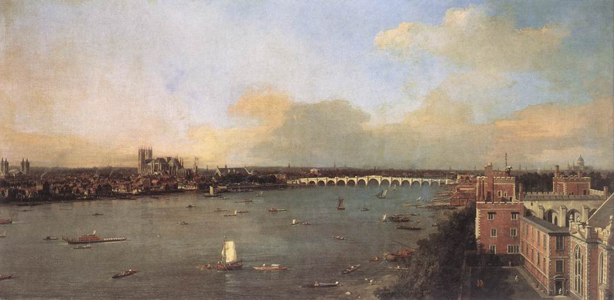
Figure 4-9 - Giovanni Antonio Canal, il Canaletto 1746-55, “The River Thames looking towards Westminster from Lambeth”

A painting of Westminster from Lambeth by the renowned Italian painter Canaletto in 1746-55 (Figure 4-7), clearly shows the industrial character of the area now occupied by Victoria Tower Gardens and the area surrounding Westminster Abbey and the palace at this time. To the left of the painting, a series of wharves and riverside buildings are depicted, bordering the River Thames. Unlike Rocque’s map, it is possible to see that the building plots were occupied by complexes of smaller structures, rather than one homogenous structure as depicted on the map. There appears to be a long jetty extending from the centre of this mass of structures, although this feature is not recorded on the historic mapping. The painting, much like Rocque’s map, shows that the river was a major thoroughfare at this time.

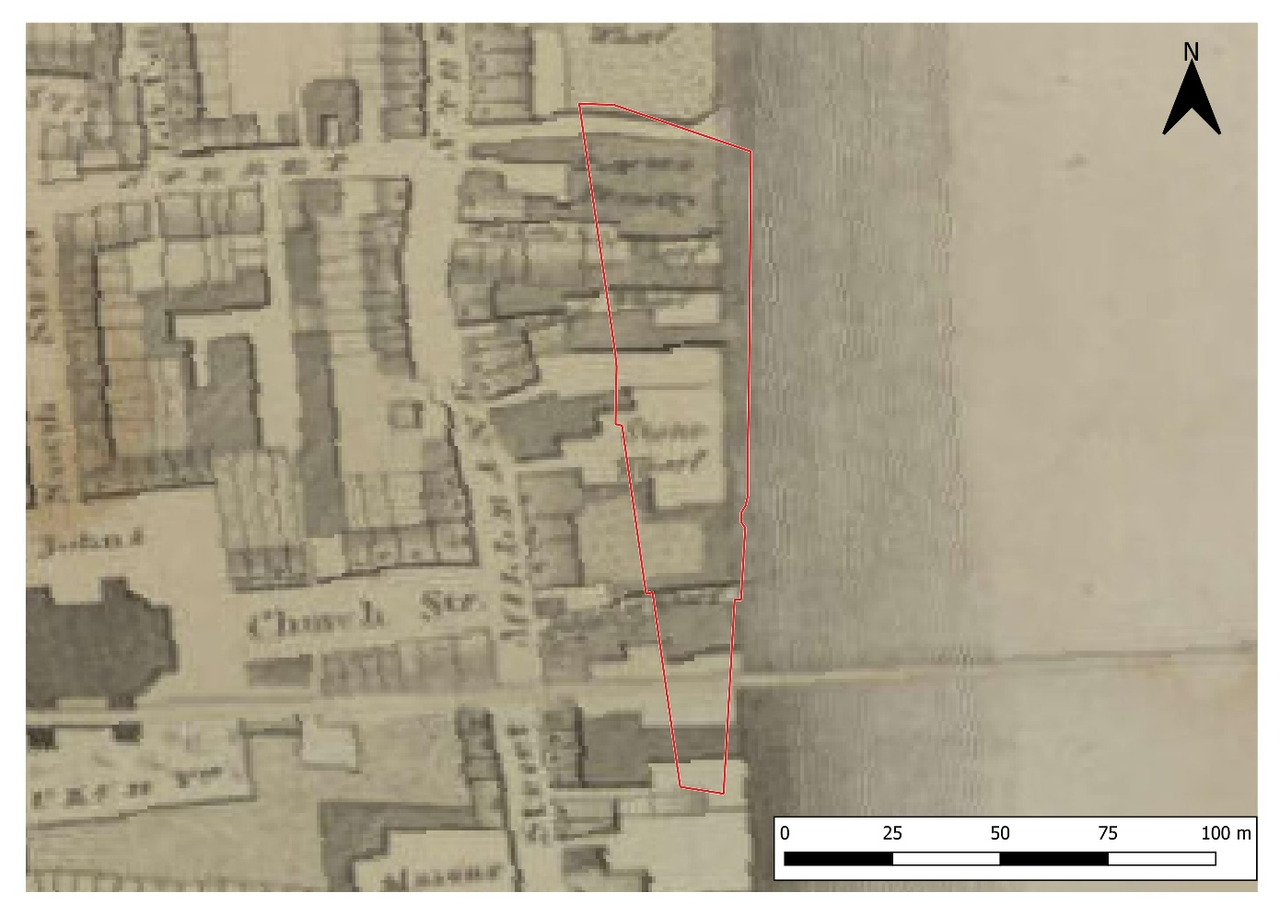
Figure 4-1 - Extract of Horwood's map of 1799 (with Scheme footprint)

Horwood’s map of 1799 (Figure 4-8) shows the composition of the area to be occupied by the Scheme footprint in greater detail than Rocque’s map. Individual building plots are recorded on the map, demonstrating that the western was occupied by residential (and possibly retail) buildings in the latter half of the 18th century, the eastern part, adjacent to the river, was occupied by wharves and warehouses, although it appears that by the end of the century these had declined in number.

Norway Wharf (probably a timber wharf) lies to the north of the Scheme footprint, and appears to comprise a largely open yard area, with small building in the west, and a row of houses along Millbank Street. The brewery in the north of the Scheme footprint on Rocque’s map, is labelled as Pearce’s Brewery, and appears unchanged in plan. To the south of this is Watkins and Co. Wharf and Hendey’s Wharf which occupy the same areas as the wood wharf and timber wharf shown on Rocque’s map. The bricklayer’s wharf appears to have been replaced by a stone wharf, comprising a large open area, a yard, and a commercial building fronting onto Millbank. The engine manufacturer’s is labelled as Johnstons Wharf, and comprises a large east-west orientated building, likely a warehouse or manufactory. The eastern extent of the Scheme footprint again broadly conforms to the river frontage at this date.
Figure 4-2 – D. Roberts, 1861 "Houses of Parliament from Millbank"

Fire broke out at the Houses of Parliament in 1834, destroying much of the old palace; only the chapel under croft, the Jewel Tower, and St Stephen’s chapterhouse and cloister survived. In 1836, the competition for constructing the new Houses of Parliament building (the New Palace) was won and the work was awarded to Sir Charles Barry, with contributions from Augustus Pugin. The result was the iconic gothic building that remains in use to this day.

A painting of the Houses of Parliament from Millbank by David Roberts in 1861 (Figure 4-9) suggests that the river front was irregular at the time. Although the painting is dominated by Barry’s building, it shows a timber dock in the bottom left-hand corner with a stone or brick building extending from it to the north and several mooring posts along the river bank. Any uniformity of the water’s edge shown in earlier maps, may reflect the presence of timber docks, as well as localised areas of more substantial water frontage. The geophysical survey noted a linear feature running north-south across the site, along the line of the waterfront shown on these maps and has been interpreted as a possible river wall. This may be a projection of the general trend, and perhaps not a true reflection of the individual wharf buildings that would have made the frontage.
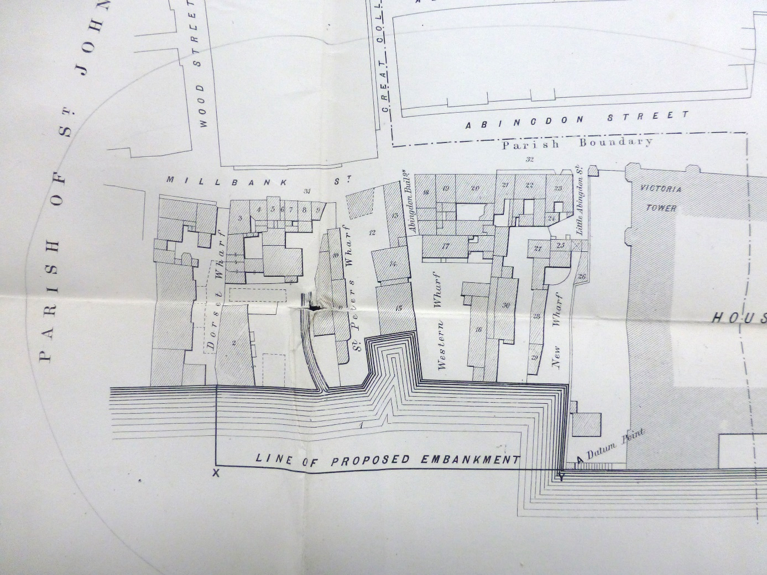
Figure 4-3 - Extract of a plan showing Parliament and its environs, 1867

The 1867 plan of Parliament (National Archives WORK 11/63) and its environs (Figure 4-10) was prepared in 1867 as it had been decided, as part of the earlier 1830s to 1851 rebuilding scheme for Parliament to acquire the land to the south of Victoria Tower and for this to be redeveloped as a public open space. All of the buildings within the proposed area of new gardens were surveyed and numbered individually (a transcript of the reference book that accompanied this map is in Appendix C). This plan also clearly indicates the location of the earlier waterfront and two inlets. The riverward line of the proposed embankment conforms to the existing width of the present gardens and shows the extent of land reclamation that was undertaken in the first phase of the creation of Victoria Tower Gardens. The gardens would be extended to their present extent at a later date (see below), whilst the Scheme footprint lies just to the south of the mapped area.

The proposed creation of a new embankment in the north of the area occupied by Victoria Tower Gardens coincides with the creation of Joseph Bazalgette’s Great Sewer, which follows the line of Chelsea Embankment to the south of Westminster , and Victoria Embankment to the north. The Embankments were constructed to house the sewer system, which otherwise would have had to be diverted north, along the Strand and Fleet Street, and involved a vast programme of land reclamation. Between the new granite faced embankments, the sewer followed Millbank, looping the area occupied by Victoria Tower Gardens and Palace of Westminster to the west, before joining up with the stretch along Victoria Embankment. Bazalgette’s work was instrumental in eliminating cholera, typhoid, and typhus in the London metropolitan area, which had been caused by contaminated water. The proposed embankment to the north of the Scheme footprint is likely indicative of a wider trend in dividing the riverine space from the land, rather than part of Bazalgette’s works.

The reference book that accompanied this plan indicates a wide range of uses within this area (which now represents the northern portion of Victoria Tower Gardens) including several public houses, dwelling houses, warehouses, wharves. Building number 22 on the plan was occupied by both the London Warming and Ventilating Company and the North British Oil and Candle Company.

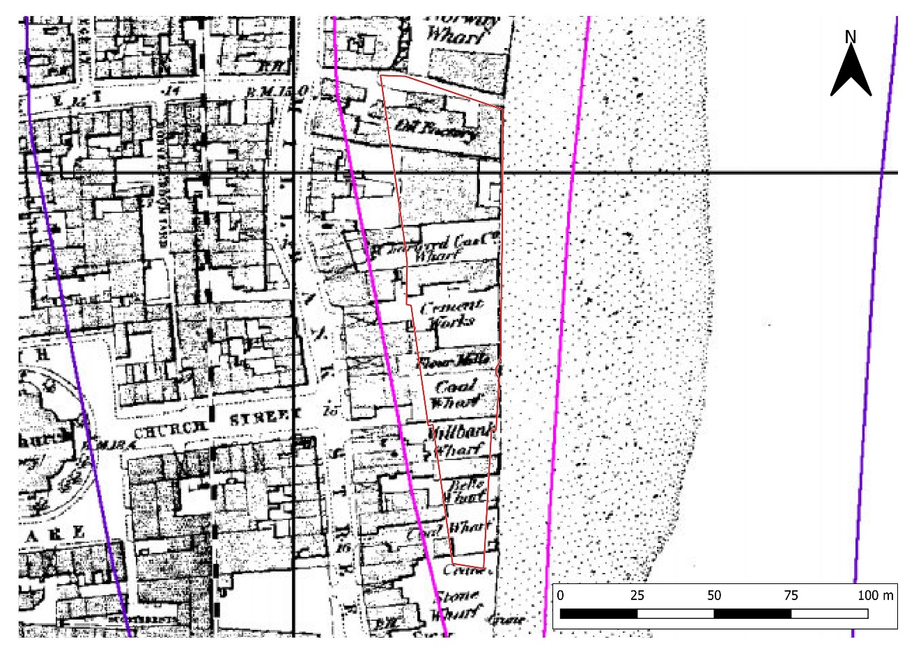
Figure 4-1 - Extract of the Ordnance Survey 1st edition 25":mile map of 1875

The Site retained its largely commercial nature until the end of the 19th century. The Ordnance Survey 1st edition 25” map of 1875 (Figure 4-11) shows a similar arrangement of wharves and warehouses occupying the Scheme footprint. These comprise from north to south:
- an oil factory; which at this date was likely involved in the processing of whale oil;
- a brickyard and coal wharf;
- a cement works;
- a flour mill;
- another coal wharf;
- Millbank Wharf;
- Bells Wharf;
- A third coal wharf

A crane is also indicated on the southernmost coal wharf, and may just lie within the southern edge of the Scheme footprint. The riverfront at this date appears to pretty much follow the proposed eastern edge of the Scheme footprint. The three coal wharves may be associated with the import of fuel for domestic consumption in the by now established fashionable suburbs of the West End. The oil factory may also have been servicing local domestic consumption.
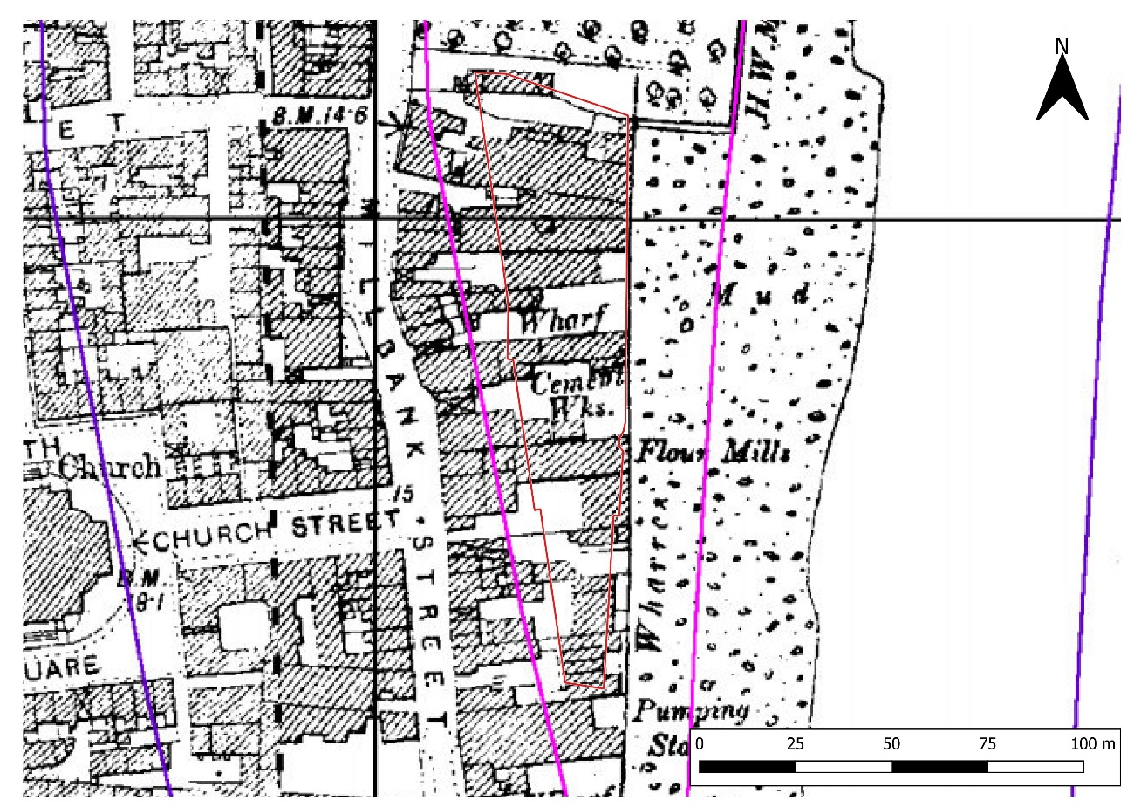
Figure 4-2 - Extract of the Ordnance Survey 2nd edition 25":mile map of 1896

The Ordnance Survey 2nd edition 25”:mile map of 1896 (Figure 4-12) shows that the wharves to the north of the Scheme footprint had been cleared by this date and the northern section of Victoria Tower Gardens had been laid out, extending as far south as in line with Great Peter Street (then Wood Street), at the extreme north of the Scheme footprint. The area of the gardens extends eastwards, in line with the present extent of the gardens, and is bound on the east and south by a river wall. The river boundary in the southern two thirds of the area now occupied by Victoria Tower Gardens appears much straighter on this map, suggesting the possibility of a river wall reconstruction sometime in the late-19th century. The alignment of this feature appears to broadly coincide with the general line identified in the SUMO geophysical survey.

There appears to be little change in the layout of buildings and likely their function from the previous 1875 map (Figure 4-11). A pumping station is shown immediately to the south of the Scheme footprint. Possibly associated with sewerage; and interestingly again located broadly where a buried Tyburn channel has been identified during the geoarchaeological evaluation.

The Site was cleared out in the early 20th century.

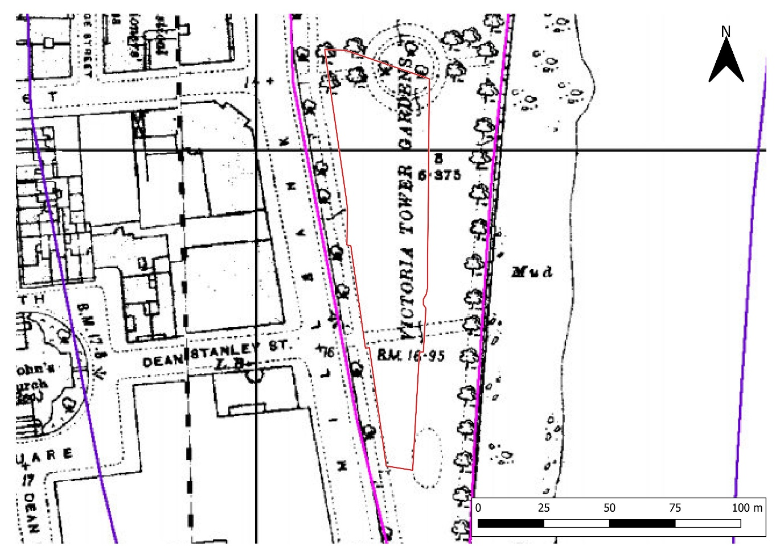
Figure 4-1 - Extract of the Ordnance Survey 3rd edition 25":mile map of 1916

The Ordnance Survey 3rd edition 25”:mile map of 1916 (Figure 4-13) shows that Victoria Tower Gardens has expanded by this time to its present extent. By this time, the existing river wall, which bounds the eastern extent of the gardens is clearly shown. The original layout of the expanded gardens was established at this time, as the map shows a path running the perimeter of the gardens and a central circular area shown within the northern part of the Scheme footprint, predating the later, larger circular walk to the north. This map suggests the remains of pathways and potentially beddings will be present within the imported park soil.
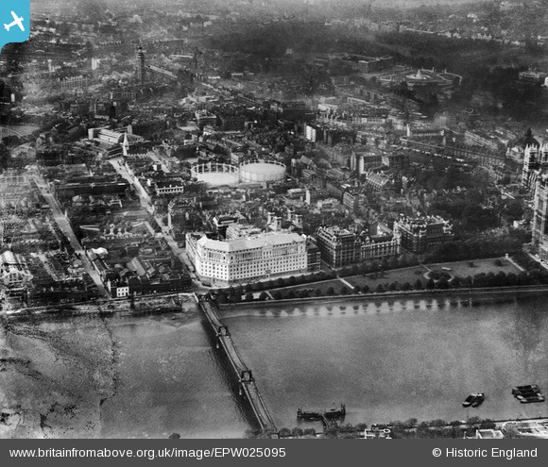
Figure 4-2 - Imperial Chemical House and environs, Westminster, from the east, 1928 (EPW025095 ENGLAND(1928). © Historic England

An aerial photograph of the Imperial Chemical House, taken in 1928 (Figure 4-14) shows the original layout of Victoria Tower Gardens as indicated in the Ordnance Survey 3rd edition 25”:mile map of 1916.

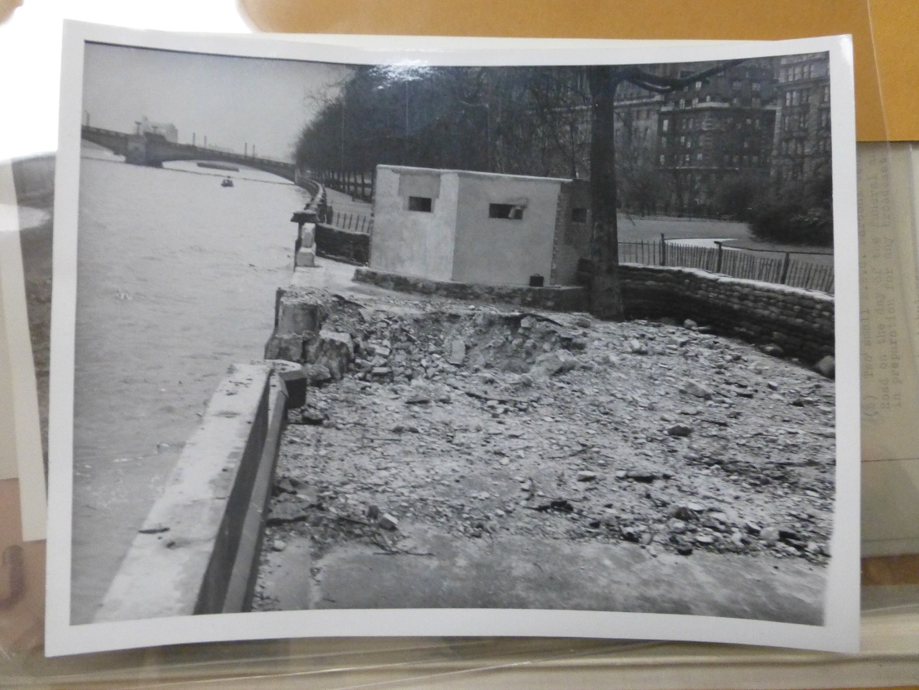
Figure 4-1 - Photo of pillbox and bomb damage within the Site, May 1941 (National Archives WORK 16/2555)

The Bombsight map indicates the Site was struck three times by high explosive bombs during the Second World War. Photos held in the National Archives (WORK 16/2555) show damage to the river wall, but also that a pillbox had been constructed along the river front, to defend from a possible invasion (Figure 4-15). The pillbox shown in the photo is likely that erroneously positioned on the GLHER in the west of the Site (MLO105786).

The Site has remained an open public garden from this period and is Grade II registered. The path around the park has changed since the early 20th century, and in 1949 the Grade II* Buxton Memorial Fountain was moved from Parliament Square to its present location, and the installation of Sturgeon Lamps. No further changes have taken place.

Results of the Geophysical Investigation

SUMO Services carried out a ground penetrating radar (GPR) survey of the Site in 2017, details of the survey can be read in the report. The geophysical survey has been utilised in informing the design of all subsequent archaeological fieldwork for the UKHM project.

In summary, the investigation identified a north – south orientated boundary feature bisecting the site. The outlines of the former early 20th century garden features were recorded, as well as localised areas of made ground or possible building foundations. Towards the south of the Site, a series of linear features of unknown date were identified. The results of the geophysical survey are presented below in Fig 4-16.
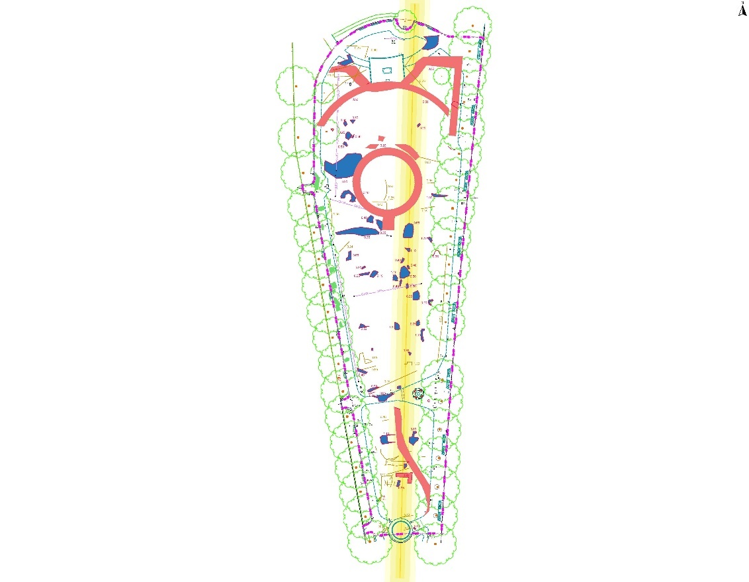
Figure 4-2 - Interpretive results of ground penetrating radar survey. After SUMO 2017 (SOR11461, Fig 5)

The general trend line crossing the image from north-south has been interpreted as a former river wall. From historic mapping, it is apparent that the river front along the Thames did not have a uniform appearance for much of its history.

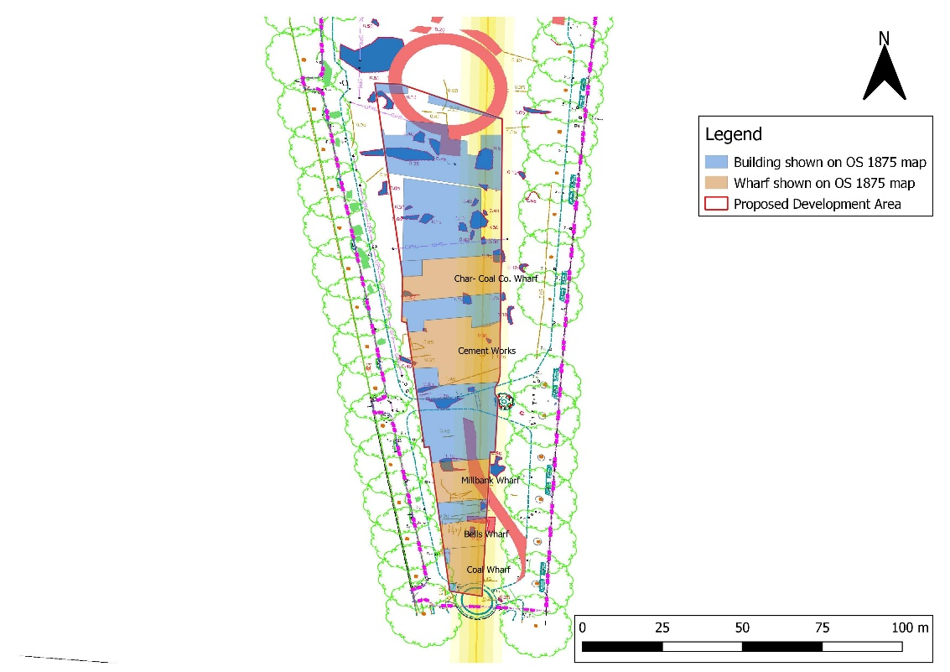
Figure 4-3 - Georectified interpretive plan of geophysics results overlain with principal features from the OS 1875 map

Overlaying the interpretive plan of the geophysical survey with the Ordnance Survey 1st edition 25”: mile map of 1875 (Figure 5-17) shows that the areas interpreted as made ground or footings coincide with the location of historic wharf buildings (marked in light blue on the figure) within the Scheme footprint. It is apparent that the general trend line represents the former line of the foreshore (marked in red) against which the eastern edge of the Scheme footprint lies and that the lack of anomalies to the east of this is representative of this area’s historic location within the Thames foreshore. It is possible that the linear anomaly represents an early river wall or revetment, however, as noted above, the river frontage did not appear to be uniform until the creation of the present embankments, and that any uniformity shown on historic maps may have included areas of timber dock and wharves.

- Potential and Significance
  - Survival Potential

The potential for archaeological survival is expected to be High.

The Site was converted into a public park in the early 20th century and has remained so since. In the west of the Site earlier remains will have likely been truncated by the footings of later wharf buildings, but these are considered to be of heritage value in their own right.

The east of the Site was within the River Thames until the creation of the full extent of the park in the early 20th century. The thick made ground deposits will have protected palaeoenvironmental remains within alluvial deposits although the post medieval land reclamation and wharf side development and re-development may also have truncated the upper levels of the underlying alluvium.

Underlying alluvial deposits are likely to be waterlogged, resulting in anaerobic conditions that are perfect for preserving organic material. Any archaeological remains within these deposits are likely to be exceptionally well preserved. The potential for there being significant archaeological remains buried within the alluvium is, however, considered to be Low.
  - Statement of Potential and Significance

The Site was historically located within the confluence of the River Thames and River Tyburn, south-east of Thorney Island, a raised area of gravels within the rivers. Remains of Bronze Age revetments, found 200m north of the Site, indicate the earliest attempts to manage the floodplain in the area, although it appears that tidal flooding in the Iron Age made the area unsuitable to intensive habitation. Activity moved some distance to the north, at Charing Cross until the Early Medieval period, when the first Abbey was established. Development of the ecclesiastic precinct and the royal palace proceeded from the 11th century onwards, focused to the north and west of the Site, and included large amounts of land reclamation in these areas.

During these periods it is likely that the area of the Site was exploited for its riverine location and used as transportation access to settlement areas on the drier gravel island. Remains such as timber jetties, boats and trackways may be present within alluvial deposits, as well as possible votive offerings. Evidence of prehistoric to medieval riverine activity would be considered of up to High significance, derived from its evidential value in developing the understanding of early human interaction with the Rivers Tyburn and Thames. Later such features have the potential to be associated with the historic landscape of the scheduled monuments and World Heritage Site in the vicinity of the Site.

By the end of the 16th century, the process of land reclamation had expanded southwards, covering the western portion of the Site. Early historic mapping shows a water mill (the Abbott’s mill) and a slaughterhouse and yard were located outside of the scheme footprint to the north-west of the Site and it is likely that some form of river wall or timber revetment existed at this time as well. The balance of probability is that any evidence for either the mill or slaughter house are located outside of the footprint of the scheme.

By the 17th century, the west of the Site was developed into wharves, and remained so until the end of the 19th century, with individual wharves being reclaimed from the river, connected by wooden docks. It is possible that these earlier wharves were located to aid in the storage and transportation of materials for the construction of London’s fashionable West End suburbs, and Great Estates. By the early 20th century, the full extent of the Site had been reclaimed from the River Thames, and the present gardens laid out. Ordinarily, the footings of post-medieval wharves would likely be considered of low significance, however, as they collectively offer a unique insight into the development of the Westminster waterfront and transitions in use for the area, they are considered to be of Medium significance based on their evidential and historical values. Geophysical survey of the site revealed the original pathways of Victoria Tower Gardens, and it is possible that remains of original garden features survive. None of the garden features identified by geophysical survey or from historic maps and photographs appear to be anything other than typical for a municipal park of late 19th to early 20th century date. The park and garden features are therefore considered to be of low significance.

There is a high potential for the alluvial deposits of the River Thames and River Tyburn to contain palaeoenvironmental remains, as concluded in the 2019 borehole assessment. These remains include plant macro and micro fossils and can be used to recreate past environments from the earliest Holocene period onwards. The results of the geoarchaeological assessment concluded that the “geoarchaeological and palaeoenvironmental remains would be of considerable local importance, further adding to the current understanding of the River Tyburn and development of the local area”. The evidence indicates the likely existence of rare and potentially very significant Late Upper Palaeolithic to early Mesolithic channel deposition within the southern part of the Site, but also suggests reworking of the deposit sequence throughout the prehistoric period from the early Neolithic through to Romano-British period. Terrestrial alluvium once more exists through the Romano-British through to the mid to late Saxon period when the deposition sequence is truncated. The exact mechanism for this latest truncation remains unknown.

Table 5-1, below, summarises the archaeological potential and significance of the Site. Archaeological remains are expected to be immediately beneath ground levels in the west of the Site.
Table 5-1 - Summary of archaeological potential and significance
Period | Potential | Features | Significance
Palaeoenvironmental | High | Environmental evidence and artefacts contained within alluvium particularly with regard to what may be Late Upper Palaeolithic/early Mesolithic interface deposits within a former channel of the Tyburn in the south of the Site. | High to very High (evidential)
Prehistoric | Low to Moderate | Evidence of wetland exploitation (trackways, docks, votive items, boats etc) extending into the Tyburn/Thames interface. Evidence from the site strongly suggests that the site lay within an active and potentially at times tidal environment during this period.  Residual artefacts | High (evidential)  Low (evidential)
Roman | Moderate to High | Evidence of wetland exploitation (trackways, docks, boats etc). Evidence from the Site indicates that more organic alluvial deposition recommenced on the Site during this period with palaeoenvironmental evidence suggesting proximity to anthropogenic activities.  Residual artefacts | High (evidential)  Low (evidential)
Early Medieval | Moderate to High | Evidence of wetland exploitation (trackways, docks, boats etc)  Residual artefacts.  Evidence from the Site indicates that more organic alluvial deposition continued on the Site during this period through to the 8th-10th centuries with palaeoenvironmental evidence suggesting proximity to anthropogenic activities. The alluvial sequence is then truncated and immediately overlain by post-medieval reclamation and development of riverside wharfage etc. | High (evidential)  Low (evidential)
Later Medieval | Low to very low | Footings of 16th century Abbott’s Mill (almost certainly outside of the scheme footprint)  Footings of 16th century slaughterhouse (almost certainly outside of the scheme footprint)  Evidence suggests that any channel deposits on the Site have been truncated from the mid to late Saxon period onwards. | High (associated)  High  (associated)  High (evidential)  Low (evidential)
Post-medieval | Very High | River management features from the 16th century (timber revetments, walls etc); including reclamation dump deposits and successive extension of river walls into the Thames  Footings of wharf buildings and wharf features from the 17th century through to mid to late 19th century  19th and 20th century original garden features of Victoria Tower Gardens | Medium (evidential/ historical)  medium (evidential/ historical)  Low  (associated)

- Potential Impacts
  - Proposals
  - Archaeological Impact

The western extent of the Site is considered to have a high potential for palaeoenvironmental remains contained in underlying alluvial deposits, and the footings of post-medieval riverside buildings and wharves. The eastern extent of the Site is considered to have a high potential for palaeoenvironmental remains covered by thick made ground deposits laid during the expansion of Victoria Tower Gardens.

The identification of potential physical impacts upon previously unrecorded archaeological remains within the Site considers all activities that may entail ground disturbance. The main impacts to archaeological remains arising from the proposals above are presented in the table below.
Table 6-2 - Potential impacts to archaeological remains from proposals
Proposal | Implication | Impact
Creation of piling mat | Would remove up to 1.5m of material within the footprint of the development. | Any remains within the upper imported park soil deposits would be entirely removed,  It is evident that creation of the piling mat will remove a homogeneous imported topsoil, exposing the top of the footings of the post-medieval wharf and Wharfside activities.
Insertion of new piles | Insertion of new perimeter piled wall around the area of proposed basement level.  New piles would be inserted | New piles would remove archaeological remains from their footprints as they are driven downwards. Remains may survive in a truncated state between each pile depending on pile size and density.
Excavation of material to formation level | Removal of material within the footprint of the proposed development to 8.0-10.0m below ground level | All archaeological remains will be entirely removed within the footprint of the proposed basement levels to the formation depth of c. 8-10m in places.  This will include all evidence for the post medieval reclamation, development and re-development shown on historic mapping. The basement will also remove the upper levels of the underlying alluvial sequence.

Objectives and research themes

Introduction

Construction of the Scheme offers an opportunity to explore our past through heritage work. Evidence arising from this archaeological strategy should allow key questions about the area’s history and prehistory to be answered, all within a cost-effective manner and within the confines of construction and engineering programme for UKHM.

This section outlines the key research objectives that the UKHM archaeological programme may address. The archaeological investigations will be grounded on sound and current research objectives; thus, this chapter begins with a brief overview of the main current research agendas relevant to the Scheme.

From here and combined with the wider resource assessment, a number of key research themes are identified. it is important to appreciate that the themes are not necessarily specific to periods, regions or specific locations, but seek to identify useful and universal topics, topics that are highlighted as important areas for study in current research thinking.

Specific Research Objectives (SROs) are then suggested (section 6.5). These SROs translate the key research themes into tangible potential actions that could be addressed during delivery of the Scheme.

The SROs will be referenced in the individual mitigation area specific WSIs that will be generated on the basis of this strategy. It is likely that the SROs will need to be reviewed and updated as individual work programmes progress. Thus, this document, and the associated WSIs, should be viewed as evolving documents with questions and agendas updated and refined as fieldwork progresses.

Regional Archaeological Research Frameworks

No formal archaeological framework currently exists for the Greater London Area although there is to a degree ample guidance of thought streams provided by the Museum of London’s 2000 publication: The Archaeology of Greater London. Further guidance is also offered by the Greater London Archaeological Advisory Service’s guidelines for undertaking archaeological projects in Greater London and within archaeological priority areas.

The Archaeology of Greater London is a synthesis of the understanding of the archaeology of the capital as it stood in the year 2000 and although now dated following the extensive amount of fieldwork that has been carried out since there are broad themes for future research included within each of the period chapters. Of particular relevance to the UKHM site with its likely complex and intact post medieval archaeology is Paul Schofield’s Chapter 10: Post Medieval London – The Expanding Metropolis.

Below the post-medieval archaeology of the Site there appears to be a truncation of alluvial deposition in the early medieval period, with a largely preserved sequence dating back to the early Mesolithic within what may be a palaeochannel of the Tyburn below that. James Rackham and Jane Sidell address research priorities with regard to the palaeoenvironment in Chapter 1: London’s Landscapes: The Changing Environment. It should also be borne in mind, as this chapter states, that the palaeoenvironment is also a critical part of understanding the post-medieval development of the Site in terms of the potential for dating imported exotics, understanding diet and the contents of refuse that may very well have been utilised to create new land to develop on the riverside of the Thames..

Further thematic and period guidance is also available from publications provided by Historic England.

A discussion is also planned with experts in the archaeology of this part of London following delivery of the first draft iteration of this AMS. It is planned that this round table discussion will include:
- Sandy Kid: Principal Archaeologist for GLAAS;
- Sylvia Warman: Historic England Science Advisor;
- Jane Sidell: Inspector of Ancient Monuments with Historic England; and
- Tim Tatton Brown:

These documents and discussion with experts in the archaeology of this part of London have all guided the research themes and objectives, and (where possible and practical) the methodologies that will be used throughout delivery of the archaeological programme for the Scheme.

Geographical Context

The implications of the geographical and topographical context of the Scheme at Tyburn mouth with the Thames on the very southern edge of the royal and ecclesiastical centre of Westminster need to be understood in terms of how the location has driven the development of activities in the area.

This context includes considering the evidence for potentially very early Holocene deposition of exceptionally well preserved organic palaeoenvironmental sequences at depth within the southern end of the Scheme. If they prove to be Late Upper Palaeolithic to early Mesolithic in date this would make them a significant deposit sequence in this part of London. Questions also arise as to the nature of the apparent hydraulic reworking of deposits within the Scheme footprint from the early Neolithic through to Romano-British periods resulting in what may be a relatively low archaeological potential between these periods when the Site seems to have mainly lain within a migrating channel system. More organic and relatively undisturbed alluvial deposition returns between the Romano-British and mid to late Saxon periods before the sequence appears to be abruptly truncated, the process for which is not presently known.

On present evidence it would appear that no evidence between the mid to late Saxon and early post medieval period (c. 1600 AD) exists within the Scheme footprint and that immediately over the mid-late Saxon truncation of the alluvial sequence at c. 5m BGL post medieval reclamation and riverside development extending from c. 1600 through to the turn of the 20th century is present. This riverside development occurred during the principal development of Britain as a global maritime and trading power and in a location adjacent to the burgeoning fashionable western suburbs of the city in immediate proximity to the palace of Westminster. Although upstream of London Bridge, and therefore beyond the reach of larger vessels, the site is obviously tied to riverine trade and most specifically it would appear the import of building materials during a critical period during the development of the fashionable western suburbs around Westminster.

The location, alongside the scale of development led archaeology that has occurred elsewhere in London in recent years, also opens up possibilities for comparison with other comparable sites within this part of London (and indeed elsewhere in the capital) which have witnessed similar levels of archaeological investigation. This is particularly relevant to this Site, where the level of modern disturbance is negligible to non-existent due to its preservation beneath c. 1.5m of imported topsoil to establish the existing park. The archaeology within the Scheme footprint can therefore, in London terms, be suggested to be in a potentially exceptional state of survival.

Research Themes

In keeping with the above thinking any remains encountered during construction of UKHM have the potential to give insight into some of the following Research Themes:

A) Increasing the understanding of artefact studies and palaeoenvironment, locally to Westminster, for Greater London and more widely;
B) Charting London’s post medieval growth as a burgeoning capital and principal market for an expanding maritime trade empire;

C) Understanding the changing character of this part of Westminster over time and how it relates to the rest of the Capital;
D) The place of London as a capital city with regard to:
- Potential evidence for the development of the neighbouring Royal, Government and Ecclesiastical centre of Westminster;
- Evidence for conspicuous consumption related to its primary position as a national and global focus.
E) Informing on the developing nature of infrastructure on the site and comparisons with other examples elsewhere in London; including understanding:
- the development of quays and wharfs in the tidal stretch of the river above London Bridge
- development of the local water and sewerage systems and their relationship with the historical culverting of the Tyburn
- the development of and the drivers for industrial and economic activities on the Site.
F) Evidence from the Site which can inform on the development of trade and commerce during the historic period with emphasis on:
- Local, regional and international trade and mercantile exchange;
- The developing nature of trading installations and waterfronts
- The development of ships and boats
G) To relate and link, as far as is, practicable the post medieval archaeology on the Site with available historic and documentary sources including insurance details, business guides (ie Kelly), deeds, national census records, wills, inquisitions post mortems etc.
H) Understanding the changing nature of the interface between the Thames and the Tyburn over time
I) Understanding and dating the transition from the early Holocene alluvial sequence to a series of apparent Tyburn channel migrations at the beginning of the Neolithic and how this is related to the changing climate and associated rise in sea levels of the period;
J) Understanding the nature of the apparent Tyburn migrations from the early Neolithic through to Romano-British period and their relationship with climate change and changes in the local environment;
K) Understanding the nature of the development of the alluvial sequence during the Romano-British to mid/late Anglo-Saxon periods and the mechanisms for its truncation during the mid to late Anglo-Saxon period;
L) Understanding the changing nature of the Thames and Tyburn tidal regimes/heads and the influence this has had on local environment and the nature of nearby human activities

The archaeological assets dentified during delivery of this archaeological strategy for the Scheme will also contribute significantly to our understanding of the nature of evidence, chronology, material culture and the past environment.

As outlined in Sections 9 to 21, the industry standard archaeological methodologies that will be used during delivery of the Scheme will require the study of, for example, ecofacts and artefacts, and a programme of radiocarbon dating (and/or other appropriate dating techniques, such as isotope analysis).

There will also be opportunities to investigate methodological research questions which may include, for example.

Specific Research Objectives (SROs)

The following SROs translate the key research themes into tangible potential actions that can be undertaken during the archaeological programme. The SROs will be referenced further in the WSI and project plan for the archaeological work.

The archaeology to be removed within the basement box is predominantly relates to the post medieval reclamation of this area from the rivers Thames and Tyburn and subsequent development of this area for Thameside wharves and associated activities.

The SROs also include approaches to the treatment of the buried alluvial sequence lying under the post-medieval archaeology with particular emphasis on:
- The potential Late Upper Palaeolithic to Early Neolithic organic deposition within what is probably a channel system of the Tyburn;
- The hiatus between a relatively terrestrial environment at the beginning of the Neolithic and the onset of a subsequent sequence of apparent channel migration during the remainder of the prehistoric period; and
- The shift back to a more organic deposition sequence during the Romano-British and Anglo-Saxon periods and its apparent truncation sometime during the mid to late Anglo-Saxon period

However, discoveries and research across the wider landscape (e.g. outside the immediate Scheme boundaries, but within the wider hinterland) suggest that other heritage assets may be encountered during the course of the archaeological programme, particularly for earlier periods. Thus, the SROs also cover potential discoveries, assets that, for whatever reason, are not currently known.

It is important to identify SROs that are relevant to current research thoughts that may be answered during the archaeological programme from assets that are currently unknown. It may be that that some of the SROs highlighted below may be deemed irrelevant on completion of the works or actually gain wider prominence during the post-excavation phases. It is also possible that other research objectives will suggest themselves during the course of the on-site archaeological works and subsequent post excavation analysis.

The following Specific Research Objectives (SROs) can be identified and related back to the wider research themes suggested by the relevant regional archaeological research frameworks above.

SRO1 THIS SECTION WILL BE COMPLETED FOLLOWING PLANNED DISCUSSIONS WITH GLAAS AND OTHER EXPERTS

Standards and responsibilities

Responsibilities of the Principal Contractor

The Principal Contractor will be responsible for the overall management of engineering and health and safety protocols. This will include, although potentially not be limited to:
- Being the principal contractor for the Site in terms of the CDM regulations and the appropriate oversight of health and safety, environmental and contamination protocols;
- Providing all engineering solutions and de-watering required to support the archaeological works;
- Securing and maintaining the security of the Site from unauthorised access including provision of all necessary hoarding and access arrangements;
- Providing all engineering solutions and mechanical plant that will be required to support the archaeological works including potentially large excavators, mini excavators, pumps for de-watering, bucket/spoil lifts and hoists and if required; access, lighting and ventilation solutions to allow archaeological works to continue under the floor slab;
- Arranging for spoil and arisings management within the Site and bulk muck-away of excavated material;
- Providing welfare and equipment storage facilities of the appropriate standard for a team of up to 70 archaeologists on site for a c. 6-month period;
- Providing covered facilities for on-site processing and triage of archaeological artefacts and palaeoenvironmental samples; including provision of power and water supply;

Responsibilities of Archaeological Contractor

The Archaeological Contractor is responsible for the design and delivery of all required works within the Specific Research Objectives and Research Themes as set out in this document. In particular they will be responsible for:
- Managing budgets and programmes for archaeological works;
- Preparing and delivering the specified archaeological programme of works integrated with delivery of the engineering required to excavate the basement area;
- Preparing the project plans, written scheme of investigation (WSI) and risk assessment for the specified archaeological works;
- Defining the necessary plant and welfare requirements pertaining to the archaeological works for the Principal Contractor to implement and provide;
- Delivering specified archaeological works;
- Preparing defined archaeological outputs;
- Preparing and delivering physical and digital archive materials;
- Engaging with the Lead Heritage Consultant, Client, Principal Contractor and external parties to deliver community engagement activities; and
- Attending specified progress meetings with the Lead Heritage Consultant, Client, Principal Contractor and Statutory Consultees.

Compliance with Heritage Specific technical standards

The following general guidance and standard documents will guide all work undertaken. Where relevant others, are referred to directly in the appropriate Specific Methodologies as set out in Sections 9 to 21 of this Strategy.
- Campbell, G, Moffett, L and Straker, V 2011 'Environmental Archaeology. A Guide to the Theory and Practice of Methods, from Sampling and Recovery to Post-excavation (second edition)'. Portsmouth: English Heritage
- Chartered Institute for Institute for Archaeologists (CIfA), 2014a. Code of Conduct.
- Chartered Institute for Archaeologists, 2014b. Standard and guidance for archaeological field evaluation.
- Chartered Institute for Archaeologists, 2014c. Standard and guidance for archaeological geophysical survey.
- Chartered Institute for Archaeologists, 2014d, Standards and Guidance for Archaeological Excavation
- Chartered Institute for Archaeologists, 2014e, Standards and Guidance for and Archaeological Watching Brief
- Chartered Institute for Archaeologists, 2014g, Standards and Guidance for the Creation, Compilation, Transfer and Deposition of Archaeological Archives
- Chartered Institute for Archaeologists, 2014h, Standard and Guidance for the collection, documentation, conservation and research of archaeological materials
- DCLG, 2018. National Planning Policy Guidance.
- Historic England, 2008, MoRPHE Project Planning Note 3: ‘Archaeological Excavation’
- Historic England, 2011, Environmental Archaeology: A guide to the theory and practice of methods, from sampling and recovery to post-excavation
- Historic England, 2015a. Management of Research Projects in the Historic Environment: The MoRPHE Project Managers’ Guide.
- Historic England, 2015b. Conservation Principles, Policies and Guidance: For the sustainable management of the historic environment.
- Historic England, 2015c. Digital Image Capture and File Storage Guidelines for Best Practice;
- Historic England, 2016a. Preserving Archaeological Remains: Decisions-taking for Sites under Development.
- Watkinson, D and Neal, V., 2001. First Aid for Finds.

Health and Safety Considerations and Protocols

The Archaeological Contractor will provide the Lead Heritage Consultant, the Principal Contractor and the Client with details of their public liability and professional indemnity insurance cover.

It is expected that any archaeological works undertaken ahead of the construction period will not fall within the definition of Construction Works as defined under the Construction Design and Management (CDM) Regulations 2015; however, mitigation work undertaken during construction periods, i.e. Strip, Map and Sample, Construction Integrated Recording and Archaeological Monitoring, will fall within the CDM Regulations 2015. The Principal Contractor, therefore, will prepare the necessary Health and Safety Plan, Risk Assessment and Method Statements and provide suitable welfare facilities. The Principal Contractor will be responsible for delivering the Health and Safety Site Inductions for all staff that work on the project.

The Archaeological Contractor will have their own Health and Safety policy as required under the Health and Safety at Work etc Act 1974. A copy of the Archaeological Contractor’s latest Health and Safety policy will be submitted to the Lead Heritage Consultant, who will forward it on to the Principal Contractor and Client.

Communication and engagement

All enquiries on the archaeological works from Stakeholders and other interested parties (including the media) should be referred to the Lead Heritage Consultant and the Client.

If confronted by members of the public, ensure communication is polite and respectful. If staff are abused verbally by members of the public or there is clear intent to harm staff, the Archaeological Contractor should take appropriate action by either disengaging in conversation or exiting the site to seek safety. Any such incidents must be reported to the Lead Heritage Consultant and Client immediately.

Monitoring of progress

The Statutory Consultees will be invited to monitor all archaeological fieldwork. All fieldwork will be subject to regular monitoring visits by the Lead Heritage Consultant and the Statutory Consultees. The Lead Heritage Consultant and Statutory Consultees will have unrestricted access to the records or any other information.

Weekly written progress reports (via email each Friday to be received no later than 1200 hrs) will be provided to the Lead Heritage Consultant, who will forward on to the Statutory Consultees during the fieldwork. In addition, the Archaeological Contractor will inform the Lead Heritage Consultant on the progress of the fieldwork verbally upon request.

The Archaeological Contractor will only accept instruction from the Lead Heritage Consultant. All instructions will be in writing.

GIS/BIM outputs

For Curators, ESRI ArcGIS is the software to be used to produce all GIS based mapping for the project. All files and data associated with them are to be compatible with at least ArcGIS 10.3.

Sequence of Mitigation

The exact engineering approach to delivering the archaeology alongside the construction of the Scheme has yet to be fully developed with a number of options being explored. In broad terms though the Site can be divided vertically into three archaeological units requiring different methods of approach.

First will be the removal of the overlying imported park soil. This material extends from c. 0 to c. 1.5m BGL and is a homogeneous bulk soil import to the Site, expected to be of low archaeological potential. This material can be bulk machine removed under with Construction Integrated Recording (CIR) implemented to ensure no archaeological remains associated with the post-medieval archaeology below extend upwards into this layer and to rapidly record any parkland archaeology features that may be revealed during removal.

Second will be the full excavation of the post medieval sequence of riverside reclamation and development of wharves, warehouses, associated industries that have been identified as underlying the imported park soil. This archaeology is expected to be complex and well preserved with little or no more recent intrusions.. The post medieval archaeology is expected to cover a date range from the late Tudor period (c. 1570-1600) through to the late Victorian (1860s – 90s) and appears to be present across the Scheme footprint from a depth of c. 1.5m BGL to c. 5m BGL.

Thirdly will be the investigation of the alluvial sequences underlying and very possibly truncated by the post medieval development of the area. It is expected that any complex alluvial archaeology will be limited to the topmost and bottommost parts of this sequence with a lower grade series of channel migration deposits in-between. Palaeoenvironmental sampling, assessment, analysis and dating will be necessary throughout the entire sequence although it is expected that the general approach will be Construction Integrated Recording (CIR). A toolkit of methodologies will be developed to address the potential range of archaeological and palaeoenvironmental characters that may be encountered. These toolkits may well have to be amended and/or added to as the archaeological works proceed. Geoarchaeological evaluation shows that this alluvium extends from c. 5m BGL to c. 8m BGL at its deepest and is likely to be at its most complex and potentially most interesting within the southern part of the Site where very early Holocene (and potentially Late Upper Palaeolithic) environmental sequence have been identified associated with the early Tyburn.

Engineering Solutions

Overview

Four options were originally considered to deliver construction of the Scheme seamlessly alongside the associated archaeological programme.

General Methodology

Health and Safety

Health and Safety considerations will be of paramount importance in conducting all fieldwork. Safe working practices will override archaeological considerations at all times.

All work will be carried out in accordance with the Health and Safety at Work etc. Act 1974 and the Management of Health and Safety Regulations 1992, and all other relevant Health and Safety legislation, regulations and codes of practice in force at the time for the fieldwork.

A Risk Assessment and Method Statement (RAMS) for the work will be prepared by the Archaeological Contractor prior to the commencement of fieldwork and submitted to the Lead Heritage Consultant for review and acceptance.

Full Personal Protective Equipment (PPE) will be worn by all archaeologists and monitoring visitors while on site and in line with Health & Safety requirements. Any specific PPE will be confirmed following appointment.

Fieldwork

Digital copies (ESRI compatible shapefiles) of the agreed excavation areas, areas for archaeological monitoring and borehole locations to be monitored and logs assessed will be supplied to the Archaeological Contractor.

Ahead of the construction period the Archaeological Contractor will be responsible for ensuring that areas of work are clear of services, and individual work locations are scanned using appropriate cable avoidance equipment by an appropriately qualified member of the Archaeological Contractor’s team

During the construction period, the Principal Contractor will be responsible for ensuring that areas of work are clear of all services, and individual work locations are scanned using appropriate cable avoidance equipment by an appropriately qualified member of the Principal Contractor’s team.

Areas of excavation, boreholes and structures subject to historic building record will be tied in to the Ordnance Survey National Grid and Ordnance datum. Any control points used to locate these relative to base mapping and/or absolute position on the Earth’s surface, must be located to survey-grade accuracy (±0.01m).

On Site Artefact and Palaeoenvironmental Processing

Measures will be taken to develop on-site initial assessment and potentially triage of recovered artefacts and palaeoenvironmental samples. This process will be used to inform decisions on what aspects of the archaeology present on site is to be concentrated to fulfil the outlined Research themes and SRO.

This will include provision for rapid spot dating of recovered artefacts and identification of key deposit sequences to target recovery from as well as to identify lower grade archaeological features and deposits that could be removed in bulk under a monitoring regime, rather than formal excavation.

Monitoring and Stakeholder Liaison

The Archaeological Contractor will liaise with the Lead Heritage Consultant in all archaeological matters concerning this project and will not contact Westminster Council or any other archaeological organisations directly unless otherwise specified.

The Lead Heritage Consultant will ensure that monitoring visits are arranged as necessary with the Statutory Consultees.

The Lead Heritage Consultant will notify any changes to the programme, WSIs or working practices that may be required to the Principal Contractor and Statutory Consultees. Any changes to methodology and WSIs will be communicated to the Statutory Consultees prior to implementation for their information and comment.

The Archaeological Contractor will make at a minimum a weekly report to the Lead Heritage Consultant as to the progress of archaeological works. The weekly report will detail the progress of the archaeological works, staffing rates, estimate of percentage of completion and a brief report on any archaeological findings; including where relevant spot dates and basic interpretations. The Lead Heritage Consultant will communicate these to the Client and Statutory Consultees as appropriate.

Public Engagement and Outreach

Overview

The archaeological programme for UKHM will represent a major excavation of likely unusually well-preserved remains of post-medieval riverside development and infrastructure in a very prominent and sensitive location at the heart of the Capital.

The public front to the archaeological programme should be planned and delivered in an appropriate manner and represents an excellent opportunity to generate good publicity and to advertise UKHM to the wider community without compromising or overshadowing its wider goals.

Geoarchaeological Investigations and Deposit Modelling

Overview

Aims and Objectives

Analysis of the results of geoarchaeological investigations will seek to answer key research questions with regard to the nature and date of deposit sequences and to inform on the date and nature of changes within the local environment as a result of human interactions with it well as recording the footprint of and responses to past climate change.

Methodology

The Archaeological Contractor shall provide a detailed WSI for the excavation of test pits and boreholes including log assessment specifying methodology to be utilised following the guidance of Ayala et al. (2007) and CIfA (2014) and Historic England’s 2020 guidance on deposit modelling in archaeology.

A geoarchaeologist will observe the excavation of each test pit and borehole to identify the presence/absence of archaeological remains and to make a record of the stratigraphic sequence. Should archaeological remains be observed within the test pit, then the monitoring archaeologist will investigate and record the identified remains.

Recording

The sedimentary record shall be recorded through use of graphic logs and written description by the Archaeological Contractor’s suitably qualified geoarchaeologist. As a minimum, all logs must include the following descriptive information in a table format:
- Sample Unique Identification Number
- Location (XY coordinates)
- Level of the top of the sample (e.g. m OD)
- Depth for top and bottom of each lithological unit
- Depths for poor / no sediment retrieval
- Sampling locations.

Deposit Modelling

Deposit models are conjectural maps and cross-sections that can be used to investigate the archaeological and geoarchaeological potential of buried deposits. Known information is extrapolated across areas not directly examined, in order to build up a picture of the buried sequence. Their purpose is to inform future decision making, management and mitigation of impact to the buried archaeological and geoarchaeological resource.

The aims of geoarchaeological deposit modelling are to:
- Use available Ground Investigations (GI) data from within the Scheme, purposive geoarchaeological works proposed by this AMMS and geoarchaeological data obtained during previous investigations in the surrounding area to characterise the principal superficial geological deposits present;
- Assess the archaeological and geoarchaeological potential of the superficial deposits underlying the scheme;
- Identify the extent of superficial deposits with archaeological and/or geoarchaeological potential;

These aims will be addressed by achieving the following objectives:
- Collating geotechnical data from the Scheme and comparing with previous geoarchaeological data from the area;
- Producing of a series of outputs to model the vertical and lateral extent of deposits across the scheme;
- Interpreting the sediments in their local and regional geoarchaeological context;
- Assessing the likely archaeological and geoarchaeological potential of the deposits present;

The different lithologies recorded will be entered into industry standard software (such as Rockworks ™ v17.0 or similar) and assigned to a stratigraphic unit. A stratigraphic framework for the scheme will be produced.

The data will then be exported into Arc GIS (or similar) and used to create a range of outputs, potentially including thickness plots, digital elevation models (DEMs) and representative transects mapping the subsurface topography beneath the scheme.

Reporting

Following completion of the deposit model, a draft report will be submitted for approval to the Lead Heritage Consultant and Statutory Consultees for comment. Once approved, a final version will be submitted.

The report will include the following elements:
- Non-technical summary;
- Project background;
- Aims and objectives;
- Archaeological and geoarchaeological context;
- Methods;
- Results – deposit modelling outputs, stratigraphy, palaeoenvironmental analysis and dating;
- Conclusions in relation to the project research themes and specific research objectives, and discussion in relation to the wider local, regional or other archaeological and geoarchaeological contexts and research frameworks etc;
- Recommendations;
- Appendices;
- Illustrations; and
- References.

Digital data from the deposit model will be provided in AGS Data Format.

Archaeological Excavation

Overview

Full excavation will be the method applied to the excavation and recording of the complex and likely well preserved/undisturbed sequence of post-medieval archaeology that has been identified to exist on the Site between c. 1.5m BGL to c. .4.5 to 5m BGL.

Full Excavation will be targeted on areas where significant and potentially complex archaeology has been identified during delivery of the archaeological programme. Full Excavation will be undertaken ahead of the construction programme to ensure that all archaeology in the area has been investigated appropriately without risk to the construction programme.

The specified area will be machine stripped under archaeological control to the first archaeological horizon. All archaeological features are recorded in plan and a sample of features will then be excavated according to a strategy that will be developed once the full plan of the upper archaeological surface is visible.

The appropriate and proportionate onsite strategy will be fully developed in consultation between the Client, Principal Contractor, Lead Heritage Consultant, Archaeological Sub-Contractor and Statutory Stakeholders.

It is highly likely that an initial small sample evaluation and analysis/ spot dating may need to be undertaken, before a strategy for the entire site is developed in consultation with the Lead Heritage Consultant and Statutory Consultees

A per section 5.6, all fieldwork will be subject to regular monitoring visits by the Lead Heritage Consultant and the Statutory Consultees in order ensure that it is being carried out to the required standards and that it will achieve the stated objectives in line with the approved WSI.

All archaeological works will be carried out by the Archaeological Contractor in accordance with national, regional and local policy and guidelines and in particular will be carried out in accordance with the CIfA Standard and guidance for archaeological excavation.

All machine activities will be undertaken in accordance with the site-specific Spoil Management Plan provided by the Principal Contractor.

Aims and Objectives

The aims of Full Excavation and SMS within the specified works area will be:
- To provide a comprehensive record of the archaeological features and analysis of the results;
- To determine the significance, extent, condition, nature, character, quality and date of any archaeological remains encountered;
- To record and sample or fully excavate a formally agreed percentage of any significant archaeological remains encountered;
- To assess the eco-factual and environmental potential of any significant archaeological features and deposits;
- To assess and investigate the palaeoenvironmental potential of the Site;
- To determine the extent of previous truncations of the archaeological deposits, if this has not already been determined through trial trenching;
- To inform the Lead Heritage Consultant and Statutory Consultees of the nature of archaeological remains within the specified area, thus allowing for a decision on the necessity for further works; and
- To make available to interested parties the results of the investigation.

All archaeological works will contribute to the overall research themes and specific research objectives within this AMMS.

Methodology

A tool-kit of archaeological responses to different forms/natures of encountered archaeology will be prepared by the Archaeological Sub-Contractor for approval by the Lead Heritage Consultant and Statutory Consultees. These toolkits will be developed in accordance with current policy and practice and all investigations will adhere to the specific methodologies set out. However, the documents may be subject to change depending on the results, and developments in industry policies and standards.

Any changes to the toolkit of methodologies must be agreed in writing with all relevant parties prior to the commencement of the works.

Fieldwork

Fieldwork will adhere to the following methodology as well as the appropriate toolkit of methodologies and site-specific Soil Management Plan, wherever reasonably practicable e.g. where site conditions and health & safety consideration allow. Any significant variations, such as reduction of samples size due to site condition or live services to the WSI and toolkits of methodologies must be agreed verbally with all relevant parties (i.e. the Lead Heritage Consultant and Statutory Consultees) prior to the works, to allow for variations to be dealt with rapidly in the field. However, such agreements must be confirmed as soon as practicable by in writing.

All use of plant for excavation will be monitored and directed by the supervising archaeologist. Archaeological supervision of machine excavation will be at a ratio of one archaeologist per mechanical excavator. Overburden and identified low significance deposits will be removed in successive level spits down to the next significant archaeological horizon, or the natural sub-stratum, whichever is encountered first. At this point, ground works will cease while archaeological recording is carried out in line with the aims and objectives, and the requires in Table 14.1 below.

Plant will work away from, and not track across, the machined surface until the monitoring archaeologist has given permission to do so. Movement of plant over the remainder of the Site will be minimised to prevent rutting or damage to sub-surface archaeological features as far as is practicable.

Investigation of archaeological horizons and features will be undertaken by hand where appropriate. Minimum requirements for sample excavation will follow national, regional and local guidelines.

Table 14:1 Minimum requirements for sample excavation
Feature type | Minimum Sampling Requirement
Complex/ significant features/ deposits/ artefact assemblages/ artefacts | Sampling to be subject of further discussion with the Lead Heritage Consultant and Statutory Consultees. If of exceptional nature, the advice of Historic England Science Advisor may be sought.
Hearths, ovens, kilns | 100% of domestic/industrial working features (hearths, ovens). These are also to be sampled for arch/mag as standard if appropriate (this applies to any in-situ burnt features unless agreed otherwise on-site following discussion with the Lead Archaeologist and Statutory Consultees).
Structural Features | All structural features will be fully revealed in plan and recorded. All individual elements including walls, floors, doorways, and any negative features will have context boundaries distinguished facilitating a full written, drawn and photographic record.
Highly/nationally significant features (e.g. ancient ship remains) | The Employer and Curator, to be notified immediately on discovery/recognition. Strategy for excavation/scientific investigation/conservation etc to be agreed before work resumes.

Finds

Full details of the specific methodology for archaeological finds is outlined in Section 17.

Human Remains

Any human remains will be handled in line with the specific methodology for Human Burials (see Section 18).

Environmental Sampling

Where archaeological remains are uncovered, bulk samples will be taken from appropriate contexts for the recovery and assessment of environmental data. Provision will be made for column and other appropriate samples to be taken. Sampling methods will follow the specific methodology in Section 19.

Recording

Archaeological recording will comply with the specific methodology set out in Section 20.

Health and Safety

Health and Safety regulations and requirements will be adhered to at all times during the archaeological works.

Reporting

Reporting of the archaeological works will comply with the specific methodology set out in Section 20.

Archiving

Archiving of the physical and digital record will comply with the specific methodology set out in Section 21.

Construction Integrated Recording (CIR)

Overview

CIR is a programme of observation, investigation and recording of archaeological remains. It is used where the likely extent of the remains has been demonstrated, but it is not practical or appropriate to investigate in detail before the main construction programme (e.g. due to safety or logistical considerations or environmental or engineering constraints).

CIR will be the approach implemented during removal of the c. 1.5m of homogeneous park soil that has been imported onto the Site and overlies the identified post-medieval archaeology. It is also probable that CIR will be an approach initiated during operations to remove lower significance deposits within the post medieval archaeological horizons and during excavation of the underlying alluvial sequences.

The Principal Contractor’s preferred method of working would be controlled as necessary to allow archaeological recording to take place to the required standard. The specified area will be machine stripped utilising appropriate plant fitted with toothless ditching blade under archaeological supervision.

All archaeological features will be recorded in plan and a sample of features will be excavated. The archaeological works will be conducted simultaneously with construction works and will be directed by an archaeologist. All Construction Integrated Recording will be carried out by the Archaeological Contractor in accordance with national, regional and local policy and guidelines.

If significant archaeological remains are encountered, then full excavation rather than sampling may be required. Should such remains be encountered work will stop whilst an appropriate approach is developed in consultation with the Statutory Consultees.

Aims and objectives

The purpose of Construction Integrated Recording is to identify and record any archaeological remains within the an agreed specified area during construction works or site investigations. The works will aim to avoid delays and substantial impacts on the construction programme, wherever possible.

The aims of Construction Integrated Recording within the specified works area will be:
- To identify the presence and/or absence of archaeological remains;
- To provide a comprehensive record of identified archaeological features and analysis of the results;
- To determine the significance, extent, condition, nature, character, quality and date of any archaeological remains encountered;
- To record and sample or fully excavate any significant archaeological remains encountered;
- To assess the eco-factual and environmental potential of any significant archaeological features and deposits;
- To assess and investigate the palaeoenvironmental potential of the Site; and
- To make available to interested parties the results of the investigation.

Methodology

A methodology for each element of CIR will be prepared in accordance with current policy and practice and investigations will adhere to the specific methodologies set out. However, the documents may be subject to change depending on the results of future works, such as results of the ongoing investigations on the Site, and developments in industry policies and standards. Any changes to the methodology must be agreed in writing by the Archaeological Contractor, the Lead Heritage Consultant and notified to the Statutory Consultees for comment prior to the commencement of the works.

Fieldwork

Construction Integrated Recording will adhere to the following methodology, wherever reasonably practicable e.g. where site conditions and health & safety consideration allow. Any significant variations, such as reduction of sample size due to site condition or live services etc. to the WSI must be agreed verbally with all relevant parties (i.e. the Employer, Statutory Consultees) prior to the works, to allow for variations to be dealt with rapidly in the field. However, such agreements must be confirmed as soon as practicable by in writing.

In areas subject to CIR, the construction works, and site investigations will be carried out under the direct supervision of an archaeologist working for the archaeological contractor. The archaeological contractor will be given prior notice of the nature of the construction work and site investigation works to be carried out.

All machining will be monitored and directed by an experienced archaeologist. Archaeological supervision of topsoil stripping will be at a ratio of at least one archaeologist per mechanical excavator.

The removal material must, where practicable, be carried out using a mechanical excavator utilising a flat bladed bucket (toothless), and in horizontal spits. Plant will work away from, and not track across the machined surface until the monitoring archaeologist has given permission to do so. Movement of plant over the remainder of the Site will be minimised to prevent rutting or damage to sub-surface archaeological features as far as is practicable.

A team of experienced archaeologists will carry out the archaeological works where archaeological remains are uncovered. The number of archaeologists should be proportional to the scale of the construction works and the number and scale of archaeological remains so as to ensure the requisite sample of features are adequately investigated and recorded within the necessary timeframe.

The Principal Contractor’s preferred method of working would be controlled as necessary to allow archaeological recording to take place to the required standard. In general, alluvium and reclamation dump deposits will be removed in successive level spits down to the first archaeological horizon, or the natural sub-stratum, whichever is encountered first. At this point, ground works will cease while archaeological recording is carried out where necessary.

If appropriate, hand dug test pits will be excavated through the machined surface to test underlying deposits for archaeological potential.

Where no archaeological remains are identified within the works area, this should be noted in written records and photographs of the area will be taken to demonstrate the lack of features and deposits. The construction programme may continue in areas where no archaeological remains have been identified, so long as the archaeologist consents and the works do not preclude archaeological investigations on other parts of the Site from being carried out based on Health and Safety, access etc.

Investigation of archaeological horizons and features will be by hand. Minimum requirements for sample excavation will be limited to the works area and to the formation depth and follow national, regional and local guidelines as set out in Table 15.1 below.

Table 15.1 Minimum requirements for sample excavation
Feature type | Minimum sample requirements
Complex/ significant features/ deposits/ artefact assemblages/ artefacts | Sampling to be subject of further discussion with the Statutory Consultees
Hearths, ovens, kilns | 100% of domestic/industrial working features (hearths, ovens). These are also to be sampled for archaeomagnetism as standard if appropriate (this applies to any in-situ burnt features unless agreed otherwise on-site following discussion).
Discrete cut features general | Total excavation by hand of all discrete, potentially datable and ancient cut features of less than 2 sq. metres plan area, and of such features manifestly rich in ancient palaeoenvironmental remains; except where deeper than 1 metre, when half-sections will be acceptable.
Structural Features | All structural features will be fully revealed in plan and recorded. All individual elements including walls, floors, doorways, and any negative features will have context boundaries distinguished facilitating a full written, drawn and photographic record.
Highly/nationally significant features (e.g. ancient ship remains) | The Client and Statutory Consultees, to be notified immediately on discovery/recognition. Strategy for excavation/scientific investigation/conservation etc to be agreed before work resumes.

Where nationally significant remains are uncovered, further mitigation may be required. The Client and the Statutory Consultees should be consulted as soon as possible and certainly prior to further construction works and site investigations within the specified area.

Environmental sampling

Where archaeological remains are uncovered, bulk samples will be taken from appropriate contexts for the recovery and assessment of environmental data. Provision will also be made for column and other appropriate samples to be taken of natural deposit sequences where appropriate. Sampling methods will follow the specific methodology in Section 19.

Human remains

Any human remains will be handled in line with the specific methodology for Human Burials in Section 18.

Recording

Archaeological recording will comply with the specific methodology set out in Section 20.

Reporting

Reporting of the archaeological works will comply with the specific methodology set out in Section 20.

Archiving

Archiving of the physical and digital record will comply with the specific methodology set out in Section 21.

Unexpectedly Significant Findings Procedure

If an unexpectedly significant archaeological feature or artefact is found work must immediately stop and the find shall be communicated to the Lead Heritage Consultant who will inform the Client and Statutory Consultees. Until the find is assessed it shall be protected to prevent loss/destruction.

Intrusive archaeological investigation may be required to determine the extent of the find and to record its details for posterity. This will be undertaken in accordance with the relevant guidance and methodology contained within this document.

Works will not recommence until the appropriate statutory body has given consent for works to recommence.

Finds

Overview

The following methodology will apply wherever finds are uncovered and collected. All finds will be treated in accordance with national, regional and local policies and guidance and in particular with CIfA’s Standard and Guidance for the collection and documentation, conservation and research of archaeological materials (2014d), Historic England’s Archaeological Conservation guidance documents (English Heritage, 2006; English Heritage 2008; Historic England 2018); ICON’s professional standards and ethics (2014); and ICON Archaeology Group guidelines: A brief guide to the principles of archaeological conservation (2009).

Methodology

All finds shall be recorded by context; individually significant finds (“special finds” or “small finds”) shall also be recorded three-dimensionally using a sequence of unique numbers. To inform the investigation strategy finds processing shall be carried out during the course of the investigations and provisional spot dates and information provided to the Lead Heritage Consultant who will provide the information to the Statutory Consultees as appropriate.

All identified finds and artefacts will be collected and retained. Certain classes of material, i.e. post-medieval pottery and building material, may on occasion be discarded after recording if a representative sample is kept. No finds will be discarded without the prior approval of the archaeological representative of the local authority and the receiving museum.

Any finds covered by the provisions of the Treasure Act (1996, amended 2003) and Treasure (Designation) Order 2002, including gold and silver, will be moved to a safe place and reported to the coroner's office according to the procedures determined by the Act. They will also be reported to the local finds liaison officer from the Portable Antiquities Scheme.

Exposed finds will be lifted at the end of each working day. Where removal cannot be undertaken on the same working day as the discovery, suitable security measures will be taken to protect the artefacts from theft or damage.

On site a representative sample of finds will be examined to establish the date range of the assemblage, with particular reference to pottery. In addition, the artefacts will be used to characterise the site, and to establish the potential for all categories of finds should further archaeological work be necessary.

All finds of gold and silver will be moved to a safe place. Where removal cannot be undertaken on the same working day as the discovery, suitable security measures will be taken to protect the artefacts from theft or damage.

Provision for onsite conservation and finds treatment, in addition to any scientific dating of materials uncovered, will be undertaken where appropriate.

All finds will be treated in a proper manner and to standards agreed in advance with the recipient museum. Finds will be retrieved and cared for in accordance with Historic England Archaeological Conservation guidance documents (English Heritage, 2006; English Heritage 2008; Historic England 2018); ICON’s professional standards and ethics (2014); and ICON Archaeology Group guidelines: A brief guide to the principles of archaeological conservation (2009).

The protection of all finds on site and during transportation to the post-excavation facility will be the responsibility of the Archaeological Contractor

Upon completion of the project, the landowner will be contacted regarding the preparation, ownership and deposition of the archive and finds. The local museum will also be contacted to ascertain whether deposition can be attained.

Post-excavation

Where artefacts are encountered and collected, a post-excavation research strategy should be prepared by the Archaeological Contractor following the completion of the on-site archaeological investigations.

Artefacts will be cleaned and conserved, where necessary, to allow for identification and to accommodate further investigation.

Post-excavation storage will be secure and appropriate to the material and significance of the object. Analysis will be in line with national best practice guidelines for artefact conservation and may include x-radiography and consolidation as part of the process.

All post-excavation work will be undertaken in accordance with Historic England Archaeological Conservation guidance documents (English Heritage, 2006; English Heritage 2008; Historic England 2018); ICON’s professional standards and ethics (2014); and ICON Archaeology Group guidelines: A brief guide to the principles of archaeological conservation (2009).

Human Remains

Overview

No known burial sites will be impacted during the works however ground works may result in unexpected human remains being exposed.

The following methodology will apply where human remains are encountered. All human remains will be treated in accordance with national, regional and local policies and guidance. In addition, all works will comply with the following relevant best practice guidelines:
- Brickley and McKinley, 2004. Guidelines to the Standards for Recording Human Remains.
- APABE, 2017. Guidance for Best Practice for the Treatment of Human Remains Excavated from Christian Burial Grounds in England.
- Historic England, 2018b. The Role of the Human Osteologist in an Archaeological Fieldwork Project.
- McKinley and Roberts, 1993. Excavation and post excavation treatment of cremated and inhumed human remains.
- Mitchell and Brickley, 2017. Updated Guidelines to the Standards for Recording Human Remains – December 2017.

Methodology

Any finds of human remains will be left in situ, covered and protected. An initial in situ visual observation and assessment of the remains will be carried out in order to inform the Lead Heritage Consultant, Highways England, the Statutory Consultees and notifiable parties. All works will cease within the area until consultation has been undertaken and provision made for an osteoarchaeologist to attend the site.

Where human remains are encountered the Archaeological Contractor will inform the Lead Heritage Consultant, the Ministry of Justice and the local constabulary immediately.

If removal of human remains is deemed necessary following consultation with the Client, a coroner’s licence from the Ministry of Justice will be required prior to the excavation and removal of the remains.

Human remains will be treated with dignity and respect at all times. It may be necessary to screen off the human remains from public view and other construction works and this will be arranged as soon as possible where required.

All articulated and disarticulated human remains, including structured burials and charnel, will be excavated and lifted in a logical and appropriate manner with the suitable tools. There should be an awareness that further human remains may be present within the surrounding area.

All articulated human remains will be lifted by hand by archaeologists or, if required, an exhumation contractor. Each excavated individual will be bagged separately and permanently labelled as to content and cross referenced with the archaeological records of the excavation (APABE 2017). Different skeletal areas and bones from the left and right sides will be bagged separately (APABE 2017, Annex S3, 38) and all bags labelled.

Unstratified disarticulated human bone is of limited scientific value (APABE 2017, 41) as there is often little opportunity to relate types of data together (e.g. number of individuals, bone size and age). Disarticulated bone will be rapidly screened when discovered and any anomalies, such as anatomically dissected disarticulated remains or remains thought to have been deposited within a deliberate deposit that may have cultural significance (APABE 2017, 44) will be brought to the attention of the Osteoarchaeologist who will determine the appropriate course of further investigation, in consultation with the Lead Heritage Consultant, the Statutory Consultees. Any disarticulated remains will be carefully cleared from the spoil. Care will be taken to clearly differentiate disturbed but originally articulated human burials

All grave goods and associated exposed artefacts will be recorded and removed at the end of the working day to limit the risk of theft and disruption to the area. If this is not possible, security will be required and should be coordinated in conjunction with the Client.

Samples may be taken from the fill around the head and around the torso and feet for the recovery of small bones/teeth and for the possibility of further scientific investigation (e.g. investigation of parasite flora) (APABE 2017, Annex S3, 38).

Recording

All human remains should be bagged and boxed with an assigned identification number or code.

All applicable pro forma record forms, including context sheets and skeleton recording sheets, should be completed. Written descriptions should include details about the human remains and their surrounding context as well as the degree of truncation and disruption. The location of all skeletons should be accurately located on plans and mapped using measured photogrammetry and tied in to the OS NGR, with levels given to AOD.

Photography is generally recognised as the best way to record in situ human remains. Only authorised photographs should be taken, and these should be carried out in a sensitive manner. A suitable scale should be visible in photographs. The photographic record would be provided jpeg and. RAW formats and all photographs would be taken at a minimum of 16 megapixels.

Reporting

Reporting of the excavation and/or removal of human remains will be incorporated into the relevant archaeological investigation report, or independent report if the investigations have been carried out separately.

All reporting will comply with the specific methodology set out in Section 20.

Archiving

Archiving of the physical and digital record will comply with the specific methodology set out in Section 21.

Generally, human remains should be reinterred within two years. However, this time limit may be altered after consultation with the Ministry of Justice.

Environmental Sampling

Overview

Archaeological science refers to the science-based research methods used in archaeology in the post-excavation phase. Provision must be made during the intrusive on-site works, including trial trenching, Construction Integrated Recording and archaeological monitoring, to ensure that archaeological science can be comprehensive and accurate as the post-excavation analysis can greatly contribute to knowledge creation and can improve the understanding of a Site. The following methodology will be of relevance to environmental samples.

Methodology

All environmental sampling will be conducted in accordance with national, regional and local policies and guidance. All aspects of the collection, selection, processing, assessment and reporting on the environmental sampling shall be undertaken in accordance with the principles set out in Environmental Archaeology: a guide to the theory and practice of methods, from sampling and recovery to post-excavation (English Heritage 2011) and with reference to the Association for Environmental Archaeology’s Working Paper No. 2, Environmental Archaeology and Archaeological Evaluation.

Historic England’s Science Advisor and Statutory Stakeholders should be consulted during development of environmental strategies within individual WSIs.

A site-specific environmental sampling, processing and assessment methodology shall be prepared by a suitably qualified environmental archaeologist as part of any WSI generated by the Archaeological Subcontractor(s) under the provisions of this AMMS.

Provision shall be made for the removal of samples from all securely stratified deposits which shall be scatter sampled for retrieval and assessment of biological remains. A sampling strategy appropriate to the archaeological features and deposits will be adopted. Where appropriate natural deposit sequences will also be sampled should important palaeoenvironmental evidence and/or important sequence dating be possible.

As a minimum this will include bulk samples for most archaeological contexts as well as provision for column and/or other necessary sampling as set out in the paragraphs below. There may be a potential requirement for other types of sampling, for example using a grid technique to sample surfaces and occupation layers. The processing and assessment of samples shall be undertaken in parallel with the trial trenching so that preliminary results are available to inform the development of the sampling programme. If these preliminary results indicate the need for a sampling strategy which deviates from the requirements set out here, this will require to be agreed with the Lead Heritage Consultant.

Bulk samples will be taken using 10L plastic, lidded tubs (with handles) or securely fastened strong polythene bags (double bagged). All sample tubs/bags will be appropriately and clearly labelled with site codes, context details and sample information using permanent ink.

Bulk samples of dry context will be taken in the range of 40L-60L as appropriate. Samples of wet (i.e. waterlogged) deposits should total 20L. Where the context is of a lower volume, 100% of the context will be sampled.

Monolith and Kubiena box samples should be taken where necessary to allow for specialist analysis of deposits. The location and depth should be accurately recorded, and all samples should be taken with a 50mm overlap where more than one monolith is required. Column samples should also be taken down the length of a section where appropriate. These samples should be neatly packed and secured with plastic and rubber bands. All samples will be appropriately and clearly labelled with site codes, context details and sample information using permanent ink.

In waterlogged conditions, it is possible that timbers will survive below ground. Where there is potential for timbers to be dated, they should be sampled following guidelines in Waterlogged Wood: Guidelines to the Recording, Sampling, Conservation and Curation of Waterlogged Wood (Brunning and Watson 2010).

All samples will be recorded in a sample register forming part of the site record.

The Archaeological Contractor will be responsible for the safekeeping of all samples on-site and during transportation to the processing facility.

Post-excavation

Where archaeological remains are encountered, a post-excavation research strategy should be prepared by the Archaeological Contractor following the completion of the on-site archaeological investigations.

Processing and assessment of samples shall be undertaken in line with the agreed strategy for the recovery and sampling of environmental remains and Environmental Archaeology: a guide to the theory and practice of methods, from sampling and recovery to post-excavation (English Heritage 2011). Subject to variations agreed in writing based on this, samples shall be processed and assessed under the supervision of the contractor’s palaeoenvironmental specialist(s).

Suitable samples for scientific dating shall also be recovered. Dating techniques shall only be applied where required to meet the aims and objectives of the investigations and on written instruction from the Lead Heritage Consultant. These may include:
- Radiocarbon dating;
- Radiocarbon dating (Accelerator Mass Spectrometry);
- Optically Stimulated Luminescence (OSL);
- Archaeomagnetic dating; and
- Dendrochronological dating

Appropriate techniques for assessment of the range, diversity, abundance and state of preservation of environmental remains should be employed. Such assessment must be sufficiently robust to determine the potential of the full range of environmental evidence for contributing to the existing or updated archaeological research objectives.

All processing, recording, cleaning, storage and conservation of samples shall be in accordance with the Chartered Institute for Archaeologist’s Standard and guidance for the collection, documentation, conservation and research of archaeological materials (2014d).

The results of the sampling and dating of deposit sequences (both archaeological and natural) will be incorporated by a suitably qualified Geoarchaeologist into the existing deposit modelling for the area. The Archaeological Subcontractor(s) will clearly define the details of this requirement in their individual WSI undertaken under the provisions of the AMMS.

Recording and Reporting

Recording

All excavated contexts shall be fully recorded by detailed written context records giving details of location, composition, shape, dimensions, relationships, finds, samples, cross-references to other elements of the record and other relevant contexts.

Written and photographic records will be maintained at all sites, even where archaeological features have not been encountered, in order to document the scope of the works, their location and the presence/absence of archaeological remains.

The record of archaeological investigations will include, at minimum:
- The site/trench codes as defined by the Archaeological Contractor;
- the location of the works area;
- the date(s) of the works;
- personnel involved in the works;
- a description of the archaeological and/or construction works;
- scope of excavation works and depths, if applicable;
- degree of visibility and capacity to observe archaeological features, noting any areas where obstructions occurred and reasons for this;
- location and description of any archaeological remains;
- location and description of any modern remains; and
- areas and depths where archaeological remains were left in situ.

In order to achieve this, on-site recording of archaeological features, where not precluded by Health & Safety considerations, will consist of:
- Hand cleaning of archaeological features, sections and surfaces sufficient to establish the stratigraphic sequence exposed;
- Examination of excavated material in order to retrieve artefacts to assist in the analysis of their spatial distribution;
- Sample excavation of exposed features (see relevant methodology sections for minimum sample requirements);
- Completion of pro-forma record sheets;
- Plans and sections of all exposed archaeological features and horizons (including boundaries of natural) at an appropriate scale. A scale of 1:100 and/or 1:200 will be utilised to initially map the entire exposure and will be linked to detail plans at 1:20 of excavated features and sections at 1:10, if necessary. All features will be accurately tied into the Ordnance Survey National Grid and Ordnance Datum;
- A scaled photographic record of representative exposed sections and surfaces, along with sufficient photographs to establish the setting and scale of the groundworks; and
- A record of the datum levels of archaeological deposits.

Records will be produced using either pro-forma context or trench record sheets.

All written records should be completed with black or permanent ink and all drawings will be completed using a ‘hard’ pencil (recommended 2H or 4H). All documents will include the unique site code.

A record of the full sequence of all archaeological deposits as revealed in the investigation works will be made. Plans and sections of features will be drawn at an appropriate scale of 1:10 or 1:20, with sections drawn at 1:10.

A full photographic record will be maintained inclusive of working shots to represent the general context of the archaeological investigations. The principal features and finds will both be recorded in detail and in a general context. This will consist of SLR digital photography (using a minimum of a 16-megapixel camera) capturing RAW and JPEG data. An appropriate scale should be included in detailed images wherever possible.

Registers of all contexts, drawings, photographs, finds, and samples will be maintained in a standardised format.

Where archaeological features are encountered, linear features and occasional discreet features will be located using a GNSS GPS and tied into the National Grid. Where complex features or groups of features are encountered, these will be recorded at a scale of 1:20 on planning sheets, based on a 5m grid system. The grid will be used for planning features and all other horizontal control on site. Unless otherwise appropriate, all planning should be undertaken utilising GNSS GPS to provide ESRI compatible shapefiles.

For trial trenching, trench locations and the extent of the excavated area will be surveyed using a differential GPS. The actual areas of ground disturbance and any features of archaeological interest will be accurately located on a site plan and to a known, permanent location. This will also be required in cases where significant remains are uncovered during a watching brief. A site grid will be accurately tied into the National OS Grid and located on a map of the area.

Human remains

Any human remains will be recorded as per this methodology and in accordance with the Specific Methodology for Human Burials in Section 18.

Finds

Specific methodologies for dealing with finds is set out in Section 17. All finds recording on Site will include, as a minimum:
- the site/trench codes as defined by the Archaeological Contractor;
- the location of the works area;
- context number in which the artefact was found;
- designated find number;
- material type; and
- brief description of the artefact.

All finds will be labelled and bagged or boxed, where possible, with attached identification tags in plastic bags and entered into an on-site finds register and numbered accordingly. Any finds that are too large to be bagged will be labelled in an appropriate and visible manner with a finds tag.

Report preparation

Upon completion of the fieldwork, the Archaeological Contractor will prepare at least an interim fieldwork report within four to twelve weeks, this will be dependent upon the scope and nature of the fieldwork and upon the results of the fieldwork and external specialist reports. This timetable may be extended on those sites with extensive and significant archaeological remains; this will be agreed in advance with the Lead Heritage Consultant.

The Archaeological Contractor and the Lead Heritage Consultant should agree the reporting timescales in writing once work in the field is complete. Where appropriate an interim report will be provided.

The report will adhere to national standards and will include the following, as a minimum:
- Non-technical summary;
- Contents list;
- List of Tables, Figures etc.;
- Introduction;
- Summary of project background;
- Description and illustration of the Site location;
- Geology and topography of the Site;
- Archaeological and historical background details for the Site including relevant previous archaeological interventions;
- Statement of objectives and aims;
- Statement of methodology;
- Results and observations based on the quantitative and stratigraphic record with reference to any specific project constraints;
- Discussion of the results in terms of the location, extent, date, nature, condition, quality and significance of any archaeological remains identified during the works;
- Statement of archaeological significance and potential of the Site;
- Assessment of results in terms of the Site-specific aims and wider context;
- Conclusions and recommendations for appropriate further archaeological investigation and mitigation with reference to the specific aims and research agenda as set out in Section 4 of this Strategy;
- Bibliography;
- Acknowledgements;
- Site matrix, if applicable;
- Trench, context, find, drawing and photographic etc. registers, as applicable.
- A copy of the OASIS form.

Copies of the all stages of reporting will be sent to the Lead Heritage Consultant for onward transmission to the Client and Statutory Consultees for comment; final copies of the report (paper & electronic) will also be submitted to be deposited in the Greater London Historic Environment Record (GLHER).

Any significant variation in the project design, including timetables, proposed after the agreement of the proposals will be communicated by the Lead Heritage Consultant to the Statutory Consultees.

An OASIS form will be completed, and a paper copy will be appended to the report. An electronic copy of the post-excavation assessment report will be deposited with the Archaeological Data Service (ADS).

Post Investigation Assessment and Updated Project Design

On completion of the fieldwork a methodology for processing, sampling and the analysis of all artefacts and ecofacts recovered during the investigations will be determined, commensurate to the complexity and character of the data recorded. This will enable an informed decision to be made on the need for any further archaeological mitigation, assessment and reporting. Emphasis will be given to placing the results of investigations into the context of the archaeology of the area and include a statement on the archaeological significance of the results.

Within four weeks of completion of fieldwork a draft interim report will be prepared and submitted for review by the Lead Heritage Consultant. Following any necessary revisions, the Archaeological Contractor will submit a final version of the report within a further week of receipt of comment to the Lead Heritage Consultant for approval and issue to Statutory Consultees.

The reporting will include as a minimum:
- A non-technical summary;
- Introductory statements;
- The aims and methods used in the investigations;
- Methodology(s);
- Results and conclusions;
- A table summarising the deposits, features, classes and numbers of artefacts encountered and spot dates of significant finds;
- A synthesis of the findings and research aims achieved to date;
- Proposed further stages of archaeological analysis and reporting through an updated project design;
- A synthesis of the specific research aims that could be answered through implementation of the updated project design (UPD);
- Recommendations for any appropriate and proportionate further fieldwork and/or assessment to achieve the identified objectives within the UPD; and
- Proposals for deposition of the complete archive, including artefacts and physical and digital archive material.

Immediately upon completion of the finalised assessment report, the report and any data or other documentation produced during the post-excavation process shall be integrated into the site archive. The archaeological contractor shall store the archive in suitable conditions in a secure location until instructions are received from the Lead Heritage Consultant for its deposition.

Copies of final reports will be deposited with Greater London HER (GLHER) accompanied by all associated GIS and other digital data in a suitable format.

Archive Preparation and Deposition

Overview

Archaeological material recovered from fieldwork is irreplaceable and data recorded during the course of fieldwork should be copied and held securely in a separate location in line with current good practice, until it can be deposited in an appropriate recipient repository.

All archaeological archives generated under the provisions of this AMMS will be collated together for ease of reference. The Archaeological Subcontractor(s) will clearly define this within their individual WSIs and the potential for archive handling and box charges allowed for in project designs.

Methodology

The methodology for archiving the physical and digital record is included in this section:
- Physical archive: All written records, drawings, and photographs as well as artefacts, eco-facts and environmental samples; and
- Digital archive: All ‘born digital’ material such as GIS files, survey data, digital images, databases, spreadsheets, LiDAR data, etc.

The paper and digital archive will be security copied via the Archaeology Data Service (ADS), the only accredited digital archive in the United Kingdom for heritage data. The digital archive copy will be prepared and deposited through ADS-easy 2.0.

All archiving will comply with national, regional and local standards and guidance. In addition, archiving will comply with the following guidelines:
- ADS, 2011. Guides to Good Practice;
- Brown, D.H., 2011. Archaeological Archives: A guide to best practice in creation, compilation, transfer and curation (Second Edition);
- Brown, D.H., 2011b. Safeguarding Archaeological Information. Procedures for minimising risk to undeposited archaeological archives;
- Chartered Institute for Archaeologists, 2014. Standards and Guidance for the Collection, Documentation, Conservation and Research of Archaeological Materials; and
- Society of Museum Archaeologists, 1993. Selection, Retention and Dispersal of Archaeological Collections: Guidelines for use in England, Wales and Northern Ireland.

Physical archive

The physical archive for all archaeological investigations at every specified Site will comprise all artefacts, environmental samples and written and drawn records. It is to be consolidated after completion of each phase of archaeological works with records and finds collated and ordered as a permanent record which is accessible and secure.

The documentary archive includes written and drawn records and photography generated during Site fieldwork as well as associated site matrix, summary of key findings, photography, specialist reporting, specialist data and finds and environmental inventories generated during post-excavation.

Deterioration and damage of all documents is to be avoided by ensuring that the site records, drawings and post-excavation records are stored in a secure and stable environment.

All documents will be appropriately labelled and include the site code and be consistent within the confines of the project. A contents list will be included within the archive.

Printed copies of any reports and publications, if applicable, of the archaeological investigations at each Site will be included along with all maps and figures associated with the reports.

In addition to deposition with the receiving museum, the documentary archive will be security copied as PDF/A files and deposited digitally, alongside “born digital” material, with the ADS.

The material archive refers to finds and environmental samples. This includes:
- Small finds;
- Bulk finds of material grouped by type i.e. ceramic fragments, animal bone, etc.; and
- Environmental samples, including thin-sections, and other environmental remains

Prior to fieldwork, the Archaeological Contractor will have storage facilities in place to temporarily house the Site archive for a period of one year from completion of fieldwork; this should be an appropriate period of time for archive preparation and deposition.

Archaeological finds rarely have any monetary value, but they are an important source of information for future research, included in museum exhibits and teaching collections. The Chartered Institute of Archaeologists (CIfA 2014) recommend that finds are publicly accessible and that landowners donate archaeological finds to a local museum.

All receiving museums require notification before fieldwork begins. The appropriate notification forms should be completed, and discussions should be had with the museum to discuss arrangements as early as possible. On completion of the project, the archaeological contractor will discuss arrangements for the archive to be deposited with the corresponding local museum and with Highways England. This will be prepared in the format agreed with local museum services and following national guidance (ADS 2011 and Brown 2011).

Prior to the deposition of the material archive, all finds will be kept secure and clean, wherever possible. They will be recorded and catalogued and stored in suitable archive boxes or in conditions suitable to their material composition and size as per national guidelines.

All finds will be labelled, with reference to the accession number, and accompanied with catalogues and copies of specialist reports.

The retention, selection and dispersal of finds will be carried out after discussion with the receiving museum and relevant specialists prior to museum deposition.

In the case where finds are retained, landowner consent will be required to allow transfer of the finds. A Deed of Transfer will be drawn up by the relevant museum for signing by the landowner. The complete finds inventory and further finds information can be provided to the landowner, on request.

The Site archive will be deposited with the relevant museum within one year of the completion of all fieldwork (if no further work is required). It will then become publicly accessible.

Human remains

The specific methodology for human remains should be followed during the post-excavation stage. Human remains should be reburied unless exceptional circumstance call for their retention for future study and this is agreed with all relevant parties. All ethical and conservation considerations must be carefully deliberated.

Digital archive

The Contractor will complete OASIS records for each individual phase of archaeological works resulting in a report as soon as possible after the completion of the works. All applicable sections of the record should be completed.

An electronic copy of the final report will be deposited with the Archaeological Data Service (ADS).

The digital archive shall include all relevant files.

References
ADS, 2011. Guides to Good Practice. Archaeology Data Service.
APABE., 2005. Guidance for best practice for treatment of human remains excavated from Christian burial grounds in England. Historic England.
Ayala, G., Canti, M., Heathcote, J., Sidell, J. and Usai, R. (2007). Geoarchaeology: Using earth sciences to understand the archaeological record. Swindon: Historic England.
Baker, P. and Worley, F. (2014). Animal Bones and Archaeology: Guidelines for Best Practice. Swindon: Historic England.
Bayliss, A. and Marshall, P. (in prep.). Guidelines on the Use of Radiocarbon Dating and Chronological Modelling in Archaeology. Swindon
: Historic England.
Bayliss, A. 2009: Rolling out revolution: using radiocarbon dating in archaeology. Radiocarbon 51.
Blinkhorn and Milner 2013, Developing a Mesolithic Research and Conservation Framework: Resource Assessment.
Brickley, M. and McKinley, J.I., 2004. Guidelines to the standards for recording human remains. IFA paper, 7.
Bridgland, D R, 1994 Quaternary of the Thames, Chapman and Hall, London
British Geological Survey (BGS Survey) http://mapapps.bgs.ac.uk/geologyofbritain/home.html
Brown, D.H., 2011. Archaeological Archives: A guide to best practice in creation, compilation, transfer and curation (Second Edition). English Heritage.
Brown, D.H., 2011b. Safeguarding Archaeological Information. Procedures for minimising risk to undeposited archaeological archives. English Heritage.
Brunning, R., and Watson, J. (2012). Waterlogged Wood: Guidelines on the recording, sampling, conservation and curation of waterlogged wood, third edition. Swindon: Historic England.
CIfA (2014a). Standards and guidance for archaeological excavation. Reading: The Chartered Institute for Archaeologists
CIfA (2014b). Standard and guidance for the collection, documentation, conservation and research of archaeological materials. Reading: The Chartered Institute for Archaeologists.
CIfA., 2014c. Standards and guidance for commissioning work or providing consultancy advice on archaeology and the historic environment. Reading: Chartered Institute for Archaeologists.
DCLG., 2012. National planning policy framework in Section 12: Conservation and enhancing the historic environment. Department for Communities and Local Government.
Duller, G.A.T. (2008). Luminescence Dating: guidelines on using luminescence dating in archaeology. Swindon: Historic England.
Dungworth, D. (in prep.) Archaeometallurgy Guidelines, Second Edition. Swindon: Historic England (due 2015).
English Heritage 1991. Exploring Our Past: Strategies for the Archaeology of England. English Heritage.
English Heritage, E., 2008. Conservation principles, policies and guidance. English Heritage, London.
English Heritage, 2011. Environmental Archaeology: A guide to the theory and practice of methods, from sampling and recovery to post-excavation. English Heritage.
Harris, E. C., Brown M. R. and Brown G. J. (1993) Practices of Archaeological Stratigraphy. London: Academic Press Limited.
High Speed Two., 2017. HS2 Phase One Historic Environment Research and Delivery Strategy. Department for Transport (DfT)
Historic England, 2008. Management of Research Projects in the Historic Environment PPN 3: Archaeological Excavation. Historic England.
Historic England 2018. The Role of the Human Osteologist in an Archaeological Fieldwork Project. Historic England, Swindon.
Historic England (2004). Dendrochronology: Guidelines on producing and interpreting dendrochronological dates. Swindon: Historic England
Historic England, 2015, Management of Research Projects in the Historic Environment: The MoRPHE Project Managers’ Guide, Swindon, Centre for Archaeology Guidelines
ICON Archaeology Group., 2009. A brief guide to the principles of archaeological conservation. ICON.
ICON., 2014. ICON’s professional standards and ethics. ICON
Karsten, A., Graham, K., Jones, J., Mould, Q., Walton Rogers, P. (2012). Waterlogged Organic Artefacts: Guidelines on their Recovery, Analysis and Conservation. Swindon: Historic England.
Lark, R.M., Mathers, S.J., Thorpe, S., Arkley, S.L.B., Morgan, D.J. and Lawrence, D.J.D. (2013). A statistical assessment of the uncertainty in a 3-D geological framework model. Proceedings of the Geologists’ Association 124 (6), 946-958.
Linford, P. (2006). Archaeomagnetic Dating: Guidelines on producing and interpreting archaeomagnetic dates. Swindon: Historic England.
Mays, S., Brickley, M. and Dodwell, N., 2004. Human Bones from Archaeological Sites: guidelines for producing assessment documents and analytical reports. English Heritage.
McKinley, J. and Roberts, C., 1993. Excavation and post-excavation treatment of cremated and inhumed human remains. Birmingham: Institute of Field Archaeologists.
MACPHAIL, Richard I. Reconstructing past land use from dark earth: examples from England and France In: Archéologie de l’espace urbain [online]. Tours: Presses universitaires François-Rabelais, 2013 (generated 17 mars 2020). Available on the Internet: http://books.openedition.org/pufr/7676>. ISBN: 9782869065451. DOI: https://doi.org/10.4000/books.pufr.7676.
Mellars, P and Reinhardt, S 1978: Patterns of Mesolithic landuse in southern England a geological perspective. (In Mellars P (ed) The Early Post-Glacial Settlement of Europe)
Mitchell, P.D. and Brickley, M. eds., 2017. Updated guidelines to the standards for recording human remains. Chartered Institute for Archaeologists.
Museum of London Archaeology (MOLA). 2000. The Archaeology of Greater London: An assessment of archaeological evidence for human presence in the area now covered by Greater London.
Reynier, M 2005: Early Mesolithic Britain; origins, development and directions. BAR British Series 393
Roe, D. A., 1968. A Gazetteer of the British Lower and Middle Palaeolithic sites. Council for British Archaeology.
Scaife, R and Burrin, P 1983: Floodplain development and the vegetational history of the Sussex High Weald and some archaeological implications. Sussex Archaeological Collections 121.
Schmidt, A. and Ernenwein, E., 2011. Guide to Good Practice: geophysical data in archaeology. Archaeology Data Service/Digital Antiquity Guides to Good Practice.
Schmidt, A.R., Linford, P., Linford, N., David, A., Gaffney, C.F., Sarris, A. and Faßbinder, J., 2016. EAC Guidelines for the use of Geophysics in Archaeology: Questions to Ask and Points to Consider.
Society for Museum Archaeologist., 1993. Selection, Retention and Dispersal of Archaeological Collections: Guidelines for use in England, Wales and Northern Ireland. Society for Museum Archaeologist.
Treasure Act 1996 (amended 2003). Available at: https://www.legislation.gov.uk/ukpga/1996/24/contents (Accessed: 25 April 2019).
Treasure (Designation) Order 2002. Available at: https://www.legislation.gov.uk/ukdsi/2002/0110424700/contents (Accessed: 25 April 2019).
Wymer, J., 1999. The Lower Palaeolithic Occupation of Britain. Wessex Archaeology.
CIfA (Chartered Institute for Archaeologists), 2014, Standards and guidance for commissioning work or providing consultancy advice on archaeology and the historic environment, Reading
CIfA (Chartered Institute for Archaeologists), 2017, Standard and guidance for historic environment desk-based assessment, Reading
City of Westminster, 2016, Westminster’s City Plan
DCLG (Department of Communities and Local Government), 2014, Conserving and Enhancing the Historic Environment: Planning Practice Guide
DCLG (Department of Communities and Local Government), July 2018, National Planning Policy Framework
DGLC [Department of Communities and Local Government]
EH (English Heritage), 2008 Conservation principles, policies and guidance (Swindon: Historic England)
GLA (Greater London Authority), 2016, The London Plan
GLAAS 2015: Guidelines for Archaeological Projects in the Greater London Area
GLAAS 2016: Greater London Archaeological Priority Area Guidelines
MOLA, 2019, UK Holocaust Memorial, Victoria Tower Gardens, Westminster, a report on geoarchaeological monitoring of geotechnical work. London, MOLA
SUMO Survey, 2017, Victoria Tower Gardens, Westminster, London, Survey report 11461 (unpublished client report)
Thomas C, Cowie R, Sidell J, 2006, The Royal Palace, Abbey and Town of Westminster and Thorney Island, MOLAS Monography 22, Museum of London Archaeology Service, London
United Kingdom Holocaust Memorial, Environmental Statement – (Volume 2) Main Report, Chapter 10: Soils, Geology and Hydrogeology. December 2018.
Weinreb B and Hibbert C et al, 2008, The London Encyclopaedia, Macmillan, London
Westlake H, 1923, Westminster Abbey, London

Atkins
Atkins Limited
The Axis
10 Holliday Street
Birmingham
B1 1TF

Tel: +44 (0)121 483 5000
Fax: +44 (0)121 483 5252

© Atkins Limited except where stated otherwise

GLAAS (Greater London Archaeological Advisory Service), 2015, Greater London Archaeological Advisory Service Guidelines for Archaeological Projects in Greater London. London, Historic England
GLAAS 2016: Greater London Archaeological Priority Area Guidelines
British Geological Survey (BGS) Map Viewer, www.bgs.ac.uk, accessed 09/10/2018
MoLA 2019b UK Holocaust Memorial, Victoria Tower Gardens, London SW1P, City of Westminster: Geoarchaeological Evaluation Report
MoLA 2019 United Kingdom Holocaust Memorial, Victoria Tower Gardens, Westminster: Watching brief on geotechnical works
MoLA 2019a United Kingdom Holocaust Memorial, Victoria Tower Gardens, SW1P, Westminster: Geaorchaeological evaluation report
MoLA 2019 United Kingdom Holocaust Memorial, Victoria Tower Gardens, Westminster: Watching brief on geotechnical works
MoLA 2019a United Kingdom Holocaust Memorial, Victoria Tower Gardens, SW1P, Westminster: Geaorchaeological evaluation report
Thomas C, Cowie R, Sidell J, 2006, The Royal Palace, Abbey and Town of Westminster and Thorney Island, MOLAS Monograph 22, pp 13
MoLA 2019a United Kingdom Holocaust Memorial, Victoria Tower Gardens, SW1P, Westminster: Geaorchaeological evaluation report
MoLA 2019a United Kingdom Holocaust Memorial, Victoria Tower Gardens, SW1P, Westminster: Geaorchaeological evaluation report
Thomas C, Cowie R, Sidell J, 2006, The Royal Palace, Abbey and Town of Westminster and Thorney Island, MOLAS Monograph
Westlake H, 1923, Westminster Abbey, pp 2
MoLA 2019a United Kingdom Holocaust Memorial, Victoria Tower Gardens, SW1P, Westminster: Geaorchaeological evaluation report
Westlake, H, 1923, Westminster Abbey
Thomas C, Cowie R, Sidell J, 2006, The Royal Palace, Abbey and Town of Westminster and Thorney Island, MOLAS Monography 22, pp 41
Weinreb B and Hibbert C et al, 2008, The London Encyclopaedia, pp 1004
Weinreb B, Hibbert C et al. 2008, The London Encyclopaedia, pp 1005
MoLA 2019a United Kingdom Holocaust Memorial, Victoria Tower Gardens, SW1P, Westminster: Geaorchaeological evaluation report
Thomas C, Cowie R, Sidell J, 2006, The Royal Palace, Abbey and Town of Westminster and Thorney Island, MOLAS Monography 22, pp 54
Weinreb B and Hibbert C et al, 2008, The London Encyclopaedia, pp 1010
Thomas C, Cowie R, Sidell J, 2006, The Royal Palace, Abbey and Town of Westminster and Thorney Island, MOLAS Monography 22, pp 54-55
Ibid pp 81
MoLA 2019a United Kingdom Holocaust Memorial, Victoria Tower Gardens, SW1P, Westminster: Geaorchaeological evaluation report
Reproduced under Wikicommons license
Reproduced under Wikicommons license
Architecture of the Palace: The Great Fire of 1834. www.parliament.uk/about/living-heritage/building/palace/architecture/palacestructure/great-fire/ accessed 9/10/2018
Banerjee, J “Sir Joseph Bazalgette 1819-1891” http://www.victorianweb.org/technology/engineers/bazalgette.html (accessed 09/10/2018)
SUMO Survey, 2017, Victoria Tower Gardens, Westminster, London, Survey report 11461
MOLA, 2019, UK Holocaust Memorial, Victoria Tower Gardens, Westminster, geoarchaeological evaluation report.
ibid
MoLA 2000, The Archaeology of Greater London: An Assessment of the Archaeological Evidence for Human Presence in the Area Now Covered by Greater London.
GLAAS 2015, Guidelines for Archaeological Projects in the Greater London Area
GLAAS 2016, Greater London Archaeological Priority Area Guidelines
CIfA., 2014c. Standard and guidance for archaeological excavation. Reading: Chartered Institute for Archaeologists.

