Asset of Community Value Nomination Form
Your Organisation
Organisation name
Purpose of the organisation
Description of Membership
Organisation type | Parish/Community Council  Neighbourhood Forum  Unincorporated Body  Registered Charity  Company Limited by Guarantee  Community Benefit Society  Community Interest Company  Other  (select from the list above)
If you answered “Other” to the proceeding question, please provide details
If your organisation is a registered charity or a community interest
company, please provide your registration number
here
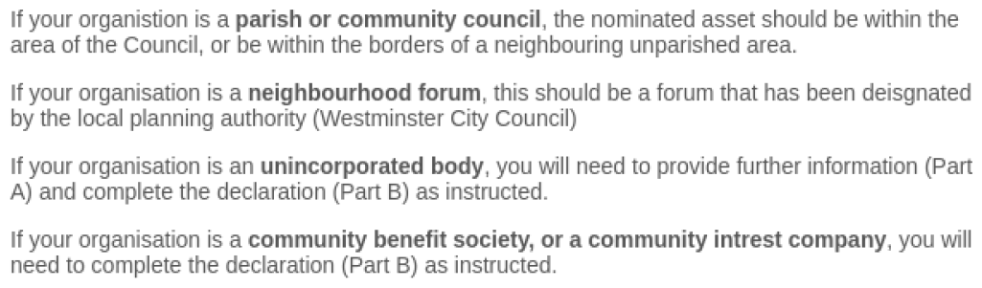

PART A
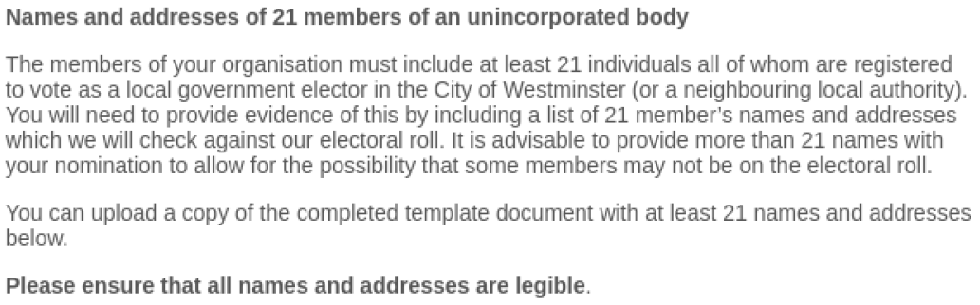
PART B Declaration
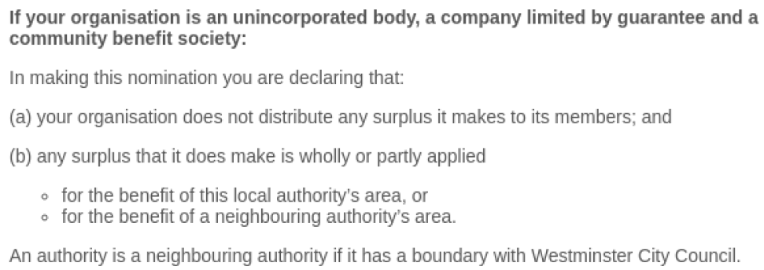
Declaration

I confirm on behalf of the unincorporated association I represent, that the organisation does not distribute any surplus it makes to its members, or any surplus it does make is wholly or partly applied for the benefit of the City of Westminster or a neighbouring local authority area.

☐ Please tick this box to sign the above declaration.

Named Contact
Name
Address
Phone Number
Email
Your relationship to the nominating organisation
The Nominated Property
Description of the property
Address
Current use of nominated property
Nominated Property Ownership
Name of owner
Name of organisation (if owner)
Address of owner
Email of owner
Phone number of owner
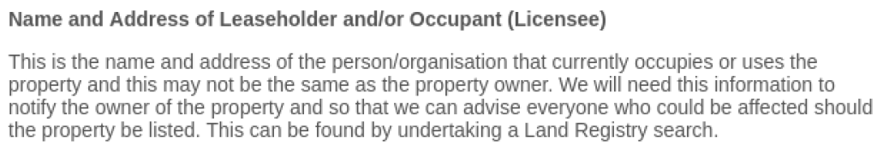
Name of leaseholder
Name of organisation (if leaseholder)
Address of leaseholder
Email of leaseholder
Phone number of leaseholder
Name of licensee
Name of organisation (if licensee)
Address of licensee
Email of licensee
Phone number of licensee
Why you have nominated the Property
Reasons for nomination
Evidence of past or existing community use and importance
Extent of use by the community
Proposed use of the asset and ongoing relevance to the local community

End of form

