A2
Westminster Schools Forum paper on Isos Partnership review of falling primary rolls

Summary
This paper sets out the findings of a review of falling pupil numbers in primary schools in Westminster, and the associated impact on primary school finances, carried out by Isos Partnership. On pages 10 to 14 several recommendations are made for Schools Forum to consider. The paper also sets out a brief proposal for further work that would be needed in the autumn term to make progress on the recommendations, if these are agreed by Schools Forum.

Scope of work
In June 2020, Isos Partnership was commissioned by the Schools Forum to undertake a short review of the falling number of children in Westminster’s primary schools and the related pressure this is placing on primary school finances. The specific focus of the review was to:
- Support the local authority and schools in developing a forward plan for addressing the shortfall in primary-aged children.
- Strengthen systems around monitoring and reporting on primary school finances.
- Establish a shared understanding of the current context and future projections for primary rolls.
- Capture good practice in how schools have addressed existing financial and capacity challenges.
- Shed light on successful approaches that have been used elsewhere.
- Recommend a process and governance options for taking forward decision-making in relation to primary capacity / financial monitoring.
Explicit consideration of the impact on school finances arising from pressures in both Early Years and SEND did not form part of the scope of this work, although clearly these issues are also contributing to financial instability at school level.
In carrying out the review we held individual interviews with headteachers, and in some cases also chairs of governors, in 15 primary schools; analysed the relevant data and documentation; engaged elected members and key local authority officers; and invited all primary headteachers and chairs of governors to two online workshops. This report brings together the findings of this process.

Current situation in terms of vacancies at borough level

Overall vacancy numbers
As the chart below shows, the last three years have seen a reduction in 7% of the numbers of pupils on roll in Westminster primary schools. The local authority and schools have acted together to take around six forms of entry out of primary schools – equating to 1,190 places – in response to falling pupil numbers. However, there remain 1,877 surplus places as of January 2020 – a vacancy rate of 16.7% across the whole borough. The Department for Education recommends that to enable a degree of parental choice and to have some flexibility in the system, surplus places should ideally be in the range of 5% to 10%. The vacancies are not evenly distributed across the primary age-range – currently vacancies in Reception are almost three times the level of those in Year 6.

Why are Westminster primary schools experiencing vacancies?
The experience of reducing numbers of primary-aged children is not unique to Westminster. It is being seen, to a greater or lesser extent, across Inner London boroughs. There are several factors which appear to be contributing to the reductions in primary aged children. Perhaps the most pertinent, and the easiest to demonstrate in terms of data, is the falling birth rate. The chart below shows that live births in Westminster fell from 2,700 in 2015 to 2,400 in 2018. The September 2020 cohort of children entering Primary school was born in 2016, so the full extent of a falling birth rate has not yet fully worked through the system. This suggests that primary schools should prepare for further pupil reductions.
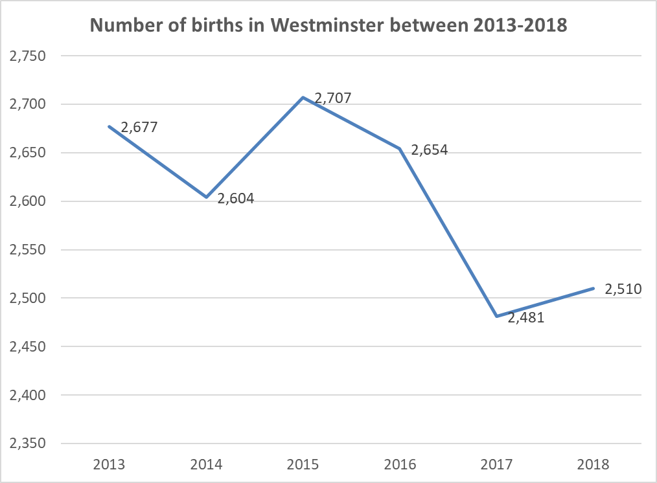
However, a falling birth rate is not the only factor contributing to the drop in pupil numbers. There is also evidence from schools, and others who engaged in the review, that:
- Reducing levels of inward migration, either as a result of Brexit or other economic or social forces, is leading to fewer families moving to London.
- Benefit caps and pressure on social housing has led to families being rehoused in other areas outside Westminster.
- The affordability and scarcity of family housing means that increasing numbers of families choose to move out of central London as their children get older.
- Competition from the independent sector means that more families are opting to educate their children outside the state sector.
- Increasing levels of vacancies in primary schools in other Inner London boroughs supports increased movement of primary-aged pupils across LA boundaries.
These compounding factors explain why, in addition to higher vacancy rates in the Reception, Year 1 and Year 2, schools are also experiencing increasing levels of pupil mobility leading to vacancies in older age ranges. Data shows that between 2018/19 and 2019/20 there were 635 pupil exits from schools across Westminster, compared with 227 between 2017/18 and 2018/19. The charts below reinforce this point. They show that the numbers of children (both primary and secondary phase) educated in independent schools in Westminster has grown by around 1,000 pupils since 2016/17. At the same time, while Westminster remains a significant net importer of pupils, there are 200 fewer pupils from other boroughs in Westminster schools than there were three years ago.
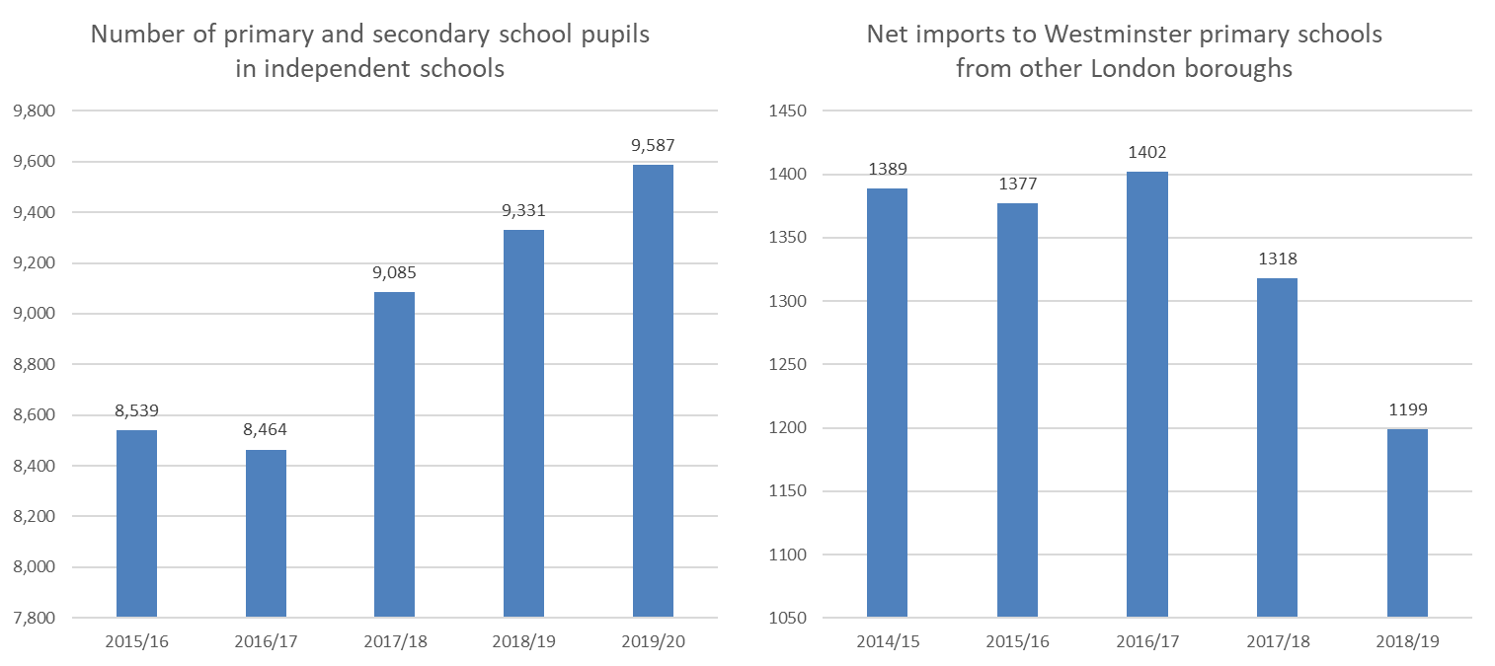

Future projections
Projecting the number of primary places needed in the future is extremely complex. Like any projections, estimates of pupil numbers tend to become less reliable the further forward one looks. The factors which are taken account in pupil projections include some known variables, such as the birth rate, and a range of unknown variables such as future levels of migration (both inwards and outwards), pupil yield from planned housing developments, parental decisions about whether to educate their children in the state sector or the independent sector, and movement of pupils between boroughs.

Pupil Projection methodologies
For the purposes of this review we considered three different projection methodologies. The first was the GLA projections which take into account birth rates, migration flows and pupil yields from planned developments. GLA projections have been subject of some controversy of late as the 2016 projections failed to account for reduced inward migration into London and consequently over-estimated the number of primary places local authorities would need. This led to some local areas responding too late to reductions in pupil numbers that were not foreseen. However, the GLA adjusted its forecasting methodology in 2018 and current projections appear to be more in line with actual numbers of pupils coming through the system. Despite recent difficulties, the GLA projections remain the most reliable and comprehensive estimates of pupil numbers.
In addition to the GLA estimates we also considered two other methodologies for pupil projections developed by Westminster City Council. Referred to as the “School Roll Model” and the “Reception Roll Model”, a short definition of each is captured below:
- School Roll Model is based on two main assumptions: that WCC’s primary school (aged 4-11) pupil roll size will remain constant as a percentage of the borough’s total projected population aged 4-11 (ONS mid-year population data), and that each school’s Reception to Year 6 pupil roll size will remain constant as a percentage of WCC’s projected primary pupil roll, as calculated in the first assumption.
- Reception Roll Model is based on three main assumptions: that WCC’s Reception (aged 4) pupil roll size will remain constant as a percentage of the borough’s total projected population aged 4 (ONS mid-year population data), and that a school’s Reception pupil roll size will remain constant as a percentage of WCC’s projected Reception pupil roll, as calculated in the first assumption. There is the expectation that there will be net zero change in each year cohort throughout the projection period.
Plotting each of these projections at borough level for the next five years, it is striking that they follow a very similar trajectory, of a fall of around 200 further pupils followed by a period of stability. Based on the information available at this point, it would therefore be prudent to plan on the basis of a primary pupil roll of around 9,000 by 2024.

Impact of Covid 19 pandemic on pupil numbers
There is an even greater degree of uncertainty at present around future pupil numbers due to the unknown impact of the Covid 19 Pandemic. It is likely that the full ramifications will not be known for a few years. This makes it all the more important to build flexibility into any future decisions. At present schools are anticipating that Covid may have a significant impact on two variables. The first is the decisions taken by families on where to live. Some believe that fear of overcrowding in cities, and greater latitude in working from home, will encourage more families to move out of London. Others hope that ongoing difficulties around transport and commuting might, conversely, encourage more families to move closer to work (and into London). The second variable is the choices made by families over independent versus state-sector education. On the one hand job insecurity may lead more families to opt for state sector education. On the other hand, the ISC has reported that requests for independent education rose significantly in response to the more comprehensive offer of online learning delivered by independent schools during school closures. It is, as yet, too early to say definitively how these different factors may impact on pupil numbers going forward.
Our earliest indicator on the potential pupil effects is the numbers coming in to primary schools this September. Very early data shows that…

Projections for individual schools
If pupil projections at borough level are complex, pupil projections for individual schools are fraught with difficulty. It was very evident from our interview and workshops with schools, and from analysis of the data, that the conditions that govern whether an individual school is empty or full are extremely difficult to model. School vacancies will of course be determined by the number of children of primary school age living in the immediate area, and by the concentration of other primary schools within walking distance. However, the popularity of the individual school, the ease of access and the demographic make-up of the intake will also play a significant part. For example, a school serving a relatively affluent population may lose more pupils to transfers to the independent sector or international families relocating with work. Schools serving more deprived communities may lose more pupils as a result of changes to benefits and rehousing outside London where social housing is not locally available.
It is also apparent that as overall pupil numbers fall, greater flexibility in the system allows for more parental choice which means that the difference between more or less popular schools in an area becomes amplified. Furthermore, oversubscribed schools are able to draw on their waiting lists if vacancies occur. This, in effect, means that the vacancies are passed on to other schools that are not oversubscribed. In terms of projecting future pupil numbers, existing models tend to assume for both transparency and simplicity, that reductions in pupil numbers going forward will be experienced equally by schools, in proportion to their current share of the overall number of pupils. However, this does not take into effect the significant impact of parental choice and the additional cushion for schools that have a long waiting list. Looking forward, to enable schools to plan better, some of these considerations may need to be taken into account in developing school-level pupil projections.

Implications at planning area and school level
Although the borough average level of vacancies currently stands at 16.7% this differs markedly between planning areas and between schools.

Variation in vacancy levels by planning area
The six charts below show the current levels of vacancies, and future projected pupil numbers in each of Westminster’s planning areas. As can be seen, vacancies range from a low of 9% in Marylebone to a high of 21% in Bayswater and the South. The charts also show the significant reductions in Pupil Admission Numbers that have already been made, particularly in Maida Vale and Marylebone, that have helped to ameliorate the overall position. The table below summarises the position for each planning area and recommends how plans to remove additional primary capacity in the short term might be targeted geographically.
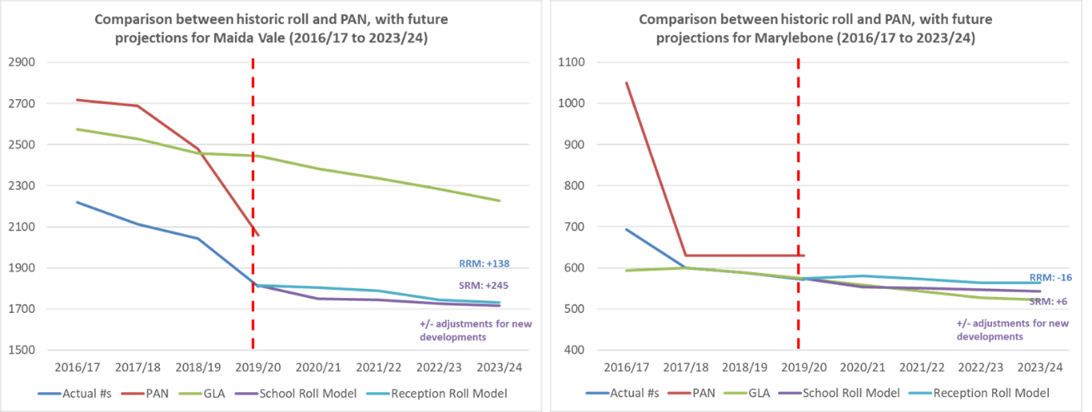
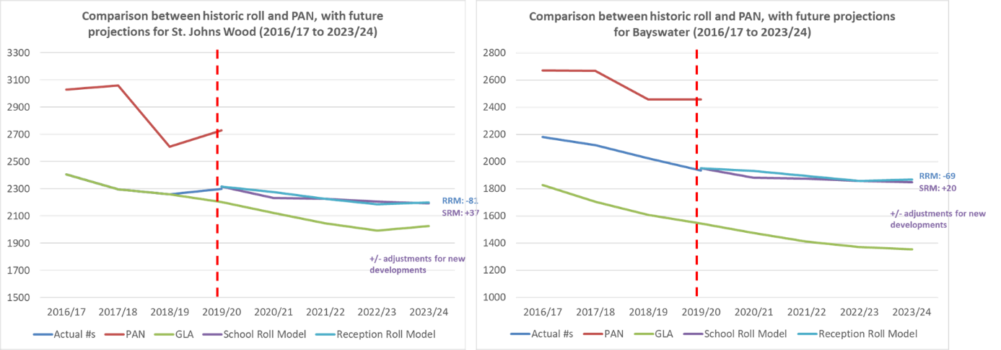
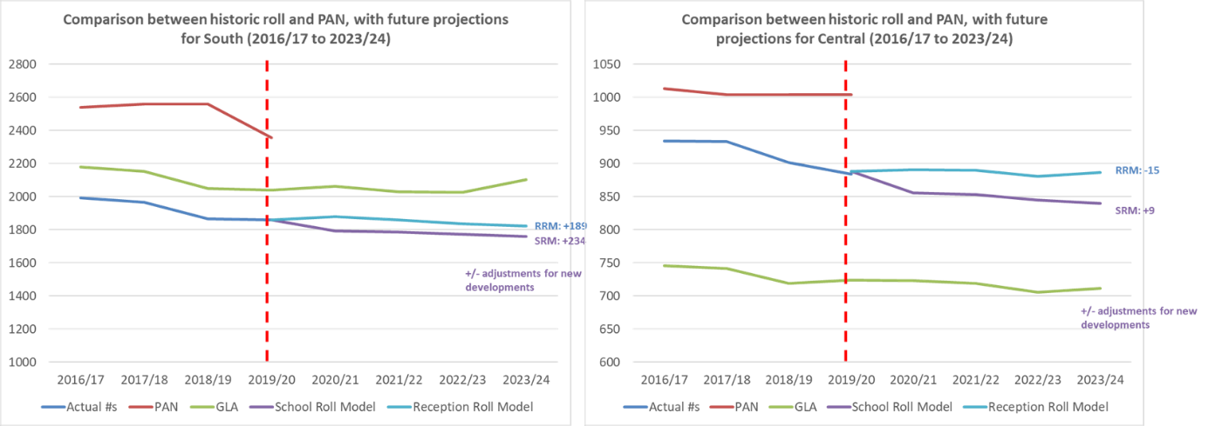
Planning area | Surplus places | Percentage surplus | Population trend | Planned development | Recent changes | Possible action
Maida Vale | 249 | 12% | Down | Yes | Reduced by c. 600 places | Consolidate recent reductions
Marylebone | 58 | 9% | Flat | No | Reduced by c. 400 places | Keep under review
St John’s Wood | 431 | 16% | Down | Yes | Reduced by c.300 places | Reduce by 1FE
Bayswater | 523 | 21% | Down | No | Reduced by c. 200 places | Reduce by 1 to 2 FE
South | 496 | 21% | Flat | Yes | Reduced by c. 200 places | Reduce by 1 FE
Central | 120 | 12% | Flat | No | None | Keep under review

Variation between individual schools
At individual school level the variation in vacancies is unsurprisingly even more marked than at planning area level. The chart below shows vacancies by school based on a September 2020 pupil count and the most recent Pupils Admissions Numbers which take into account permanent and temporary capping. It shows that vacancy levels currently range from x to y.
It is interesting that there appears to be a correlation between higher levels of Free School Meals and higher levels of vacancies. There are several hypotheses why this might be the case:
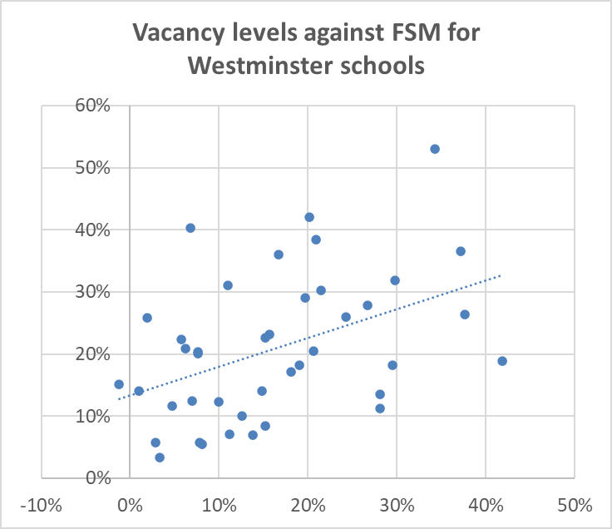
- More vacancies lead to increased opportunity for parents to act on preferences between schools. Some families may elect to send their children to schools where they perceive there to be a more varied demographic mix.
- Schools with a high proportion of children eligible for FSM are likely to have more families affected by benefits changes and/ or pressure on social housing.
- Birth rates may be changing more quickly / falling faster in lower income households.

The map below shows all schools and their level of vacancy. It is also apparent from the geographical distribution that localities with very high concentrations of primary schools within a comfortable walking distance tend to have one or more schools with high vacancy levels. It also highlights the potential vulnerability of schools very close to a local authority border.
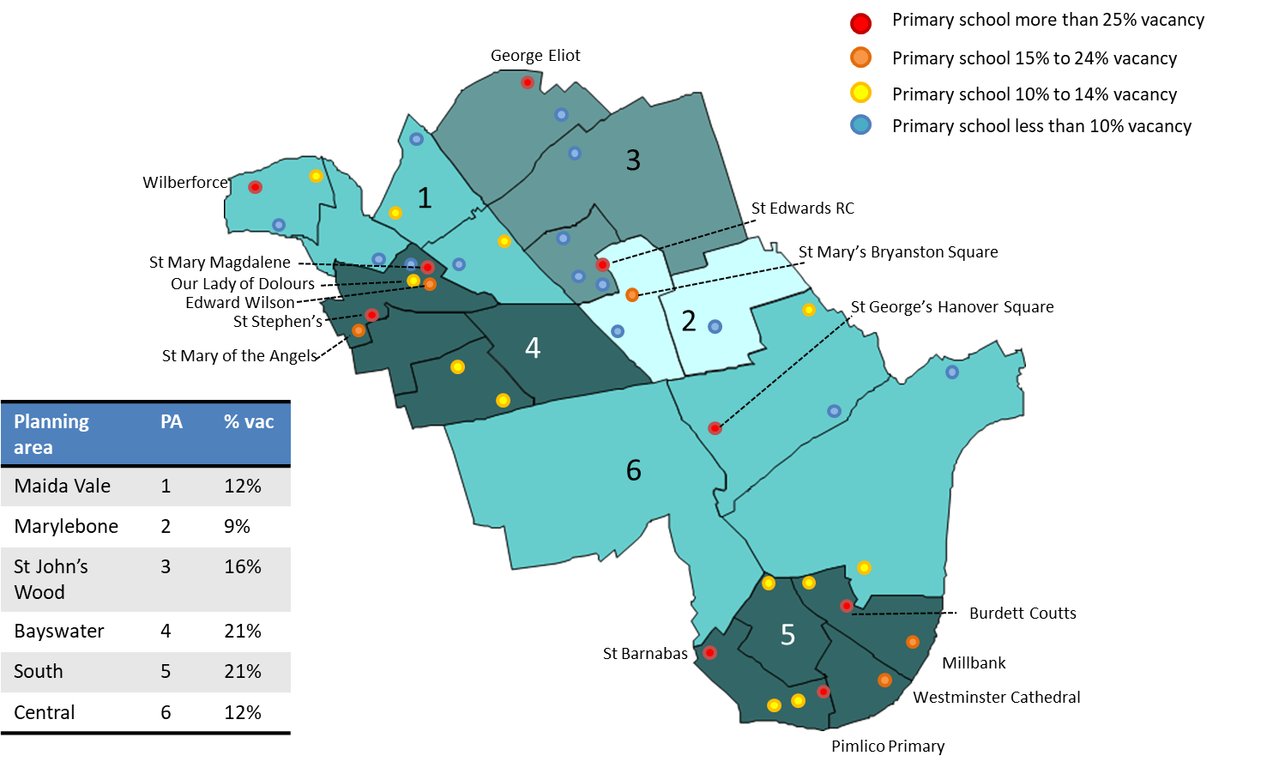

Financial implications of low pupil numbers

Overall finance situation
In Westminster, the overall financial situation for primary schools is extremely challenging. Over 70% of schools had an in-year deficit in 2018-19 and by March 2020 over a third of maintained primary schools were reporting an overall deficit. 12 primary schools have been in deficit for more than one financial year.
Our discussions with schools suggest that while many headteachers and governing bodies are taking direct and personal leadership of financial management during this difficult period, that is not uniformly the case. There is a risk that, in some schools, management of the budget is delegated to the bursar or school business manager without strong strategic leadership for, and scrutiny of, financial decision-making which is critical during a period in which budgets are under pressure. While guidance by the local authority on deficit budgets, falling rolls funds, SEND funding and other finance issues were generally clear they were not sufficiently understood by all schools. This may highlight a need for specific training or additional communication.

Relationship between pupil numbers and finance
Clearly there is a strong relationship between low pupil numbers and financial insecurity at school level. Of the 26 primary schools in Westminster which had vacancies of more than 10%, 20 also reported an in-year overspend in 2018/19. Estimating the financial impact of losing a pupil is challenging due to the range of different funding streams which can attach to individual pupils. However, in Westminster the range is between £3,616 accounting just for AWPU through to £5,918 taking into account pupil premium. Not all the headteachers and governors to whom we spoke were working through the potential budget implications for their school of falling rolls over the next three years.

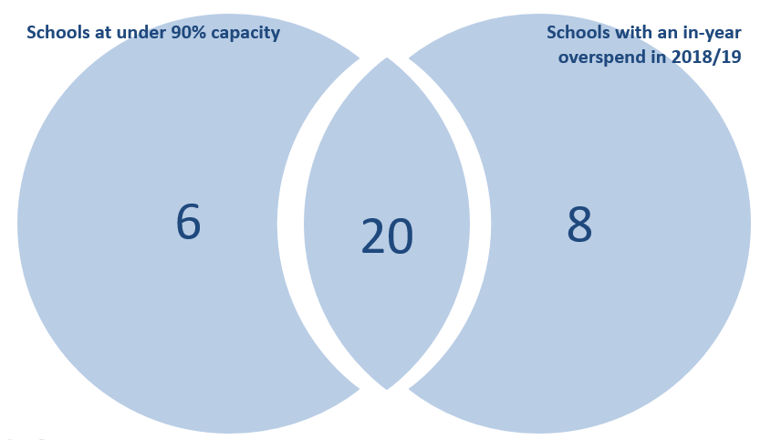

Other contributing factors
Not all schools with low pupil numbers are struggling financially, and not all schools struggling financially have low pupil numbers so there are clearly other contributing factors at play. Westminster is unusual for the high percentage of 1 form entry primary schools. In the current financial climate headteacher and governors have said to us that 1 form entry primaries are sustainable if they are staffed economically, they are full, and they are not trying to address expensive premises issues. If these conditions are not in place it can be very difficult to run a one form entry school within the allocated budget. This is chiefly because non-discretionary elements, such as leadership, core staffing and premises, tend to make up a higher proportion of the overall budget leaving less flexibility for reducing costs overall.
A second factor contributing to financial instability is the dependence of some schools on additional income and fundraising. Analysis of DfE benchmarking information shows that on average Westminster schools receive around £160 per pupil in donations income, but in some schools that is considerably higher. One school, for example, received over £1,000 per pupil in donations income in 2018/19. Many schools are anticipating that these additional sources of income, from fundraising events to business donations, may be severely curtailed in coming months in response to the Covid 19 pandemic. This will be a real challenge where the additional income streams are being used to pay for core expenditure – for example staff salaries – rather than non-essential items that can be turned off and on more flexibly.
The third issue which was of concern to many schools was the financial implications of supporting children with SEND, in particular those with EHCPs. Their specific anxieties, which are not unique to schools in Westminster, were that:
- They were struggling to find the first £6,000 in support costs for each child with an EHCP from their base budgets after EHCPs reached a certain threshold.
- The money spent in supporting a child with significant SEND between the child arriving at the school and having an EHCP in place was often substantial and could not be recouped.
- The rate for top-up funding does not cover the actual support costs experienced by schools.
Addressing these issues are beyond the scope of this piece of work but are noted here as schools felt that it was one of the key factors contributing to the financial pressure they were experiencing. It is worth remarking that, on the face of it, there does not appear to be a strong relationship between numbers of children with EHCPs and in-year deficit levels. However, the relationship may be masked by the presence of additional resourced provision in some schools.

How schools and the local authority are responding to these pressures
The local authority, schools and partners such as the Dioceses have already taken action to address the combined issues of falling rolls and financial pressure. Since September 2018, 6 forms of entry have been permanently removed from the primary estate through the closure of Minerva Academy and Paddington Green, and through the permanent reduction to 1 form of entry at Burdett Coutts, 2 forms of entry at Hallfield and 1 form of entry at Wilberforce. Temporary caps also occurred at St Edward’s from two to one form entry in Reception, Year 1 and Year 2, and Pimlico Primary Academy in Year 5. This has helped to alleviate what would otherwise have been extremely high vacancy levels.
At the same time, schools have been working to address the financial pressures. 20 schools have been successful in eliminating or significantly reducing their overall deficit in the last three years through tight financial management and restructuring their staff complement. Many schools report working more closely together to share staff and other costs such as caretaker services or school business managers. There are now ten primary schools which share an executive headteacher, which can lead to savings of around £40,000 across two one-form entry primary schools. Three schools have taken a further step towards integration and collaboration and have formed federations in which the governance and leadership of the two or more schools is combined.

Recommendations for the future
To ensure the continued high quality, resilience, and sustainability of primary education in Westminster going forward will require a strategic and collaboration approach to planning and financial management over the next period. Set out below are recommendations for Schools Forum to consider in how this might be achieved.

Principles
It is important to have an agreed set of principles that can underpin the work in future. Although these may seem self-evident our work on similar issues in other London Boroughs suggests that an agreed set of principles, to which everyone is signed up, can provide a useful reference point when difficult decisions have, inevitably, to be made. The draft principles that we have generated, based on our initial discussions with schools and LA colleagues are:
- Focus on the quality of the educational offer.
- Ensure that we have sustainable and resilient schools.
- Build flexibility into the future offer to manage unforeseen changes.
- Retain skilled staff and leaders.
- Ensure a balance of provision across the borough that matches local need and strengthens local communities.
- Ensure that there continues to be a good balance of secular and faith education that supports families’ preferences.
- Continue to prioritise inclusion in our primary offer.
- Ensure that a high-quality state education is the first choice for as many families as possible.
- Use the opportunity to improve and maximise the potential of sites and premises.
- Maximise opportunities for children, families and professionals by working across institutions.
- Maintain a strong ethos of collaboration and partnership working across the borough.

It is recommended that, subject to any further refinement, these principles are formally adopted by the Schools Forum as a foundation for the work going forwards.

Governance
It will also be important to put in place a robust governance structure to oversee decision-making in the next phase of work. There is already discussion underway within the local authority and with partners to establish as Education Partnership Board. It is therefore proposed that this should be one of the workstreams that ultimately reports to the board. However, this work will also require more hands-on and regular oversight. To achieve this, Schools Forum may wish to consider setting up a formal working group or other governance structure which would have the capacity to meet regularly, oversee progress and report to Schools Forum and the Education Partnership Board. In conversations with schools it was clear that the governance structure set up to oversee this work will be most effective if it is seen to be fully representative of all types of school in borough and is committed to establishing clear and regular communications with all schools on progress and decisions. Schools are anxious, for example, about feeling excluded from decisions that may have a significant impact on their future viability.

Three areas of action
With a strong governance structure and agreed set of principles in place, we are then recommending a focus on three key areas of action – maximising pupil numbers, tighter financial planning and reducing surplus capacity.

Maximising pupil numbers
Although an individual school may be successful in increasing its own pupil numbers, there are only three sources of additional pupils for the borough as a whole: the first is children in independent schools; the second is children in primary schools in other London Boroughs; the third is children of parents who work in Westminster but do not live in Westminster. All three of these can be a source of additional pupils, and the local authority, schools and other partners should do all they can to maximise pupil numbers through these routes. However, this work should be undertaken with clear and sensible expectations in mind. A focus on these areas may yield some additional pupils and may ameliorate the situation for a minority of schools. But, on their own, efforts to attract additional pupils, however carefully crafted and executed, are unlikely to solve the problem.
Actions to attract more families to opt for state-sector rather than private-sector education might entail:
- Undertaking market research with families in PVI nurseries to understand the factors that might influence their decision about state or independent primary school.
- Identifying schools where a lot of families leave for independent school at Y3 or Y5 and talking to them about what might encourage them to stay.
- Actively promoting schools in areas where there is a high concentration of independent school take up and consider how the core offer might be made more attractive to these families.
- Holding ‘Meet the parents’ style workshops in specific communities.
In order to reduce cross border exits and encourage more Westminster parents to choose Westminster schools, further analysis will be needed on travel to school patterns to understand which communities / localities are most likely to travel and then focus on strongly promoting schools near the border to those families.
Efforts to attract the children of parents who work rather than live in the area may be more effective when the impact of the current pandemic on patterns of travelling to work become clearer. However, it may be worth targeting promotion at large employers (including public sector employers) combined with smart wrap-around childcare options.

Tighter financial planning
For primary schools managing the next five years with increasingly tight budgets and falling pupil rolls will require headteachers and chairs of governors to take increasingly difficult strategic decisions underpinned by a clear understanding of their financial position. In order to enable this to happen routinely, in every school, we are making some recommendations for how financial planning and oversight might be strengthened in the borough. Many of these recommendations build on the work that the Schools Forum has been leading over recent years:
- Headteachers, chairs of governors and chairs of finance committees taking strong personal ownership of financial planning where that is not already happening.
- Offer of individual strategic finance support and planning to schools to offer ongoing dialogue on reshaping provision to meet budgetary challenges.
- Bespoke training for headteachers, bursars and governors on managing budgets during periods of financial uncertainty and understanding income and CFR finance modelling.
- Developing a pupil projection model to support income planning for use by all schools.
- Developing a range of worked-through models of cost saving, from executive headships to sharing staff and resources, including the use of zero-based budgeting.
- Communication of and training in the tighter controls around use of Falling Rolls funding that have been agreed, for school bursars and headteachers.
- Headteachers, Schools Forum and the Local Authority agree tighter controls around authorisation of deficit budgets, to align with DfE recommendations.
- Schools to consider impact of reduced additional income as a result of the Covid pandemic and clarify how they can maintain core provision from main income.
- Continue strategic discussions together around implications of reducing the Minimum Funding Guarantee and falling pupil premium funding.

Reducing surplus capacity
Finally, strategic action needs to be taken to continue to reduce surplus capacity. Without doing so some primary schools will enter a period of slow but irreversible decline which is not good for the children educated there, or indeed the staff who work there. The full gamut of approaches to reducing places should be in consideration from capping, to amalgamations, all-through schools and school closures.
We are suggesting, based on our analysis, conversations with schools and discussions with Local Authority officers, that taking out 4 to 5 forms of entry relatively quickly would serve to bring some stability to the system and allow a longer-term consideration of the shape of primary education in the borough over the next decade. We are therefore recommending
- The development of a risk indicator set
This would be a basket of indicators which, in combination, would highlight which schools are most at risk and allow mitigation strategies to be put in place and inform strategic decisions about reducing surplus capacity. The risk indicator should be objective, transparent and agreed with schools. An initial proposition for the indicators that might be included is set out below. However, more thought needs to be given to these both individually and in terms of how they interact. For example, a school may not be ‘high-risk’ if it hits just one of the risk indicators, but it may be if it hits three or more or if it exhibits both rolls risk and financial risk simultaneously. Further thought also needs to be given to the rapidity with which schools can change and therefore the time period over which the risk indicator set might be applied.
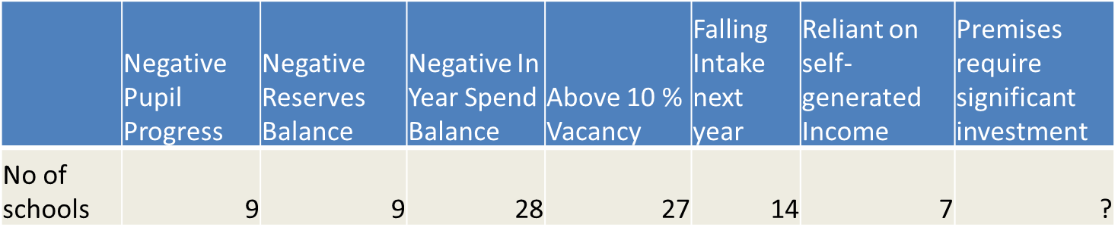
- Short term action to stabilise the system
We are recommending that the Local authority, working with the Dioceses, develop proposals to take out around 4 or 5 forms of entry over 1 to 2 years to bring some rapid stability to the primary system. These proposals to be discussed, refined and agreed with schools as partners in the process. Any final decisions on school reorganisation will of course rest with school governing bodies and be subject to the normal consultation processes. Significant changes for September 2021 (such as closures or amalgamations) would require consultation to start by the end of September 2020.
- Medium term action to re-imagine the shape of primary provision for the next decade
We are recommending that primary schools, secondary schools and nurseries might come together in local clusters for facilitated discussions about how primary provision might evolve over the medium to long term. This would be an opportunity to think imaginatively about new forms of delivery and different patterns of provision, including integrating with other schools and settings. It is likely that these conversations will be more productive if they are facilitated and based on a strong initial evidence base relevant to the locality.

Planned next phase of work
If Schools Forum agrees with the analysis and recommendations set out in this paper, then the following actions could begin from September:

Overarching
- Putting in place the overarching governance arrangements
- Refining and agreeing the principles

Maximising pupil numbers
- Undertaking market research to understand why families are choosing independent schools
- Additional analysis of areas where independent school take up is highest
- Journey to school analysis to understand which schools may be losing children to other boroughs
- Developing promotional materials for individual schools or Westminster primary schools more broadly
- Initial conversations with large employers about marketing Westminster schools to their staff

Strategic support for financial management
- Developing the offer of strategic financial and planning support to schools.
- Developing a further training offer for heads and governors on specific finance issues, including deficit budgets and use of falling rolls fund.
- Developing a ‘ready-reckoner’ tool to support schools’ income and financial planning
- Developing worked-through examples of cost-saving opportunities.

Reducing surplus capacity
- Developing and agreeing the risk indicator set with schools, and then applying it.
- Carrying out more detailed analysis of individual schools and local clusters.
- Developing proposals for how to remove around 4 or 5 forms of entry in ways that will support the long-term vision for the borough.
- Facilitating dialogue in local clusters about the future primary offer, informed by more granular analysis at catchment area level.
- Making the link with housing and development.
- Considering the implications for early years, in partnership with primary.

