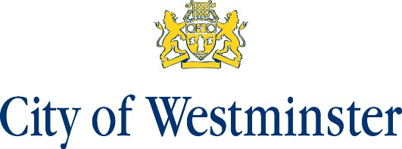

Notice of Business Referendum
Neighbourhood Plan Referendum for the Soho Neighbourhood Area

- A business referendum will be held on 2 September 2021 to decide on the question below:

“Do you want Westminster City Council to use the Neighbourhood Plan for Soho to help it decide planning applications in the neighbourhood area?”

- Applications for named voters to be included on the business voting register for this referendum must be received by the Business Registration Officer at Civica Election Services, 33 Clarendon Road N8 0NW by no later than midnight on Monday 16 August.

- Applications, amendments or cancellations of postal votes must reach the Business Registration Officer at Civica Election Services, 33 Clarendon Road N8 0NW by no later than 5pm on Tuesday 17 August 2021.

- Applications for proxy votes must reach the Business Registration Officer at Civica Election Services, 33 Clarendon Road N8 0NW by no later than 5pm on Tuesday 24 August 2021.

- Applications for an emergency change of named voter at this referendum on the grounds of physical incapacity or work reasons must reach the Business Registration Officer by 5pm on Thursday 2 September 2021

Stuart Love Dated: Friday 23 July 2021
Counting Officer
Westminster City Council
64 Victoria Street
London
SW1E 6QP

