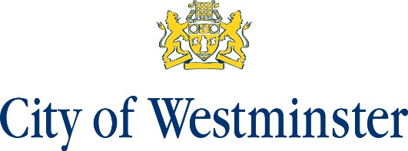

Soho Neighbourhood Plan Information Statement
Two Referendums, one Residential Referendum and one Business Referendum, relating to the Soho Neighbourhood Plan will be held on 2 September 2021.
The question that will be asked in the Referendums is ‘Do you want Westminster City Council to use the Neighbourhood Plan for Soho to help it decide planning applications in the neighbourhood area?’
The referendum area is identified on the map, which is included in this information statement. The Referendum area is identical to the area that has been designated as the Soho Neighbourhood Plan Area.

Map attached

A person is entitled to vote in the Referendum if:
He or she is entitled to vote in an election of any Councillor of Westminster City Council whose area is in the Referendum area; and
His or her qualifying address for the election is in the Referendum area. A person’s qualifying address is, in relation to a person registered in the register of electors, the address in respect of which he or she is entitled to be so registered.
A business is entitled to vote in the Business Referendum if:
The business is a non-domestic ratepayer in the Referendum area; and
The business has registered a named voter as their business voter on the business voting register
The referendum expenses limit that will apply in relation to the Referendum is
£ 2,362 + (number of electors on residential register at the start of the referendum period x 0.059) + (number of businesses on the business register x 0.059)

The referendum will be conducted in accordance with procedures that are similar to those used at local government elections.
A copy of the specified documents, which are specified below, may be inspected during normal opening hours at:
- Electoral Services, City Hall, 14TH Floor, 64 Victoria Street, London, SW1E 6QP
The documents are also available for public viewing on the Council’s website at: www.westminster.gov.uk
The specified documents are:
- The Soho Neighbourhood Plan (referendum version);
- The report of the independent examiner into the draft Soho Neighbourhood Plan;
- The representations submitted to the independent examiner
- A decision of the Statement of the Local Planning Authority’s satisfaction that the draft Neighbourhood Plan meets the basic conditions specified by statute and complies with the provision made by or under Section 38A and 38B of the Planning and Compulsory Purchase Act 2004;
- A statement that sets out general information as to town and country planning including neighbourhood planning and the referendum
- Map of the Soho Neighbourhood Plan area.

Stuart Love Dated: 1 July 2021
Counting Officer
Westminster City Council
64 Victoria Street
London
SW1E 6QP

