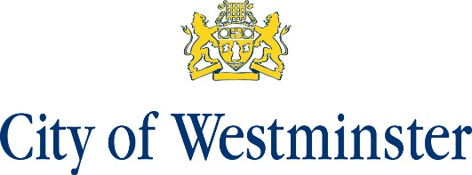

Queen’s Park Neighbourhood Plan Information Statement
A Residential Referendum relating to the Queen’s Park Neighbourhood Plan will be held on 21 October 2021.
The question that will be asked in the Referendums is ‘Do you want Westminster City Council to use the Neighbourhood Plan for Queen’s Park to help it decide planning applications in the neighbourhood area?’
The referendum area is identified on the map, which is included in this information statement. The Referendum area is identical to the area that has been designated as the Queen’s Park Neighbourhood Plan Area.
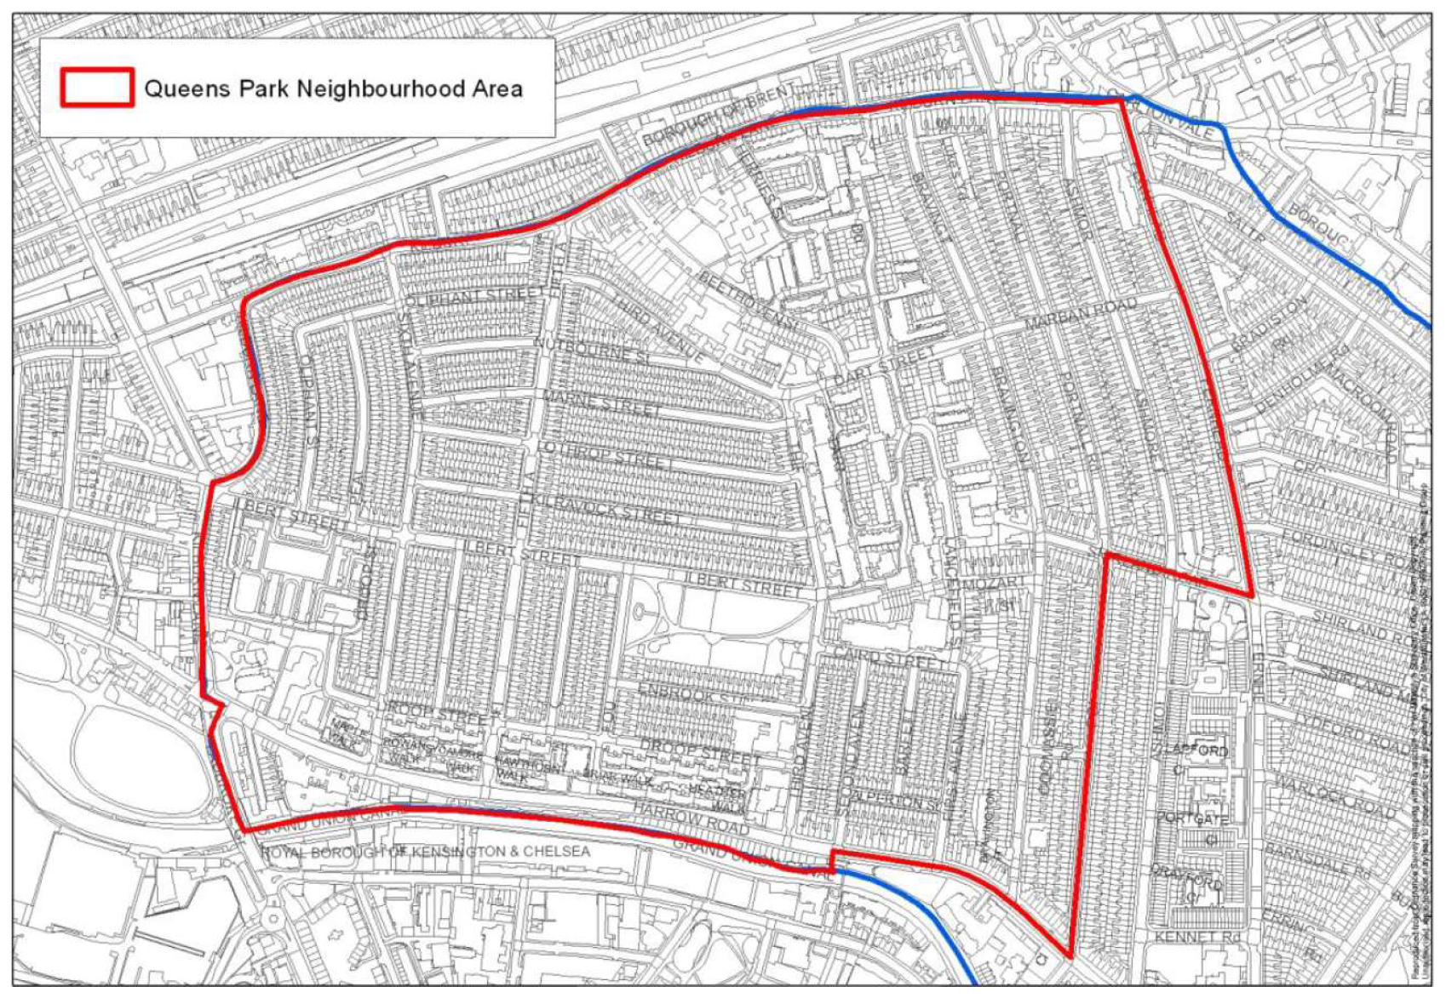
A person is entitled to vote in the Referendum if:
He or she is entitled to vote in an election of any Councillor of Westminster City Council whose area is in the Referendum area; and
His or her qualifying address for the election is in the Referendum area. A person’s qualifying address is, in relation to a person registered in the register of electors, the address in respect of which he or she is entitled to be so registered.
The referendum expenses limit that will apply in relation to the Referendum is
£ 2,362 + (number of electors on residential register at the start of the referendum period x 0.059)

The referendum will be conducted in accordance with procedures that are similar to those used at local government elections.
A copy of the specified documents, which are specified below, may be inspected during normal opening hours at:
- Electoral Services, City Hall, 14TH Floor, 64 Victoria Street, London, SW1E 6QP
The documents are also available for public viewing on the Council’s website at: www.westminster.gov.uk
The specified documents are:
- The Queen’s Park Neighbourhood Plan (referendum version);
- The report of the independent examiner into the draft Queen’s Park Neighbourhood Plan;
- The representations submitted to the independent examiner;
- A decision of the Statement of the Local Planning Authority’s satisfaction that the draft Neighbourhood Plan meets the basic conditions specified by statute and complies with the provision made by or under Section 38A and 38B of the Planning and Compulsory Purchase Act 2004;
- A statement that sets out general information as to town and country planning including neighbourhood planning and the referendum
- Map of the Queen’s Park Neighbourhood Plan area.

Stuart Love Dated: 7 September 2021
Counting Officer
Westminster City Council
64 Victoria Street
London
SW1E 6QP

