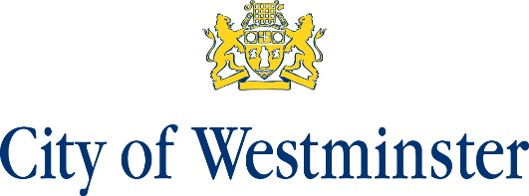

Notice of Referendum
Neighbourhood Plan Referendum for the Fitzrovia West Neighbourhood Area

- A referendum will be held on 2 September 2021 to decide on the question below:

“Do you want Westminster City Council to use the Neighbourhood Plan for Fitzrovia West to help it decide planning applications in the neighbourhood area?”

- Applications to register to vote must reach the Electoral Registration Officer at Electoral Services, 14th floor, Westminster City Hall, 64 Victoria Street, London SW1E 6QP by midnight on Monday 16 August 2021.

- Applications, amendments or cancellations of postal votes must reach the Electoral Registration Officer at Electoral Services, 14th floor, Westminster City Hall, 64 Victoria Street, London SW1E 6QP by 5pm, Tuesday 17 August 2021.

- Applications to vote by proxy at this referendum must reach the Electoral Registration Officer at Electoral Services, 14th floor, Westminster City Hall, 64 Victoria Street, London SW1E 6QP by 5pm, Tuesday 24 August 2021.

- Applications to vote by emergency proxy at this referendum on the grounds of physical incapacity or for work/service reasons must reach the Electoral Registration Officer at Electoral Services, 14th floor, Westminster City Hall, 64 Victoria Street, London SW1E 6QP by 5pm Thursday 2 September 2021. If an application is made on the basis of physical incapacity, this physical incapacity must have occurred after 5pm on Tuesday 24 August 2021. If an application is made on the basis of work/service reasons, the applicant must have become aware after 5pm on Tuesday 24 August, that he/she would be unable to vote at his/her polling station in person.

Stuart Love Dated: 28 July 2021
Counting Officer
Westminster City Council
64 Victoria Street
London
SW1E 6QP

