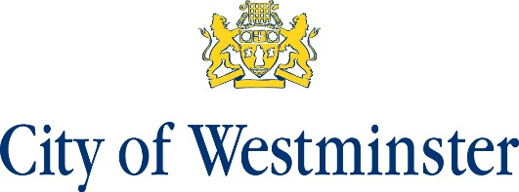

Notice of Poll and Situation of Polling Stations
Neighbourhood Plan Referendum for the Fitzrovia West Neighbourhood Area

- A referendum will be held on Thursday 2 September 2021 to decide on the question below:

“Do you want Westminster City Council to use the Neighbourhood Plan for Fitzrovia West to help it decide planning applications in the neighbourhood area?”

- The hours of poll will be from 7am to 10pm.

- Applications to vote by emergency proxy at this referendum on the grounds of physical incapacity or for work/service reasons must reach the Electoral Registration Officer at Electoral Services, 14th Floor Westminster City Hall, 64 Victoria Street, London, SW1E 6QP by 5pm on Thursday 2 September. The physical incapacity must have occurred after 5pm on Tuesday 24 August. To apply on the grounds of work/service reasons, the person must have become aware that they cannot go to the polling station in person after 5pm on Tuesday 24 August.

- The situation of the polling station and description of persons entitled to vote there are as follows:
Situation of polling stations | Description of persons entitled to vote
Fitzrovia Centre, 2 Foley St, London W1W 6DL | All local government electors registered to vote in the neighbourhood area  Business Referendum-Persons registered on the business voting register who have not applied to vote by post

Stuart Love Dated: 24 August 2021
Counting Officer
Westminster City Council
64 Victoria Street
London
SW1E 6QP

