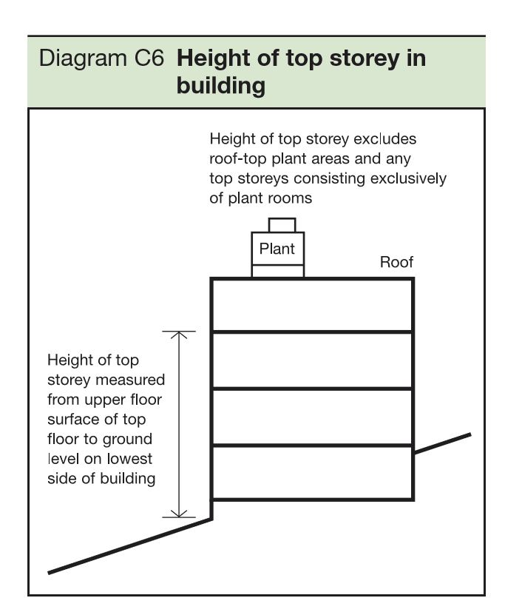

Building Regulations Approved Document B, Volume 2, Diagram C6

