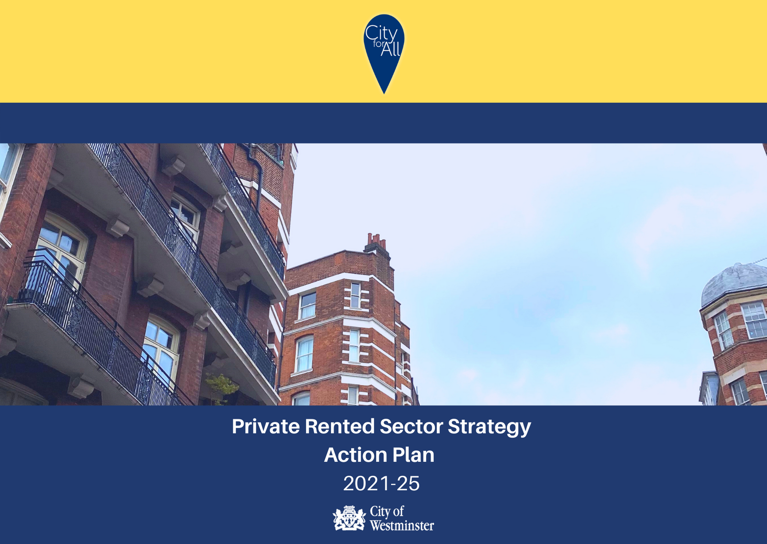
Herdman, Cecily: WCC
Bi Borough
Westminster City Council, 64 Victoria St. London.

Westminster Private Rented Sector Strategy Action Plan 2021 – 2025

Year 1: 2020/21 (January 2021 – March 2021) , Year 2: 2021/22 (April 2021 – March 2022) , Year 3: 2022/23 (April 2022 – March 2023),
Year 4: 2023/24 (April 2023 – March 2024), Year 5: 2024/25 (April 2024 – March 2025)
Aim  No | Aim | Further detail | Year | By | Owner | Others involved | Resources
Aim one: Improve conditions in the private rented sector and ensure lawful practices
1A. | Introduce discretionary licensing across Westminster for all houses in multiple occupation (HMOs), subject to having considered the results of the formal consultation | Consider results of the consultation  Introduce scheme (subject to having considered results of the consultation) | Year 1  Year 1 | Spring 2021  Autumn 2021 | WCC: Public Protection and Licensing Team  WCC: Public Protection and Licensing Team | WCC: Strategy & Intelligence Team  HMO landlords | Existing
1B. | Keep the case for other types of discretionary licensing under review | Initial review through Private Rented Sector Strategy Group and then as needed  Commission additional research if necessary | Year 3 & Ongoing | Winter 2023 | Private Rented Sector Strategy Group/WCC: Public Protection and Licensing Team | WCC: Policy Team/Strategy & Intelligence Team | Existing (for initial review)
1C. | Raise awareness of our services which tackle poor quality properties and unlawful practices and continue to address issues through negotiation and enforcement | Disseminate key messages at launch  Investigate communicating through community champions  Consider results of Camden project  Develop charter highlighting services, which organisations sign up to | Year 1  Year 1  Year 2  Year 3 | Winter 2021  Spring 2021  Summer 2021  Winter 2023 | WCC: Communications and Media teams  WCC: Policy Team  WCC: Policy Team  Private Rented Sector Strategy Group | WCC: Public Health/WCC: Public Protection and Licensing Team  WCC: Public Protection and Licensing Team  WCC: Public Protection and Licensing Team/ WCC: Policy Team | Existing  Existing. Resources may be required for expanding the champions role
1D. | Review our enforcement policies for the private rented sector | Update policies as needed | Year 2 | Summer  2021 | WCC: Policy Team | WCC: Public Protection and Licensing Team/Legal Services | Existing
1E. | Do more to publicise successful legal action against landlords and agents | Publicise when there are opportunities i.e. through newsletters, press releases and social media | Ongoing | Ongoing | WCC: Communications and media teams |  | Existing
1F. | Work with the sector to increase the number of landlords and lettings agents that are accredited with the London Landlords Accreditation Scheme (LLAS) | Promote to council leaseholders renting out their properties  Publicise as part of licensing. Offer discount to HMO landlords  Host courses about LLAS | Year 2  Year 2  Year 3 & Ongoing | Spring 2021  Autumn 2021  Winter 2022 | WCC: Housing Team/Communications Team  WCC: Public Protection and Licensing Team/Communications Team  WCC: Public Protection and Licensing Team/Communications Team | LLAS  Private landlords and lettings agents  WCC: Communications Team/Housing Services | Existing
Aim two: Support and engage with tenants, landlords and lettings agents
2A. | Continue to work with organisations like Safer Renting that provide specialist support to tenants | Investigate internal and external funding opportunities  Consider partnership bids with other boroughs (for external funding) | Ongoing | Ongoing | WCC: Public Protection and Licensing Team/Policy Team | Safer Renting | Existing
2B. | Provide better advice and signposting for private tenants on our website | Review current provision  Review results of Camden project | Year 1  Year 2 | Winter 2021  Summer 2021 | WCC: Public Protection and Licensing Team/Policy Team  WCC: Public Protection and Licensing Team/Policy Team | WCC: Web Team  Camden Council | Existing  Existing
2C. | Continue to run and develop the landlords and lettings agents’ forum | Meetings at least twice annually | Year 2 & Ongoing | Spring 2021 & Ongoing | WCC: Public Protection and Licensing | WCC: Communications Team/Policy Team  Landlords and lettings agents | Existing
2D. | Let landlords and agents know how we can support them to address serious antisocial behaviour from their properties | Agenda item at landlord and lettings agents’ forum | Year 2 | Autumn 2022 | WCC: Public Protection and Licensing | WCC: Antisocial behaviour Team  Metropolitan Police | Existing
Aim three: Improve knowledge and intelligence about the sector and work with other organisations that give advice and support to tenants, landlords and lettings agents
3A. | Embed the approach taken by the Housing Standards Taskforce into our everyday service i.e. using intelligence and data to coordinate our work | Ensure approach is incorporated into all aspects of the service | Year 1 | Autumn 2021 | WCC: Public Protection and Licensing | WCC: Strategy and Intelligence Team | Existing
3B. | Establish a new Private Rented Sector Strategy Group, bringing together organisations from across the city with an interest in the sector | Set up group/establish terms of reference  Quarterly meetings | Year 1  Ongoing | Spring 2021  Ongoing | WCC: Policy Team | WCC: Public Protection and Licensing/Public Health  Voluntary and advice agencies  Metropolitan Police | Existing
3C. | Improve the way we work with advice agencies supporting private tenants, such as by looking at ways in which they can get follow up information when they have referred a case to us | Work with the Strategy Group to develop feedback pathway | Year 2 | Autumn 2021 | WCC: Public Protection and Licensing | Advice agencies | Existing
3D. | Strengthen our relationship with the Police and other organisations to help prevent illegal evictions | Initial meeting with Police  Develop and discuss at strategy group | Year 1  Ongoing | Winter 2020  Ongoing | WCC: Public Protection and Licensing | Westminster Housing Solutions Partnership  Metropolitan Police | Existing
Aim four: Help to improve the energy efficiency of the private rented sector
4A. | Explore funding opportunities to support private landlords to make properties more energy efficient | Make the case for funding/submit bid | Year 2 | Spring 2021 | WCC: Public Protection and Licensing/Policy Team | Landlords | Existing
4B. | Investigate if private landlords can be offered dedicated advice and support to help them meet any new national energy efficiency standards | Make the case for pilot project, to understand the type of support that may be needed | Year 2 | Spring 2021 | WCC: Public Protection and Licensing/Policy Team | Landlords | Existing
Aim five: Help to shape the sector
5. | Use all opportunities to make the case for:  - A national register of landlords and lettings agents  - Changes to the national Rogue Landlord Database  - Tenants’ rights being explained as part of their tenancy agreement or license in an accessible way | Make the case in any consultation or select committee responses, meetings etc.  Develop/review asks as necessary | Ongoing | Ongoing | WCC: Policy Team | Private Rented Sector Strategy Group | Existing

